PROJECT DESCRIPTION

RESULTS OF PRIOR NSF SUPPORT

Harold P. Batchelder: GLOBEC: Effects of Seasonal and Interannual Variability on Zooplankton Populations in the California Current System Using Coupled Biophysical Models [OCE-0003273 — $140,378 OSU Amt. Only. (April 1, 2000 - March 31, 2005) We developed coupled physical-ecosystem models of the California Current system and linked those models with particle tracking individual-based models (IBMs) of mesozooplankton to examine how circulation interacting with behavior and physiology impacts the distribution and population success of major CCS zooplankton species. Biophysical simulations of the ocean off central Oregon were run in both 2D and 3D representations. All vital rates were included in the IBMs. Publications resulting from this work so far include:
Batchelder, H. P., C. A. Edwards, and T. M. Powell. 2002. Individual-based models of copepod populations in coastal upwelling regions: implications of physiologically and environmentally influenced diel vertical migration on demographic success and nearshore retention. Prog. Oceanogr., 53, 307-333.
Batchelder, H. P., and T. M. Powell. 2002. Physical and Biological Conditions and Processes in the Northeast Pacific Ocean. Prog. Oceanogr., 53, 105-114.
Batchelder, H.P. Forward-in-Time and Backward-in-Time Trajectory (FITT/BITT) modeling of particles and organisms in the coastal ocean. Submitted to Jour. of Atmos. and Oceanic Tech.
Perry, R. I., H. P. Batchelder, D. L. Mackas, S. Chiba, E. Durbin, W. Greve and H. M. Verheye. 2004. Identifying global synchronies in marine zooplankton populations: issues and opportunities. ICES J. Mar. Sci., 61, 445-456.

James J. Bisagni: (JJB-1): GLOBEC: Satellite-Derived Estimates of Mixing Across Sea Surface Temperature Fronts in the Georges Bank Region, (Principal Investigator), NSF/NOAA US GLOBEC Program, 1998-2001, $149,986. (NSF Award OCE-9806376). This data analysis project assembled a multi-year (1985-2001) time series of SST frontal locations produced from cloud-cleared AVHRR satellite images to estimate the mean seasonal cycle.
Bisagni, J. J. and K. W. Seemann, 1999. Visualizing annual and interannual sea surface temperature variability over the Gulf of Maine/Georges Bank region. Eos, 80:OS264
Mavor, T. P. and J. J. Bisagni, 1999. Seasonal variability of satellite-derived sea surface temperature fronts in the vicinity of Georges Bank. Eos, 80:OS167
Bisagni, J. J., K. W. Seemann, and T. P. Mavor. 2001. High-resolution satellite-derived sea surface temperature variability over the Gulf of Maine and Georges Bank region, 1993-1996. Deep-Sea Research II, 48:71-94.
Mavor, T. P. and J. J. Bisagni, 2001. Seasonal variability of sea surface temperature fronts on Georges Bank. Deep-Sea Research II, 48:215-244.
JJB-2: Collaborative Research: GLOBEC-01:Patterns of energy flow and utilization on Georges Bank, (Co-investigator; D. Gifford, Principal Investigator), NOAA/NSF, 2002-2006, $127,593. (NSF Award OCE-0217122). The project is in the third of four years. This project synthesizes key aspects of production and energy flow on Georges Bank, based on US-GLOBEC studies, and augments the US-GLOBEC data with information from other sources on production processes at the lower and upper levels of the food web on decadal time scales. Comparisons of food requirements with inputs from the microbial web indicate that (1) piscivore needs are relatively constant, even though there are major shifts in fish species, and these needs can be met by the production of pelagic juvenile pre-recruit fish. (2) Averaged over the four temporal stanzas, the needs of the planktivores account for 80% of zooplankton production, but recent large increases in pelagic fish stocks would appear to leave no food source for invertebrate predators such as gelatinous zooplankton. (3) Benthivorous fish requirements are a small fraction (5-15%) of available food, implying that benthic invertebrate predators such as crabs and shrimp, must play a large role in the food web. Dynamic models of the fish community include a predator-mediated shift from benthivorous fish in the 1980s to planktivorous fish in the 1990s. One postdoctoral scientist at NMFS, Woods Hole and one graduate student at the University of Massachusetts, Dartmouth were supported by the award. Presentations describing the research were given at AGU Ocean Sciences Meeting, Honolulu, Hawaii (February, 2002), the Inter-American Institute Small-Grant Program Workshop on Bio-physical Modeling of the Northern Humboldt Current, Valparaiso, Chile (January, 2003), and NOAA CAFE Workshop, Woods Hole, Massachusetts (June, 2003). Results of the modeling effort were reviewed in an invited presentation to the opening meeting of the EUR-OCEANS Network of Excellence Program (Paris, April 2005) and will be presented at the ICES Annual Science Meeting, Aberdeen (September, 2005). A series of publications is planned for submission to Progress in Oceanography within the next 12 months. Publications to date supported by the research:
Bisagni, J. J., 2003. The seasonal cycles of nitrate supply and potential new production in the Gulf of Maine and Georges Bank regions. Journal of Geophysical Research, 108(C11), 8015, doi:10.1029/2001JC001136.
Steele, J.H. and J.S. and Collie 2003. Functional diversity and stability of coastal ecosystems. In: The Sea, Vol. 13. A.R. Robinson and K.R. Brink (eds.). In press.
JJB-3: GLOBEC-01: The physics of Georges Bank and its impact on biology, (Co-investigator; R. Beardsley, Principal Investigator), NOAA/NSF, 2002-2005, $104,863. (NSF Award OCE-0227679). This data analysis project is focusing on IAV in the magnitudes and extents of the shelf water-slope-water front and Scotian shelf water cross-overs (SSCs) located on the northeast peak and southern flank of Georges Bank.
Wishner, K. F., D. J. Gifford, B. K. Sullivan, J. J. Bisagni, D. M. Outram and D. D. Van Keuren, 2003. The biological signature of Scotian Shelf Water crossovers on Georges Bank during spring 1997. Journal of Geophysical Research, 108(C11), 8014, doi:10.1029/2001JC001266.
Bisagni, J. J., 2004. Seasonal and interannual variability of the shelf water-slope water front between 75° and 50° W. Eos, 84:OS80
Bisagni, J. J., H-S. Kim, and K. F. Drinkwater (submitted) Observations and modeling of shelf-slope front seasonal variability between 75° and 50° W. Deep-Sea Research II.
JJB-4: Research Experiences for Undergraduates (REU) Supplement to Award No. ANI-0124945 (Internet2 Connection for the University of Massachusetts Dartmouth’s School for Marine Science and Technology, (Co-investigator; W. Brown, Principal Investigator), NSF, 6/1-9/30/2003, $9,548.. This REU Supplement was obtained in order to provide introductory material to two REU students and allow the students to connect a Linux server located in Dr. Bisagni's Oceanographic Remote-Sensing Laboratory (ORSL) with a similar server located in the Remote Sensing Laboratory of Dr. Andrew Thomas, University of Maine, Orono, Maine, using Internet2 technology.

Avijit Gangopadhyay: Award No. ANI-0124945 (Internet2 Connection for the University of Massachusetts Dartmouth’s School for Marine Science and Technology, (Co-investigator; W. Brown, Principal Investigator), NSF, 6/1/2002-9/30/2003, $150,000. provided expertise to help set up Internet2 technology at SMAST for large datasets and model output transfer between modeling groups at SMAST, Harvard, JPL/NASA and JHU/APL.

Dian J. Gifford: (DJG)-1: Collaborative Research: GLOBEC-01:Patterns of energy flow and utilization on Georges Bank, Principal Investigator: D. Gifford, with J. Steele, J. Bisagni, J. Collie, E. Durbin, B. Sullivan, M. Sieracki, M. Fogarty, D. Mountain, J. Link and D. Palka, Co-Is. OCE 0217399. 2002-2006, $507,382 (URI component). Results summarized in Bisagni’s section above.
DJG-2: Collaborative Research: Initiation and Maintenance of Population Maxima of the Ctenophore Mnemiopsis leidyi in Northern Coastal Waters. Co-Investigator with B.K. Sullivan, Principal Investigator and J.H. Costello, Co-Investigator. OCE 0115177 (BKS and DJG) ($655,401), 2001-2004. In situ rate processes relevant to ctenophore population dynamics and bloom initiation and maintenance were monitored weekly at three stations for two complete seasonal cycles, together with actual population response to changes in ambient physical and biological parameters. New and compelling hypotheses were developed concerning conditions that are critical for triggering rapid population growth of M. leidyi. Hydrographic regimes that determine population distributions of M. leidyi during the winter months prior to bloom initiation, transport to regions where ctenophore blooms are initiated in spring, and periods of intense warming and water column stratification all appear to control the timing and magnitude of ctenophore blooms. Significant revision of our previous understanding of the species’ biology includes new insight into physiological limits, particularly feeding and reproduction at low temperature. Plankton distribution and abundance data have been added to the URI Plankton Time Series web site (http://www.gso.uri.edu/phytoplankton/). Three graduate and 6 undergraduate students were supported by the award. Presentations were made at the ASLO summer meeting, Victoria, BC (2002), ICES 3RD International Zooplankton Production Symposium, Dijon, Spain (2003) (3 presentations), and ASLO winter meeting, Salt Lake City, UT (2003). Publications to date resulting from the research:
Sullivan, Lindsay J, and D.J. Gifford (2004) Diet of the larval ctenophore Mnemiopsis leidyi A.Agassiz (Ctenophora, Lobata). J. Plankton Res. 26: 417-431.
Costello, J.H. and H.W. Mianzan. 2003. Sampling field distributions of Mnemiopsis leidyi (Ctenophora, Lobata): planktonic or benthic methods? J. Plankton Res. 4: 455-459.
Costello, J.H., B.K. Sullivan, D.J. Gifford, D. VanKeuren and L.J. Sullivan. Seasonal refugia, shoreward thermal amplification and metapopulation dynamics of the ctenophore Mnemiopsis leidyi in Narragansett Bay, RI, USA. Limnol. and Oceanog. Submitted.
Sullivan, B.K., J.H, Costello and D.J. Gifford. A mechanism linking climate change and trophic mismatch in coastal plankton. Nature. Submitted.

1. Introduction, Motivation, and Background
This proposal addresses several mechanisms by which remote (basin-scale) forcing is likely impact the population dynamics and production of Calanus finmarchicus in the coupled Georges Bank/Gulf of Maine (GB/GoM) system. Variability in the winter North Atlantic Oscillation (NAO) index is related to changes in various physical and biological parameters across the North Atlantic and on Georges Bank, but the mechanisms underlying those relationships are not well known. Understanding basin-to-Bank connections is important for interpreting patterns of variability observed on Georges Bank during the core GLOBEC study period (1993-1999) and from earlier observations (e.g., MARMAP, CPR), and inferring process, whether local or remote, from those observed patterns. The proposed research is focused on: (1) zooplankton population dynamics as it relates to basin-scale climate forcing and physical/biological variability in GB/GoM; (2) determination of whether basin-scale forcing on the regional ecosystem occurs through a bottom-up trophic cascade (nutrients->primary production->C. finmarchicus) or through a more direct supply of seed C. finmarchicus stock to regional overwintering locations and subsequent transport into GB/GoM; and (3) evaluation of potential effects on the GB/GoM system of projected trends and variations in North Atlantic climate.

In order to address these objectives, we will:
- analyze selected satellite and in-situ data sets collected during the GLOBEC Georges Bank period;
- simulate basin-scale circulation fields for the 1990s GLOBEC study period using an eddy-resolving ROMS already in use and under validation, and
- conduct a series of coupled biophysical numerical experiments to test a set of hypotheses on the remote forcing of C. finmarchicus supply and productivity in the NWA/GB system.
We will use newly compiled datasets on nutrient concentrations and Calanus abundances from the western North Atlantic to examine potential climate-related mechanisms influencing Calanus productivity and population dynamics in the GoM/GB.
1.1 Life History of Calanus finmarchicus. The early life history stages and copepodids of mesozooplankton, especially copepods like Calanus finmarchicus, Pseudocalanus spp. and Centropages sp., are major prey for the larvae of economically valuable, historically harvested groundfish species (cod, haddock) on Georges Bank. In early spring, C. finmarchicus are by far the dominant component of mesozooplankton biomass on Georges Bank. However, C. finmarchicus are not year-round residents on the shoals of the Bank. Each year C. finmarchicus must recolonize Georges Bank from nearby “overwintering” diapause (usually as C₅) populations in deep regions (GOM basins, Scotian Shelf basins; slope waters SE of Georges Bank). In the Gulf of Maine, C. finmarchicus’ return to the surface begins around December, with the last individuals exiting diapause a few months later. Awakening C₅s arrive to the surface and mature to the adult stage. They use the plentiful resources of the spring phytoplankton bloom and the microzooplankton that accompany it to produce many clutches of eggs that are broadcast into an environment favorable for individual feeding and growth. Due to the abundant phytoplankton on the Bank in late winter and spring, many grow and develop rapidly and survive to the late copepodite stage. At the C₅ stage, some mature to adults and produce a next generation within the same year; but others, instead of maturing and reproducing delay maturation and accumulate stores of energy-rich lipids. Eventually, as conditions warm, the C. finmarchicus (usually as C₅) depart the warming surface waters in early summer (May-June) to deeper waters. If this vertical descent occurs in shallow regions (<300m) like Georges Bank, it is likely that those individuals die—probably to demersal predation. To complete their life cycle, these diapausing individuals, who are only marginally active with low metabolic rates (Ingvarsdottir et al. 1999), remain at depth until they are cued to exit this quiescent state and return to the surface to feed during the next year’s spring bloom. This diapausing state is often misnamed as an “overwintering” phase, when in fact, it is a strategy to survive the “summer,” and should more appropriately be termed an “oversummering stage.” Calanus finmarchicus has a life history strategy that enables individuals in the population to exploit (for reproduction and somatic growth) the large spring blooms that occur in temperate and boreal ocean systems, yet avoid the warm, low-food conditions of summer and autumn that would result in rapid consumption of their stored lipids. Interannual and interdecadal variations in the overall productivity of the coupled GB/GoM ecosystem and adjacent slope sea waters, as reflected by variations in the abundances or biomasses of C. finmarchicus, or altered seasonality in the production cycles that support their production (Greene et al. 2004), may strongly influence survival and eventual recruitment of planktonic larval cod and haddock. Knowledge of copepod prey field responses to water mass and lower trophic level variability is important to understand why depleted cod and haddock populations on Georges Bank are recovering or not.

1.2 A Spawning Stock Size Approach to Calanus finmarchicus. For a century, fisheries biologists have documented strong impacts of fish stock sizes on subsequent recruitment (the so-called stock-recruit relationship). We believe such an approach is equally valuable in considering interannual variability in C. finmarchicus population dynamics and abundances. A general view of the Georges Bank program has been that the population dynamics of C. finmarchicus are predominantly controlled by what happens within the 100m isobath of the bank (US GLOBEC 1992; p. 9). In later years of the project it was recognized that the adjacent deep water regions in the Gulf of Maine are important, but they were only sampled during the core January-June period (some limited sampling was done in October and December of 1997-99). We argue here that the “spawning stock” of C. finmarchicus, e.g., the abundance of deep-dwelling diapause individuals in the basins of the Gulf of Maine and Scotian Shelf, and in the slope water region SW of Georges Bank in summer and autumn, at the beginning of the short productive winter-spring is equally as important as the population dynamics that occur within the confines of the 100m isobath on Georges Bank. Our population models coupled with transport models will be used to address the potential for interannual and interdecadal variation in C. finmarchicus “spawning stock” to influence subsequent dynamics and abundances on Georges Bank.

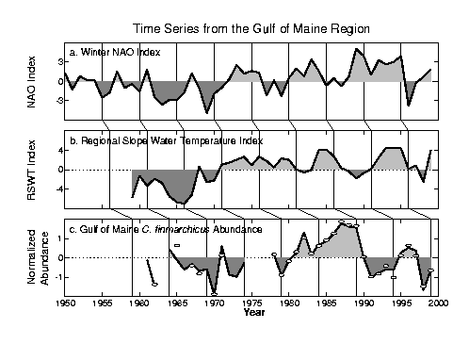
1.3 Impact of Climate-related Variability on Calanus finmarchicus. In the Northeast Atlantic there is substantial evidence that Calanus finmarchicus population abundances have varied inversely with the North Atlantic Oscillation (Planque and Reid, 1998; Greene et al. 2003), but C. finmarchicus abundance in the Gulf of Maine during 1960-90 covaried directly with the NAO (Conversi et al. 2001), suggesting that perhaps different mechanisms, acting through temperature and ocean circulation patterns/intensities are operating on the eastern and western sides of the North Atlantic. However, Planque and Reid (1998) also document the sometimes ephemeral nature of such climate-ecosystem relationships, as they observed the pattern for the Northeast Atlantic breakdown in recent times. Some of the approaches and issues related to identifying patterns of zooplankton response to climate variability are discussed in Perry et al. (2004). In their investigation of long-term temperature and salinity variability on the Scotian Shelf and in the Gulf of Maine, Petrie and Drinkwater (1993) demonstrated that the dominant low-frequency event over the last 45 years was the cooling and subsurface freshening of water masses between 1952 and 1967, followed by a rapid reversal of these trends. Largest declines in temperature (4.6ºC) and salinity (0.7) occurred near 100-m depth over the continental slope and were attributed to increased westward transport of the Labrador Current past the tail of the Grand Banks and into the Slope Sea along the shelf break. The GLOBEC decade (1990s) of studies in the Northwest Atlantic (Georges Bank) ecosystem was generally a period of high NAO index (Fig. 1). The major exception to this pattern occurred in 1995-96, when the NAO index flipped from being strongly positive to one of its most negative values of the 20th century (Greene and Pershing, 2000). This reversal was short-lived, however, as by 1998 the NAO was positive again and remained so throughout the decade.
Figure 1. Anomaly time series of a) CPR-derived Calanus finmarchicus abundance and color index from the Gulf of Maine; b) Regional Slope Water Temperature Index; c) Winter NAO index. (MERCINA, 2001)

There was no apparent immediate and dramatic response of the plankton community in the GoM/GB region to the 1995-96 NAO reversal. Bisagni et al. (2001) document significant cooling of adjacent slope water surface temperatures (using AVHRR) from 1994-1996, which covaried with volume transport anomalies through the Northeast Channel. Calanus finmarchicus populations on Georges Bank had slightly slower development and later maturation times due to lower temperatures in 1996 than in 1995 (Durbin et al. 2000).
More significant impacts on the plankton community were observed in the summer of 1998. During the 1970s, ‘80s, and early ‘90s, conditions over the Scotian Slope and in the deep basins of the Scotian Shelf and Gulf of Maine remained relatively warm and saline compared to the previous two decades. However, during early 1997, moored instruments at the shelf break off St. Pierre Bank, south of Newfoundland, detected the arrival of a sustained pulse of cold, fresh Labrador Slope Water (LSW) at depths of 50-400 m. During the rest of that year and early into 1998, the LSW progressed along the shelf edge to the mouth of Northeast Channel (Jan.’98) and into the Mid-Atlantic Bight (Mar.-Apr. ’98; Drinkwater, et al. submitted). Passing through channels and gaps in the outer banks, the cold, fresh waters flooded the inner basins, changing the temperatures and salinities abruptly by the order of 4.0ºC and 1.0 psu, respectively. By August 1998, the LSW had filled all the inner basins of the Gulf of Maine below depths of 100 m. This influx of cold, nutrient-poor northern water into the Northwest Atlantic (NWA), even into the GOM itself, was accompanied by a significant decline in the abundance of diapausing Calanus finmarchicus in the GOM in fall 1998 (Fig. 1; Greene et al. 2003). This decline might have been an effect of the generally lower productivity due to the lower nutrient concentrations of LSW, or it might have been due to altered circulation patterns associated with the presence of the LSW.

1.4 Mechanisms for Climate-related Variability of Calanus Spawning Stock Size in NWA. Interdecadal variability (e.g., 1960s cold anomaly; warm 1970s) in Western Boundary Current (WBC) transports (Petrie and Drinkwater 1993; Drinkwater et al. unpubl.) can create large changes in ocean temperature, particularly in deeper waters, that alter the distribution, migrations, spawning times, growth and physiological rates of resident organisms. The massive kill of tilefish along the Mid-Atlantic Bight in the early 1880s may be an extreme example of the impacts from an excessive inflow of cold subpolar water (Marsh et al. 1999). Altered temperature is likely to impact the physiology of diapausing C. finmarchicus and disrupt the timing of diapause exit, for which the cues are unknown. If so, this could impact the synchrony of C. finmarchicus return to the surface relative to the seasonal production cycle and phytoplankton blooming. Increased equatorward advection along the shelf-slope should provide enhanced southward transport of organisms, and this may lead to export of Calanus finmarchicus from the Labrador Sea to the Slope Sea, directly as diapausing stages in deep inflows, or indirectly through southward Labrador Shelf surface transports (Head et al. 2003). C. finmarchicus from the Labrador Sea may be important in seeding the Scotian Shelf, which is upstream from the Gulf of Maine and Georges Bank. Diapause depths of C. finmarchicus vary across the North Atlantic, with shallowest depths (<1000m) in the western Atlantic. In Wilkinson Basin in the Gulf of Maine diapausing Calanus are between 170 and 250 m, or up to 70 m off the bottom, and abundances in December 1999 were about 20,000-30,000 m⁻²; there is evidence that 1998 diapausing populations were less abundant (Greene et al. 2003; M. Benfield, pers comm). Discrete depth sampling from slope waters off southern New England show diapausing C. finmarchicus at 500 m, with 50% of the population between 400 and 600 m (Miller et al. 1991). C. finmarchicus C₅ densities in diapause ranged from 2000-12,000 m⁻², with a peak in October-November. C. finmarchicus diapause at depths of 300-900 m off Atlantic Canada and in the southwestern Labrador Sea (Head, pers comm.); diapausing copepodite densities off Labrador in December 2002 were ca. 10000-20000 m⁻². During spring and early summer C. finmarchicus comprised >60% of the biomass of the mesozooplankton and >80% of the abundance of large copepods of the Labrador Sea (Head et al. 2003). Average surface (0-100m) C. finmarchicus abundance in the western and central regions of the Labrador Sea was 17000 m⁻² during the same time. Strong southward flows from the Labrador Sea could export large numbers of Calanus to the NW Atlantic. As an extreme example, during the 1998 event the arctic-boreal copepod C. hyperboreus was recorded south of Georges Bank for the first time in more than 30 years of CPR sampling (Johns et al. 2001). A third effect of the change in WBC transport is on nutrient concentrations (Petrie and Yeats 2000). Labrador Slope Water has about one-half the nutrient concentration of older Warm Slope Water (WSW), which is more commonly found adjacent to the slope in the western North Atlantic. The low nutrient content of LSW will directly affect biological productivity in the Gulf of Maine and Georges Bank since deep water influx through the NE Channel is the major source of nutrients supporting the early spring productivity of the GoM/GB system.

1.5 Multi-Decadal to Interannual Variability of Basin-scale Circulation Related to NAO. Recent studies (Hoerling et al. 2001; Hurell et al., 2001) show that the NAO has a major impact on the North Atlantic circulation and variability. Taylor and Stephens (1998) show that over the period 1966-96, the position of the Gulf Stream north wall (GSNW) appears to be determined by the NAO, but with a lag of about 2 years. They attribute the lag to propagating Rossby waves (Gangopadhyay et al. 1992), and suggest that the delayed-response predictability observed for the 1977 to 1988 period has been a feature of the Gulf Stream system for last 30 years. Figure 2 shows the Gulf Stream position (position of the 15ºC isotherm from data in Parker et al., 1995) overlaid with winter NAO from Drinkwater (pers. comm.). Both Gulf Stream position and NAO index exhibit an upward trend since 1970 (Conversi et al. 2001; Taylor and Gangopadhyay 2001). There was a downward trend from 1950 to 1970, suggesting that these trends may be due to climate variability. The Gulf Stream was furthest south during the 1960s, and furthest north during the 1950s and 1980s. The Gulf Stream position exhibits pronounced interannual variation at periods of 3-5 years.
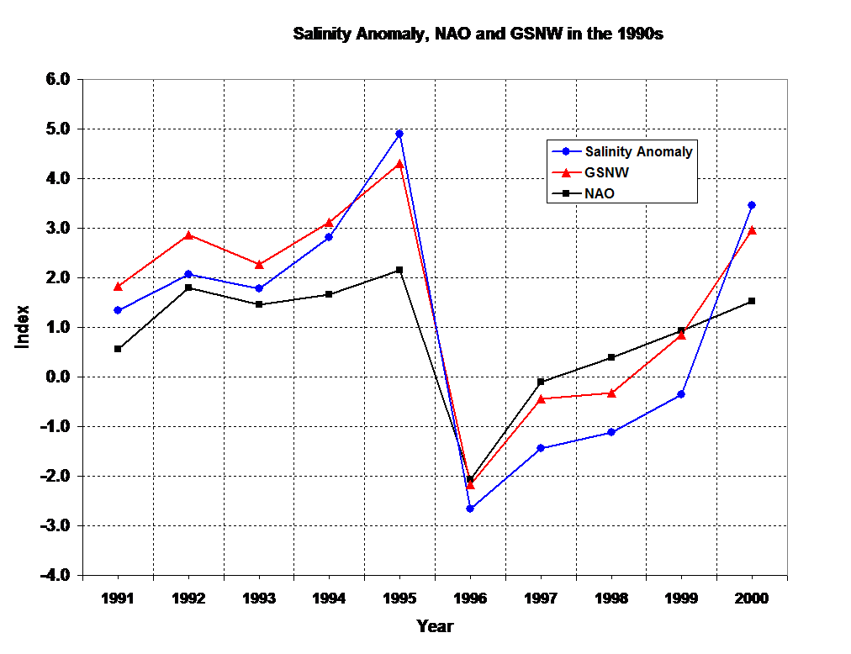
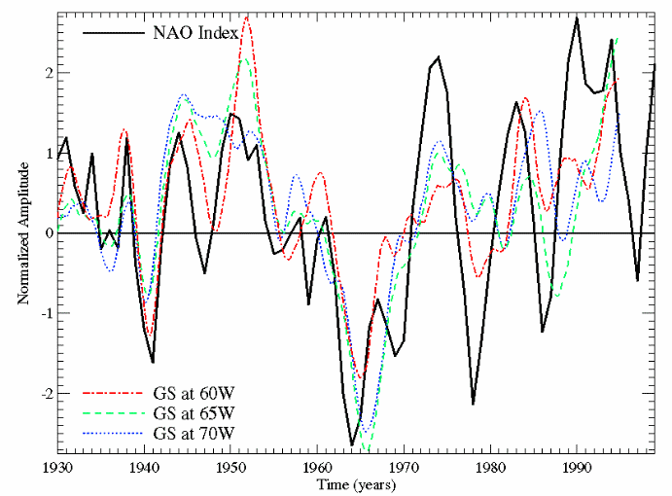
Fluctuations of the Gulf Stream are correlated with the NAO index, although there seems to have been a phase shift since the 1960s. Temperature and salinity variability in the GoM/GB region during the 1990s has been well documented. Mountain (2004) analyzed the temperature and salinity in NAFO subareas 5 and 6 during the 1990s and discovered that the surface waters in the GoM/GB region underwent a gradual freshening (Figure 3) when compared to an earlier period (1978-87), due to an increase inflow of Scotian Shelf Water. Drinkwater (2004) investigated atmospheric and sea-ice conditions in thenorthwest Atlantic during 1991-2000 and related them to low and high-NAO conditions. The atmospheric low-pressure system over the northwest Atlantic shifted eastward during the latter half of the decade, causing weaker northwesterly winds, warmer temperatures in the Labrador Sea to the Gulf of Maine and a reduction of sea-ice.
Figure 3. Interannual variability of the NAO, the GSNW, and the Salinity anomaly in the GoM/GB during the 1990s.
Figure 2. Multi-decadal normalized amplitude time series of Gulf Stream (15˚C isotherm position) at 60˚W, 65˚W, and 70˚W longitude and winter NAO index.

Fratantoni and Pickart (2005, submitted ms.) analyzed twelve years (1990-2001) of hydrographic data to examine alongstream evolution of the shelfbreak front in the western north Atlantic from the west coast of Greenland to the Mid-Atlantic Bight.. They found that the shelfbreak front in the Labrador Sea is composed of two fronts: one inshore front with fresher Labrador Sea water, and the other offshore with Irminger Sea water. This latter front completely disappears near the Grand Banks. They also found that during the 1990s there was an alongstream freshening of the shelfbreak flow right after the tail of the Grand Banks, even before the front is joined by the freshwater plume outflow from the Gulf of St. Lawrence. They suggest that the outer “salty” portion of the front turns offshore at the tail of the Grand Banks and the fresher surface layer follows the shelfbreak towards the GoM/GB region.
These three studies raise questions regarding the source of the low-salinity waters in the Gulf of Maine in the 1990s. Is it the fresh surface layer of Labrador Sea Water that flows along the shelf break and enters the GoM/GB region? What contribution, if any, comes from the freshwater outflow from the Gulf of St. Lawrence? What is the large-scale response of the shelfbreak system to seasonal forcing? What is the basin-scale response of the shelfbreak system to interannual NAO-like forcing? Our numerical modeling will focus on these questions by analyzing the basin-scale four-dimensional fields. Figure 3 shows the decade-long time-series of the NAO, the salinity anomaly in the GoM/GB region, and the GSNW Index from Taylor and Stephens (1998). It is evident that when the Gulf Stream was further south, the Gulf was fresher, and vice versa. The correlation between the salinity anomaly and the GSNW is 0.78; while that between the salinity anomaly and the NAO is 0.64. Our model simulations will provide dynamical insights on these correlations.
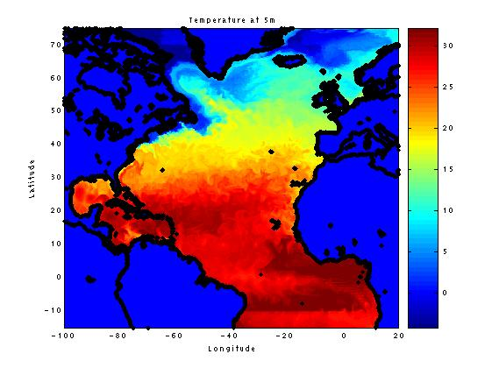
1.6 Ongoing Basin-scale Modeling for Simulating High and Low NAO Forced Fields. The physical modeling component is based on ROMS (Regional Ocean Modeling System), which was developed and modified by Rutgers University, UCLA and NASA/JPL scientists. ROMS is a split-explicit, free-surface, terrain-following ocean model, where short time steps are used to advance the surface elevation and barotropic momentum, and larger time steps for temperature, salinity, and baroclinic momentum. Recent modifications include subgrid-scale parameterizations (Gent and McWilliams 1990; Danabasoglu et al. 1994; Griffies et al. 1998) and sigma-coordinate pressure-gradient error reduction (Shchepetkin and McWilliams 2003). The improved time-stepping algorithm (Shchepetkin and McWilliams 2004) provides improved run-times.

Using NASA Interdisciplinary Science (IDS) funding (NASA NNG04GH50G), we purchased an Altix 350, eight-processor SGI computer for ROMS modeling. The eddy-resolving 15-20km ROMS has been configured for the North Atlantic (Figure 4). It encompasses the Gulf Stream system, the coastal Gulf of Maine, Georges Bank, Gulf of St. Lawrence, Labrador and Irminger seas, and the shallow regions near coast where the depth is less than 50 meters. The resolution varies from 10 to 15km (north) to about 20-22km in the southern tropical region and there are 50 vertical levels. For NASA, we are carrying out two 10-year-long simulations representative of the two phases of the NAO. We have started the simulation for the high-NAO period. The initial temperature-salinity fields are from Levitus and the forcing fields are based on the annual climatology, computed for 1980-93, by the Southampton Oceanographic Center (SOC). The model is (as of 7 May 2005) on its sixth year of simulation and the results are being analyzed.
Figure 4. Simulated surface (5m) temperature on day 1500 during the high-NAO simulation. The model is still in spin-up mode. Note the formation of the western boundary current (deep red) along the east coast of the US.

In summary, studies have shown correlations among the basin-scale NAO index and the circulation variability realized by Gulf Stream position, Slope Sea and Labrador Slope water properties, as well as between the NAO and C. finmarchicus populations in the western North Atlantic. However, additional kinematical and dynamical studies are required in order to understand the processes underlying these relationships. We are simulating ocean conditions in the North Atlantic for high- and low-NAO periods under a different project. Thus, in this proposal, our focus will be on 1) simulating the GLOBEC field years (1993-1999), and 2) using the results from all three periods to force a Lagrangian model of Calanus finmarchicus. We will conduct a number of “synthesis experiments” focused upon C. finmarchicus.

2. Research Objectives, Questions & Hypotheses

2.1 Climate-Related Basin-Scale Circulation Variability Questions, Two distinct time-scales are important for evaluating the impact of climate and basin-scale forcing on the GoM/GB ecosystem. The first is the multi-decadal variability (Petrie and Drinkwater 1993) which results from the accumulated effects of a sustained high-NAO or low-NAO condition. Clearly, the C. finmarchicus population responds to sustained long-term changes in the system. Our present NASA modeling effort will address this with the addition of biological modeling.
Rossby (1999) attributes the annual north-south shifting of the eastward-flowing Gulf Stream to a time-varying input of water from the Labrador Shelf. An increasing volume transport of Labrador shelf water during 1996-97 (Smith etal. 2001) might push the Gulf Stream further south. Associated with this shift is westward penetration of LSW along the shelf break (Fig. 5), which is also evident as cooler SST (Fig. 6). Separation of the Gulf Stream from the coast may be set-up by the wind stress curl in the subtropical gyre, while the latitudinal excursion of the eastward flowing GS (east of 65W) is related to the amount of water flowing in from the Labrador Shelf and/or slope, which in turn might be linked to NAO variability.
We will peform data analysis, modeling, and diagnostic analysis, to address several scientific questions about the NAO and its impact on western North Atlantic circulation and its variability:
(1) What is the interannual variability of the kinematical relationship between features such as the north wall of the Gulf Stream, Gulf Stream warm-core and cold-core rings and shelf/slope front, Labrador Slope Water, and Labador Sea Water?
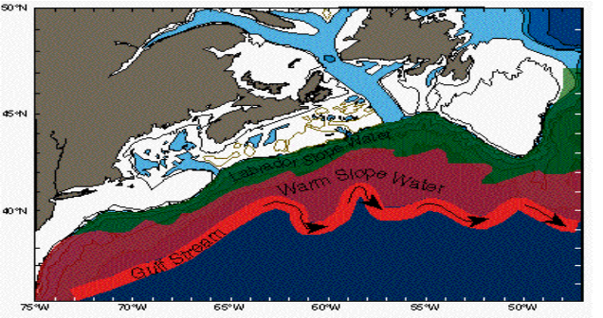
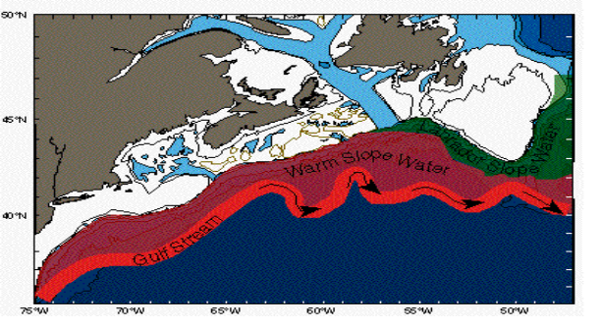
(2) What is the nature of the variability of these features during the 1993-1999 US-GLOBEC measurement period? It is presently unclear how the salinity anomaly occurred during the 1990s. The high correlation between the freshening of the GoM/GB region with southward movement of the Gulf Stream (Figure 3) is compelling enough to look for large-scale thermohaline forcings following Rossby and Benway (2000). The shelf water influx (Mountain, 2004) points to increased ice-melt.
Figure 5. A conceptual model of the large-scale response of the Gulf Stream/Slope Water system to the extremes of the winter NAO Index. During minimum NAO (leftl), the Gulf Stream shifts southward, allowing extensive westward intrusion of Labrador Slope Water (LSW). During maximum NAO (right), the Gulf Stream shifts northward, pushing warm slope water against the shelf edge, thus restricting westward intrusion of LSW.
(3) What is the nature of the interactions between the subtropical gyre and the subpolar gyre in simulations conducted for high-NAO years versus low-NAO years? Their interaction through the deeper waters in the thermohaline circulation may be very important for determining the fate of Calanus finmarchicus being transported from Labrador Sea to the Slope sea region.
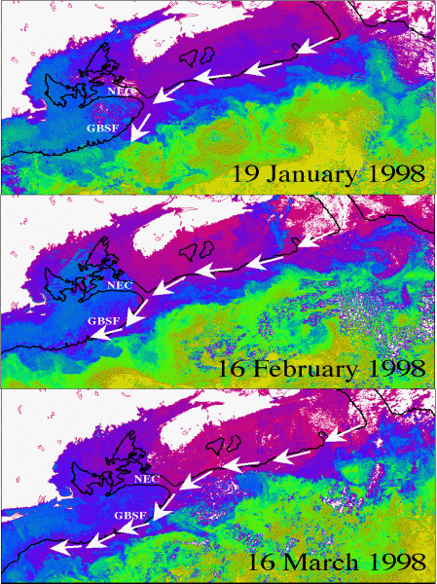
2.2 Climate-Related C. finmarchicus Variability Questions. A goal of the proposed research is to examine the impacts of seasonal and interannual variation in ocean conditions in the western North Atlantic (Labrador Sea, Slope Sea and GB/GoM) on productivity and seeding (supply) of Calanus finmarchicus to the GB/GoM. We will develop Lagrangian individual and behavior based models (IBMs) of C. finmarchicus growth, development and transport. Using these models we will evaluate potential physical exchange of copepods between the semi-enclosed Labrador Sea and Slope Sea gyres, and between the Slope Sea and the GB/GoM. There is an interesting conundrum associated with the MERCINA (2001) hypothesis on how the Labrador Slope Water influences the Slope Sea and supply of Calanus to adjacent continental shelves. The puzzle is that when Labrador Sea water masses are significant off the Scotian Shelf, Georges Bank and in the Slope Sea region, C. finmarchicus populations in the Gulf of Maine tend to be low (Figure 1). This is counter to expectations; given the high C. finmarchicus abundances in both surface layers (during spring-summer) and deep diapausing layers (remainder of year) in the Labrador Sea, one might expect higher C. finmarchicus seed supply when Labrador influences are great in the Slope Sea region. The discrepancy may be related to temperature of the water that the diapausing stocks are in, and the role that temperature-controlled physiological processes have on terminating the diapause stage. Head et al. (2000) report that surface waters of the Southern Labrador Sea in May and June have a large fraction of adult females that are from awakened diapausing C₅s. This suggests that in the Labrador Sea, the alarm clock for waking up diapausing C. finmarchicus is much later (by up to 5 months) than the waking time in the Gulf of Maine and Slope Sea (usually December-February; Durbin et al. 2000). If the arousal time is intrinsic to the individual, and if this behavioral habit (pattern) is transported with the diapausing individuals at depth, then imported Labrador Sea copepods will awake too late to exploit the spring bloom in the NW Atlantic. We will test the hypothesis that basin-scale climate oscillations (NAO), operating through time-varying intensity of deep and intermediate water-mass formation and ocean circulation, result in shelf- and slope-water transports and fluxes of Calanus and nutrients that are advantageous at some times and disadvantageous at others for the development of large overwintering populations of C. finmarchicus in deep waters adjacent to the GB/GoMsystem.
Figure 6. Weekly-composite, satellite-derived SST images from the first three months of 1998 (from G. Strout, UMD). Also shown are the 200-m isobath (thick black line), Northeast Channel(NEC) and Georges Bank Southern Flank (GBSF). White arrows indicate position of cold, southwestward-flowing LSW. Dates indicate the last day of each weekly composite.

The core hypothesis and predictions of this work are:
Hypothesis: The occurrence of large populations of Calanus finmarchicus in the coupled GB/GoM system REQUIRES (1) high seed stocks (supply) of diapausing C.finmarchicus in the deeper ocean regions nearby (GOM basins and the Slope Sea), (2) that the deep C. finmarchicus stocks terminate diapause at the appropriate time to be synchronous with continental shelf spring blooms, and (3) a nutrient enriched, highly productive ecosystem in the GB/GoM to sustain high growth and survival rates of Calanus that will provide seed for the subsequent year.

Prediction A: Overwintering Calanus finmarchicus seed stocks are LOW and GB/GoM productivity is HIGH when the water masses of the Slope Sea have little influence (input) from Labrador-Irminger Gyre (Labrador Slope Water) water masses (due to the relatively nutrient replete bottom waters and low Calanus supply in Warm Slope Waters), but C. finmarchicus recruitment is good because of a near-perfect match between the time of diapause awakening and the time of the spring bloom, the latter of which is large because of the higher concentration of nutrients in deep warm slope waters.
Prediction B: Overwintering C. finmarchicus seed stocks are HIGH and GB/GoM productivity is LOW when the water masses of the Slope Sea have a large proportion of Labrador Sea water (due to the relatively nutrient-depleted bottom waters and high C. finmarchicus supply in cold Labrador Slope Water), but recruitment and productivity are poor because of the generally low springtime productivity (low nutrients) and a timing mismatch between diapause awakening, ascent and reproduction and the NW Atlantic spring bloom.

3. Research Approach
It is clear that the relationship between the GB/GoM ecosystems and basin-scale variability related to NAO occurs over at least two different time-scales: (i) multi-decadal, and (ii) interannual. We propose to carry out a set of eddy-resolving basin-scale model simulations, analyze satellite and other available data sets from the GLOBEC period, validate the model simulations, and use the simulations to address a set of questions that relate ecosystem variability in the Scotian Shelf, Gulf of Maine and Georges Bank regions to fluctuations of the NAO.
Our approach is based on (i) analyzing satellite and hydrographic observations during 1993-1999 period; (ii) simulating the basin-scale impacts on Calanus finmarchicus from an eddy-resolving North Atlantic model simulation of high vs. low NAO periods; (iii) simulating basin-scale physical and biological fields for the GLOBEC period (1993-1999); and (iv) synthesizing the model simulations and GLOBEC data sets during the 1993-1999 period to address the specific questions outlined in Section 2 above. In addition, we will provide the basin-scale simulation fields for forcing other regional models (both physical and biophysical) to specifically address detailed hypothesis related to the interannual variability of the GB/GoM ecosystems.

3.1 Analysis and Use of Satellite-derived SST (1993-1999). We propose a comprehensive synthesis using both daily satellite-derived SST data from the western North Atlantic collected between 1993 and 1999 and five-day averaged, optimally-interpolated (OI) SST fields also derived from satellite data. The cloud-free OI SST fields have been already constructed for the five year period (1995-1999) encompassing the entire US-GLOBEC Northwest Atlantic Georges Bank field program. Five-day averaged OI SST fields were produced using the OI method of Chelton and Schlax (1991) from a time series of approximately 4000, twice-daily, high-resolution (~1.4-km) cloud-cleared Advanced Very High Resolution Radiometer (AVHRR) satellite images (Bisagni et al., 2001). Calibration of the resulting five-day averaged OI SST fields with five-day averaged bulk temperatures (z ≈ 1-m depth) from four NOAA data buoys located within the domain was completed using a least-squares adjustment between mean satellite-derived SST values from a 3 × 3 pixel array centered on each buoy location and buoy temperature values. The final set of calibrated OI SST fields will be used for our planned high-resolution synthesis (see Section 3.2.2) within the Gulf of Maine and Georges Bank region.
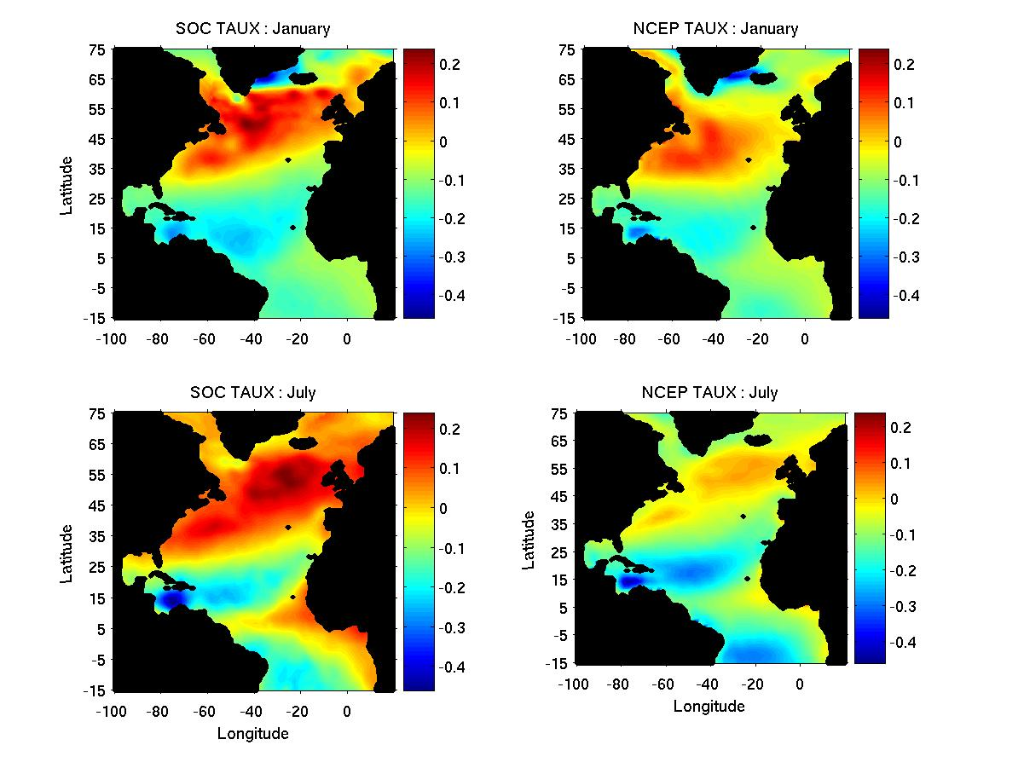
3.2 Basin-Scale Circulation Modeling. Two of us (AG and JB) are funded by NASA to simulate decade long periods of high and low NAO conditions. The high NAO conditions are currently being simulated. During summer 2005, simulation for the Low-NAO period will be done. Levitus will be used for initial temperature and salinity fields. Wind forcing is derived from the ICOADS data set during the sixties (1962-1971, low-NAO period). Zonal wind-stress fields for winter (January) and summer (July) for high and low-NAO periods are shown in Figure 7. We are addressing a hypothesis related to ‘depletion vs. dilution’ of nutrients, i.e., the dominance of low nutrient Labrador Sea Water influx in the Slope Sea during low-NAO periods as opposed to high nutrient warm slope water coming through the Gulf Stream system during high-NAO periods. So, we focus the results of the simulations towards realistically generating the Gulf Stream System and the Labrador Sea Water influx into the Slope Sea. Figure 8 show that the model is successfully reproducing the Florida Current at 32N, with core speed of 50cm/sec and a reasonable vertical extent of 800 meters. The transport of the current with 100km width at the surface is about 40Sv. Figure 4 shows the cold Labrador water flowing southward in a blue ribbon around the tail of Grand Banks (Fig. 8 – right panel). We will carry-out targeted multi-year simulations for the North Atlantic starting from the results of the 10-year long simulations.
Figure 7. Zonal wind-stress fields during high-NAO (left) are high-amplitude compared to those during low-NAO (right) period. Also note the different spatial extent of the Icelandic low and the Azores high probably due to the movement of their respective centers of actions during the two periods.

3.2.1 Proposed basin-scale simulations. In the first year, we will integrate the North Atlantic ROMS OGCM from its final high-NAO state with monthly NCEP reanalysis fluxes during 1988-1999. Based on our experience (Chao et al., 1996), we start the simulation five years before the start of GLOBEC (1993) is to allow the winds to force the response of the Gulf Stream and Labrador Current in a time-integrated manner. The simulated fields for 1990 through 1999 will be used for the zooplankton model to generate C. finmarchicus distributions in the NWA. Both physical and biological fields will be analyzed for interannual variability studies and used in the C. finmarchicus experiments in the second year.
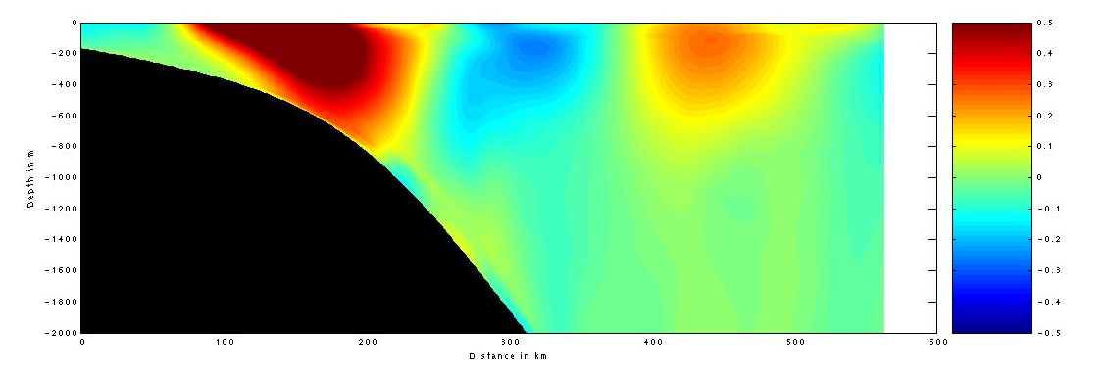
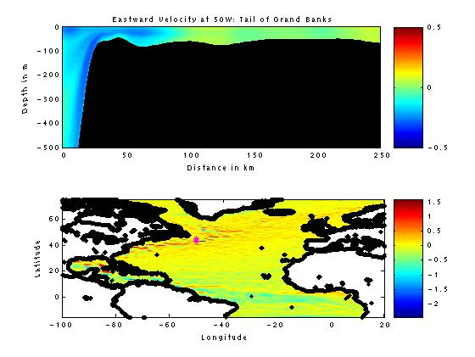
The success criteria for the proposed physical and biochemical simulation will be our ability to: (i) reproduce the high-NAO vs. low-NAO behavior of the GS path similar to that shown in Fig. 4, (ii) reproduce the nutrient variability in the Slope Sea, and (iii) simulate specific such as the 1997-98 Labrador Slope Water intrusion in Slope Sea. Biophysical simulations (described later) will be used to understand the basin-scale impact of the NAO-driven Labrador Sea water advection on the slope sea region. In particular, the vertical distribution and variation of flow and their influence on nutrients and Calanus in the slope sea will be compared between 1995 and 1998.
Figure 8. Left panel: Meridional velocity section across the Florida Current at 32N. See text for details. Note the cyclonic eddy offshore of the Western Boundary Current region. Right panel: Zonal velocity section at 50W shows westward flow indicating the turning of the Labrador Sea Water around the tail of the Grand Banks.

We will investigate transport pathways from the Labrador Sea/Slope to the Slope Sea (between the North wall of the Gulf Stream and the shelf break), the transport from the Slope Sea to the Labrador Sea and retention within the Slope Sea. We will explore whether eddies make an important contribution to the retention in the Slope Sea, transport from the Labrador Sea/Slope to the Slope Sea, and from the Slope Sea to the Labrador Sea. We are also interested in whether there are significant changes in the transport pathways from year to year. For example, were there changes in the pathways related to the 1996-98 NAO event? How different are these pathways for a high NAO (1994-95) period from a low-NAO (1997-98) period?

3.2.2 High-resolution field generation using basin-scale output and GLOBEC data sets. We propose to generate a series of high-resolution (5-km) fields by melding the basin-scale fields (10-15 km resolution) with GLOBEC period data sets using multi-scale objective analysis (OA) as done previously ((Gangopadhyay et al. 2002, 2003). The OA is performed in two stages (Lermusiaux, 1999a). In the first stage, the largest dynamical scales (from the basin-scale model fields) are resolved at each level, using estimated large-scale e-folding spatial decays, zero crossings, and temporal decay. In the second stage, the synoptic dynamics of interest (meso-scale and sub-basin scale, from data or synthetic profiles as explained below) are resolved using its estimated space-time decays. The background for this second stage OA is the first-stage OA. The primary assumption made in this two-scale OA is that the errors in the basin-scale (first-stage) and synoptic (second-stage) dynamical scales are statistically independent. This procedure effectively and smoothly melds the synoptic profiles or observational profiles and climatology for the GoM/GB region. For detail mathematical description of the OA parameters, see Lermusiaux (1999a,b).

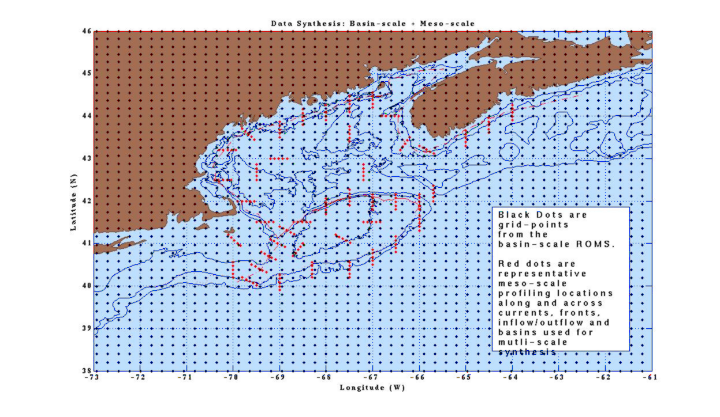
The high-resolution synthesis will be carried out in four steps. First, the temperature and salinity fields from the basin-scale ROMS simulation will be averaged over 5-day periods during the GLOBEC period of 1993-1999. The locations for these profiles are shown in Figure 9 as black dots within the region of interest (73-50W, 38-46N). Second, the 5-day averaged SST fields and the ROMS temperature field at the bottom level will be synthesized to develop synthetic temperature profiles at pre-determined locations (red dots in Figure 9). The synthesis equation is given by: T(z) = T_{s} - (T_{s} – T_{b}) Ф(z). Here T_{s} is the surface temperature (SST) and T_{b} is the bottom temperature from the nearest ROMS grid point. Ф(z) is the non-dimensional structure function (unity at surface to zero at bottom) for the temperature profile of the mesoscale feature at the location of interest. The forms of Ф(z) for all the 270 profiles are available from Gangopadhyay et al. (2003). Third, the corresponding salinity profiles will be determined using appropriate GLOBEC data-derived T-S relationships in conjunction with the T(Z) derived in step 2. Finally, the mesoscale temperature and salinity profiles from above two steps will be melded with the basin-scale fields for each five day period using multiscale OA. This process will generate three-dimensional high-resolution fields for temperature, salinity and geostrophic velocity every five-days during the whole GLOBEC period (1993-1999) that has the climatic and basin-scale impact of NAO in the flow field. We will thus resolve the sub-mesoscale variability of the Scotian Shelf and the flow through the Northeast channel into the Gulf of Maine and Georges Bank system with climate-to-basin scale variability incorporated in the mass and momentum field. A twin experiment will be carried out to understand the ecosystem behavior for Winter-Spring-Summer (WSS) of 1995 compared to that during WSS of 1998 using the IBM modeling as described in section 3.3.
Figure 9. A synoptic circulation template for the GOMGB region used for Multiscale synthesis is presented here. The red marks are pseudo-CTD stations where feature model t-s profiles are generated. The profile locations are selected along and across circulation features such as the Maine Coastal Current, the Tidal mixing front, the shelf-slope front, Northeast Channel inflow, Great south Channel outflow, and Wilkinson, Jordan and Georges basins.

3.2.3 Multi-decadal and Interannual Validation of Simulations. The model simulations will be validated with data sets available for the Gulf Stream paths from Gangopadhyay et al. (1992) and the GSNW indices from Taylor and Gangopadhyay (2001) for last 50 years. The simulated seasonal water-mass climatology for the Gulf of Maine region will be validated against MARMAP and GLOBEC data sets (Mountain, 2004). Simulated water-mass climatology for the Labrador Current and Scotian Shelf region will be validated against archived data sets (Loder et al., 2001; Fratantoni and Pickart, 2005) and variations in salinity anomalies in the Labrador Sea during 1950-1998 (Houghton and Visbeck, 2001). Model simulations in the GoM/GB region will be validated with 1985-2000 SST data from Bisagni’s lab.

3.3 The C. finmarchicus Modeling Experiments. The biological modeling follows naturally from the analysis of the physical fields and will be built incrementally from that foundation. The population dynamics of Calanus finmarchicus and transports by oceanic flows have been extensively modeled in both the Northwest Atlantic (Miller et al. 1998) and other regions of the North Atlantic (Tittensor et al. 2003; Bryant et al. 1998; Carlotti and Wolf, 1998; Carlotti and Radach 1996; Harms et al. 2000). However, almost all of those prior efforts have emphasized the population dynamics of the C. finmarchicus when they are actively feeding and reproducing in the near-surface layers. An emphasis of the coupled biophysical Lagrangian modeling we propose is to examine the role of transports on supply of deep diapausing populations of C. finmarchicus to the Slope Sea region from the Labrador Sea, where diapausing populations are very large (>17000 m⁻²) at depths of 300-800m (Heath et al. 2004; Head, pers. comm.). The Labrador Sea is recognized as one of the epicenters of C. finmarchicus in the North Atlantic (Tittensor et al. 2003; Heath et al. 2004), so export of water from the Labrador Sea to regions further south would be expected to provide influx of Calanus. Transports of C. finmarchicus from diapausing populations to the North Sea have been the focus of both field studies and extensively modeled (Heath 1999; Heath et al. 1999; Heath and Jonasdottir 1999; Gallego et al. 1999), but our proposed modeling is the first to examine transport of diapausing populations in the western North Atlantic.
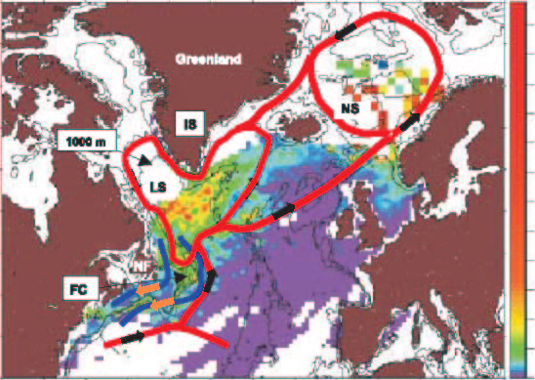
There are three distinct biological (Calanus finmarchicus) model experiments, which are linked directly to the physical model experiments. The first experiment (done in year 1) will use the results of the decade long simulations of the “prototypical” high NAO (1980-93) and low NAO (1962-71) periods. Basin-scale physical simulations for both high and low NAO periods are currently being done (with NASA funding), so the velocity and tracer fields will be available in year one for Lagrangian modeling of Calanus transports and physiology. The second biological modeling experiment (year 2), will use velocity and tracer fields from simulations of the GLOBEC field years (1993-1999) to explore the impact of the 1996 NAO reversal and later inflow of Labrador Slope Water into the NW Atlantic on diapausing Calanus finmarchicus populations. Comparison of the results of multiyear model simulations from experiment 1 and experiment 2 will provide insights on the effects of a prolonged influence of cold, nutrient deplete Labrador water on the Slope Sea, GOM-GB, and Calanus finmarchicus populations. The experiment 1 and 2 simulations on deep diapausing populations will be complemented by simulations of active phase Calanus that might be transported within near-surface continental shelf currents. For these simulations, initial and boundary Calanus densities for the Slope and Labrador Sea will be derived from the Bedford Institute of Oceanography’s Calanus finmarchicus data base (Mary Kennedy, pers comm.). The third biological modeling experiment (year 2) will use higher resolution velocity and tracer fields derived from basin-scale physical simulations melded with objectively analyzed SST fields as described in section 3.2.2. Higher resolution physical fields for the Scotian Shelf, GOM and GB, will provide the physical template to examine potential fluxes of Calanus from Slope Waters SE of the continental shelf, through the NE Channel into the Gulf of Maine deep basins.
Figure 10. The mean abundance of Calanus finmarchicus (number m-3) stages C5-C6 in the North Atlantic from CPR data during 1950-99. Red lines show schematic near-surface flows of gyres in the North Atlantic. Note the relationship between the population maxima of C. finmarchicus and the gyres. Modified from Tittensor et al. (2003). The dark blue lines near Newfoundland show proposed pathways of Calanus flux from the Labrador Sea to the Slope Sea off New England. The pathway nearest the coast is transport of active phase C. finmarchicus via shelf currents. The pathway further from shore is transport of diapausing Calanus in deeper waters.
For each circulation scenario, we will begin with an analysis of the transport using tracer experiments with Lagrangian models. Note that the high vertical resolution (50 levels) of the present ROMS set up will provide more accurate vertical fluxes than many studies before. Biological realism will be added sequentially. Deep diapausing C. finmarchicus populations in the southern Labrador Sea will be initiated with a range of lipid stores; timing of awakening will be related to lipid consumption at depth (recognizing that most lipid is not consumed during the diapause phase, but rather remains available for egg production immediately following maturation) (Irigoien, 2004), and therefore a function of temperature. Heath et al. (2004) inferred from the assumed neutral buoyancy depth of diapausing C₅ C. finmarchicus in the Labrador Sea that C. finmarchicus implied lipid weight was ca. 27.5% of total body weight. For models, we will explore a range of lipid weights that span 20-70%, which encompasses the range of measured lipid fractions in diapausing C. finmarchicus (Heath et al. 2004). Initial depths of C. finmarchicus in the Labrador Sea will vary from 300-1000m (median near 500m; Heath et al. (2004); Head, pers comm.). These simulations will indicate sensitivity to deviations in diapause depth, temperature, and timing. Simulations of the active phase (December-May) will require both temperature and food (chlorophyll) fields as controlling factors for C. finmarchicus development and growth. Satellite-derived chlorophyll fields from SeaWiFS and CZCS will be used to derive a climatological seasonal chlorophyll distribution. In the GLOBEC study region on Georges Bank, satellite fields will be complemented by in situ observations of chlorophyll. Vertical distributions of chlorophyll will be generated from local seasonal observations of vertical chlorophyll distribution, scaled by the value observed by satellite at the sea surface. The impact of chlorophyll variability will be explored using SeaWiFS chlorophyll fields from particular years. The biological simulations will focus on influence of basin-scale circulation variability on C. finmarchicus distribution, abundance, and diapause arousal timing in waters adjacent to GB/GoM.
The C. finmarchicus biological simulations (experiments 1-3) are complementary to already funded Calanus modeling projects (Franks et al. project) that are more specific to the dynamics of Calanus during the active season in the GoM/GB and Scotian Shelf regions. Our project focuses on the transports and physiological awakening of Calanus during their deep-dwelling diapause phases and on the implications of NAO variability and cold Labrador Sea influence on the population dynamic timing and ability of C. finmarchicus to exploit the strongly seasonal production cycles typical of temperate continental shelf habitats.

Significance and Intellectual Merit. This project will develop a quantitative understanding of how North Atlantic basin-scale forcing (NAO), acting through variable water mass formation and water transports, impacts the physics, nutrient chemistry and ecology of the Northwest Atlantic. Our investigation focuses on the ecological impacts of variable inflow of cold, fresh, nutrient-poor water from the Labrador Sea to the NW Atlantic, because historical records suggest that inflow events of both short duration (like 1998) and longer duration (1960's) occur and ecosystem productivity of the region, as observed in Calanus finmarchicus abundance, has responded to these changes.
To address variability over these multiple time scales, we propose to do the following during the two-year duration of the project: (1) Set up and run an individual based model (IBM) for the Northwest Atlantic, using the high-NAO (1980-1993) and low-NAO (1962-1971) forced physical fields from an ongoing eddy-resolving North Atlantic simulation to understand multi-decadal variability of Calanus finmarchicus seeding and production in this region; (2) Perform a set of eddy-resolving basin-scale model simulations during 1988-1999 starting from already existing high-NAO simulations (from an ongoing NASA project) and run the IBM to study the interannual variability of C. finmarchicus seeding and production in this region; (3) Analyze long-term in-situ physical and biological datasets and satellite-derived sea surface temperature (SST) along with in-situ physical, biological, and chemical data collected during the GLOBEC core-measurement period (1995-1999), and validate the two basin-scale physical and biological fields to develop a broader understanding of C. finmarchicus seeding and production; and (4) Generate four-dimensional high-resolution (5-km) physical fields using basin-scale fields and available data during 1993-1999, and run a series of IBM simulations at higher resolution to address questions relating ecosystem variability on the Scotian Shelf, on Slope Sea and within the Gulf of Maine and on Georges Bank to the large-scale fluctuations of the NAO.

Broader Impacts. We anticipate that our work with satellite-derived SST data under this proposal will provide a synthetic focus to assist with other regional observational and modeling work being proposed by other groups. Our study on the impact of large-scale climatic and basin-scale forcing on the regional ecosystem of the GoM/GB region will enhance the understanding of the larger community. We will train two graduate students during the two years of this project. Results will be disseminated by peer-reviewed scientific publications and presentations at national conferences. We will make the model output available via a website linked to the GLOBEC website. We will give public lectures at Dartmouth High School on the importance of NAO and its impact on the regional ecosystem as part of our ongoing K-12 outreach program.

