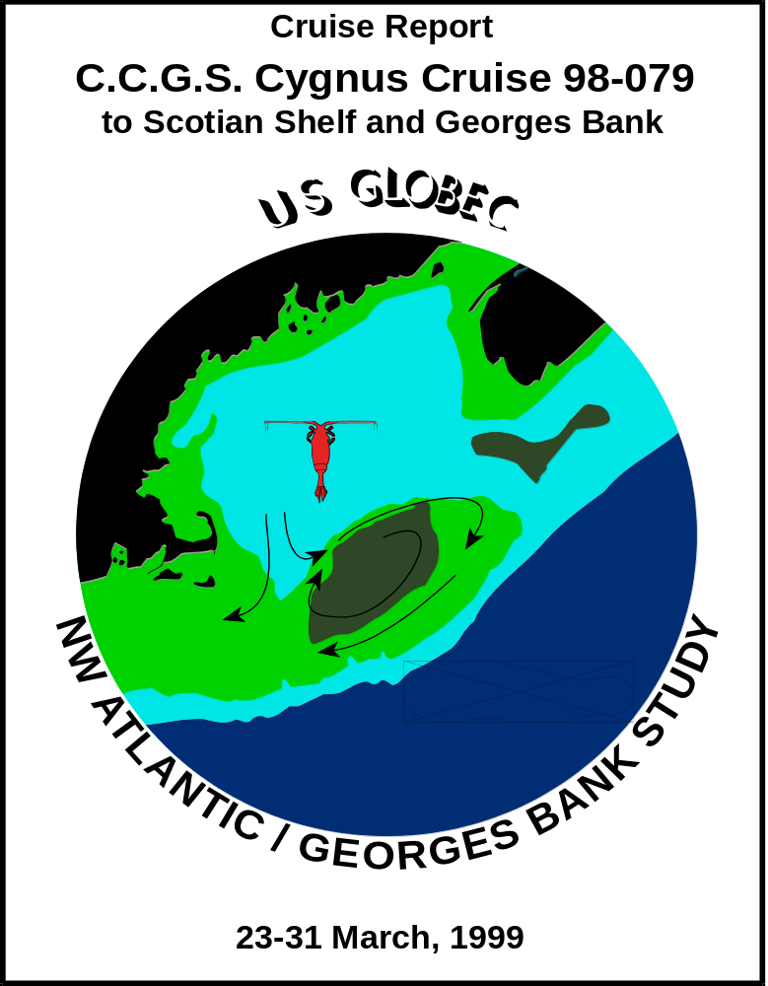

NOTE: Some tables still need reformatting for Web.
Currently displays much better under Internet Explorer than under Netscape.
*********************************************************************

REPORT ON C.C.G.S. Cygnus CRUISE 98-079
23-31 March 1999
by
Peter C. Smith and Gary L. Bugden
Ocean Sciences Division
Bedford Institute of Oceanography Dartmouth, Nova Scotia
and
Jackie Spry
Sprytech Biological Services, Inc.
CANADA

August, 1999

BEDFORD INSTITUTE OF OCEANOGRAPHY CRUISE REPORT Cygnus 98-079

Local Cruise Designation: 98-079

Vessel: C.C.G.S. Cygnus

Dates: 23-31 March, 1999

Area: Southwest Nova Scotia/Georges Bank

Responsible Agency: Ocean Sciences Division
Maritimes Region, DFO

Ship's Master: Capt. M. Champagne

Scientific Personnel:

P.C.Smith Ocean Sciences
M. Scotney Ocean Sciences
G. Bugden Ocean Sciences
B. Nickerson Ocean Sciences
J. Spry Sprytech Biological Services, Inc.
1. PURPOSE

The scientific objectives of this cruise were:

- Survey the distribution of temperature, salinity, nutrients, and biological content of a cross-over event between Browns and eastern Georges Bank,
- Lagrangian measures of surface drift on Browns and eastern Georges Banks.

The activities planned for the cruise period include:

- Conduct CTD survey of a cross-over event off SWNS and eastern Georges Bank,
- Make a series of biological measurements on Browns, Georges and offshore,
- Conduct monitoring activities at Halifax STN 2.
- Deploy an LTTM mooring off Ketch Harbour, N.S.

2. NATURE OF DATA GATHERED
A double LTTM mooring (Fig.1a; Table 1) was deployed in shallow water (~40 m) off Ketch Harbour. The mooring carried two MicroCat T,S recorders at 5 and 40 m and two Vemco temperature recorders at 10 and 20 m. The two mooring legs were connected by a 150m Kevlar groundline.

A total of 38 CTD stations (Fig.1b, Table 2) were occupied in the vicinity of Northeast Channel, primarily along the following sections:
1) Section Ia - across Northeast Channel from Browns to Georges Bank on the mooring line, i.e. near the sill (Fig.3),
- Section Ib - across Northeast Channel from Browns to Georges Bank south of the mooring line, i.e. toward the mouth (Fig.4),
- Section II – along the western edge of Browns Bank (Fig.5),
- Section III - from Browns to the centre of Georges Basin (Fig.6),
- Section IV - across the eastern tip of Georges Bank (Fig.7), and
- Section V – across the southern flank of Georges Bank (Fig.8).
In addition to these sections, single stations were taken at the monitoring site (STN 2) off Halifax and at the mooring site.

The quality of the CTD salinity measurements is quite acceptable (Table 2a), especially considering the relatively high variability of the standards used. The YSI dissolved oxygen sensor was calibrated to match surface saturation conditions at the temperature and salinity measured there by the CTD. In addition to these offsets, the YSI sensor exhibited occasional noise, spikes, and hysteresis between the up- and downtraces.

Biological measurements were taken at a total of 10 stations in the southwest Nova Scotia-Georges Bank area (Table 3a) and the Halifax Station 2 monitoring site was occupied on return to BIO (Table 3b). Nutrient, chlorophyll and salinity samples were variously drawn at roughly standard depths (0,10,30,50,70 m), and plankton samples were taken with double-oblique bongo hauls to 50 m in shallow water (<100m) or a vertical ring net cast in deeper regions. Samples from one of the bongo nets was preserved in formalin; samples from the other were preserved in alcohol for genetic analysis at Dalhousie U. (Chris Taggart).

Surface sampling of temperature, and salinity was undertaken along the ship’s track using Biological Oceanography’s flow-through system. Except for occasional freeze ups and periods of high noise during rough weather, this system provided continuous surface data over the entire cruise. The calibration of the flow-through measurements against surface values from the CTD show some offsets (Fig.2b, Table 2b)

For the Lagrangian experiment, two WOCE drifters with drogues at 10 m were placed at the suspected origin of the cross-over event on Browns Bank (Table 4). The first was deployed at the Browns end of Section Ia, following station CTD16. The second was placed further into the Gulf along the ~100m isobath, following CTD17 (Fig.1b)

3. PROGRAM SUMMARY

Date From(UTC) To(UTC) Operation

23 Mar. 1200 1900 Depart BIO enroute to Stn.2 monitoring site
1900 0130(24) Return to BIO for gyro repairs
24 Mar. 0130 1300 Depart BIO enroute to NE Channel line
1300 1800 CTD2-8 on Section Ia
1900 2330 CTD9-15 on Section Ib
25 Mar. 0050 0500 CTD16-18 on Browns, Section II, biological
sampling, deploy 2 drifters
0530 0930 CTD19-21 on Section III across Georges
Basin
0930 2000 Engine breakdown (dirty fuel tanks), head to
Shelburne
26 Mar. 2000 2200(29) Repairs in Shelburne
29 Mar. 2200 0800(30) Depart Shelburne for Georges Basin
30 Mar. 0800 1930 CTD22-31 on Section IV, biological
sampling
2220 0230(31) CTD32-36 on Section V
31 Mar. 2000 2100 CTD37, biological sampling at STN2
2230 2315 CTD38; LTTM mooring placement in Ketch
Harbour
1 Apr. 0100 Arrive BIO

4. MOORING OPERATIONS

Foul weather prevented the deployment of the Ketch Harbour on leaving BIO, but conditions were favorable upon return. Two locations in shallow water (~40 m) were identified and the ship maneuvered over the first as the floats and instruments were fed over the side. The anchor was lowered to the bottom on the groundline. When the groundline was taut, the second anchor was slipped to the bottom as the second set of floats and instruments were payed out. The anchors ended in nearly the intended positions.

5. HYDROGRAPHIC/BIOLOGICAL MEASUREMENTS
Hydrographic measurements, including dissolved oxygen, were made at a total of 37 stations (Table 2) using a Seabird 25 portable CTD system, equipped with a SBE 23Y Yellow Springs Instruments (YSI) dissolved oxygen sensor. The data were recorded internally and downloaded periodically to a laptop PC which processed them into ODF files.

In addition, biological measurements, including 1) double-oblique Bongo casts to 50 m in shoal waters (<100m); 2) ringnet casts to the bottom in deeper waters (>130m), and 3) bottle casts for nutrient, chlorophyll, and salinity samples (see Table 3a,b.). The bottle casts generally took samples at some subset of standard depths (1, 30, 50, 70, 100, 150, 200, 300m). All of this work was performed with the “trap-hauler” winch and Hyab crane located on the foredeck of the ship. The only difficulties arose when trying to read the dials on the metering block at night, but this was not a major problem.

The surface properties of the ocean (T and S) were monitored underway using Biological Oceanography’s flow through system. Because of the short leadtime for installing this system, it appears that the wrong calibration coefficients were used. This resulted in surface salinity readings that were too high by roughly 1.5. Another problem was the coating of the conductivity cell and surrounding tubing with a metallic substance (e.g. rust?) from the sea water line. This plating undoubtly affected the conductivity/salinity calibration as well. Nevertheless, the sharp changes in salinity at fronts were detected, allowing us to define our sampling criteria. Finally, because of the passage of the seawater line through the ship, the temperatures recorded by the flow-through system tended to be a bit higher (~1ºC) than those surface values from the SeaBird (Fig.2b).

Problems/Recommendations:
- Better (ie. cleaner) pumping for the flow-through surface sampling system is required. A separate pump may be necessary for greater stand-alone reliability.
- Ship Problems: ship’s gyro shut down, required resetting; sludge in the fuel tank should be eliminated.
- COS should develop its own flow-through system, so that the calibration and other problems may be fixed at sea with a minimum of lost data.

5a. Processing

The data from the portable SeaBird system were downloaded to a laptop computer after every 3-4 stations, and then processed into ODF files for archiving. The following is a summary of the processing procedure:
- Convert raw frequency data to binary pressure, temperature, conductivity, etc. using SEABIRD's DATCNV program.
- Align downcast pressure, temperature and conductivity using SEABIRD's ALIGNCTD program by advancing the conductivity signal by 0.073 sec. Also advance oxygen temperature and oxygen sensor current by 3 seconds.
- Filter downcast pressure using SEABIRD's FILTER program. This is a low pass filter and we used a time constant of 0.5 seconds.
- Mark downcast scans where the CTD is moving less than the minimum velocity of 0.01 m/s using SEABIRD's LOOPEDIT program.
- Compute salinity and dissolved oxygen in ml/l using SEABIRD's DERIVE temperature
- Plot salinity and dissolved oxygen vs. pressure using SEAPLOT program.
- Bin average downcast data to 0.5-dbar intervals using SEABIRD's BINAVG program.
- Convert the down cast from binary to ASCII using SEABIRD's TRANS program.
- Convert downcast to ODF format using OSD program SEAODF25.
- Create IGOSS message using OSD program ODF_IGOS.

Plots and status info displayed by the SEASAVE program during the acquisition are discarded when the program terminates. The post-processing plotting was not included in the batch job because SEABIRD's SEAPLOT program requires interactive operator attention. Plots produced after each station include T, S, O₂, and σ_{θ} vs. pressure and T vs. S. Section plots were produced with Igor Yakashev’s contour package, modified to compute σ_{θ} and to accept .ODF files.

5b. Calibration

Because of the nature of this operation (“rapid response”) and difficulties with loading associated with the PSAC strike, the usual calibration standards were not maintained for this mission. For selected CTD casts, salinity samples was drawn from an associated bottle cast were later analyzed at BIO and used to calibrate the CTD (Table 2a). The relatively high mean offset and large standard deviation for this calibration is due, at least in part, to the difficulties of matching times and depths of the measurements in regions of high gradients. Similarly, selected salinity samples were drawn from the flow-through system to assess its performance (Table 2a). The flow-through properties were also compared to the near-surface CTD measurements (Fig.2b; Table 2b). In addition, duplicate nutrient samples were taken from the Nisken bottles to analyze the accuracy of replicates (Table 2a). Finally, although there were no dissolved oxygen samples taken, the general accuracy of the YSI sensor was assessed by assuming that the surface values are saturated (Fig.2a). The O₂ traces still showed substantial hysteresis.

Problems/Recommendations:
(1) Efforts should be made to remove the hysteresis between the up and down traces from the YSI sensor by application of filters with various lags.

5c. Sections

CTD sections Ia,b, II, III, IV, and V (Figs. 3-8) depict hydrographic conditions, 1) across the sill in Northeast Channel, 2) across Northeast Channel roughly 10 km seaward of the sill, 3) along the western edge of Browns Bank, 4) across the western flank of Browns to the centre of Georges Basin, 5) across the eastern tip of Georges Bank, and 6) across the southeast flank of Georges, respectively. Section Ia (Fig.3) shows Warm Slope Water (WSW; T~15ºC, S~35.5) concentrated on the eastern side of Northeast Channel at depth (>100 m), with an associated oxygen minimum. At the surface, a thin layer (10-20m) of cold fresh (T<4ºC, S<32) Scotian Shelf water stretches across the Channel to CTD6 on the western side. The T-S trace at CTD6 shows interleaving between WSW and an intermediate water mass from the Gulf.

On Section Ib (Fig.4), the distribution of high temperatures is much more pervasive than on Ia, both in the NEC and on Browns Bank. The oxygen minimum is now below 4 ml/l. The cold fresh surface layer has virtually disappeared and warm, saline conditions (10-11ºC) prevail at depths near 50m on the eastern side. The minimum surface salinities (~32) indicate that significant amounts of Scotian Shelf Water is not found in this part of the NEC, except perhaps at CTD11. The density section shows that the stratification and baroclinic pressure gradient are governed primarily by salinity.

Section II (Fig.5) along the west flank of Browns Bank shows a thick (~50 m) surface layer of cold Scotian Shelf Water (T,<4ºC, S<32) covering the Bank. Oxygen levels generally exceed 7 ml/l in this layer. On the offshore side of the section, the slope water encroaches at depth.

Section III (Fig.6) indicates that the Warm Slope Water tongue penetrates Georges Basin along the western flank of Browns, with maximum temperatures and salinities occurring at CTD19. CTD22 appears to show remnants of dilluted Labrador Slope Water occurring in the central part of Georges Basin. The cold fresh surface layer of SSW covers the section to depths of 30-50 m.

Conditions on Section IV (Fig.7) show a stark contrast in T,S properties across Georges Bank. On the northern side, the classical Georges Bank water resides from CTD23-27, while on the southern side, the encroaching slope water brings higher temperatures and salinities as well as stratification. The frontal boundary with the WSW appears to lie near CTD30. In the surface layers, there is very little evidence of Scotian Shelf Water, except for a hint in the T,S trace at CTD28 on the southeast flank.

Conditions on Section V (Fig.8) again show now strong evidence for the influence of SSW, except for weak minima in temperature and salinity centred at CTD35. Again the foot of the shelf/slope front is found near the 100 m isobath.

6. DRIFTER DEPLOYMENTS

A complement of two WOCE-style drifters (spherical surface flotation ball encasing ARGOS transmitter, holey sock drogue centred at 10 m) were deployed during the mission (Tables 2 and 4). These were placed on March 25 after the casts on CTD16 and CTD17, along Section II on the western side of Browns Bank. Their initial progress (10-day trajectories) was into the Gulf of Maine, with the inshore drifter turning anticyclonically around Browns Bank, and the offshore buoy heading into Georges Basin (Fig.9a).

By contrast, a second pair of drifters were deployed on the southern flank of the Bank by a Fisheries Patrol vessel on March 29. These two buoys crossed Northeast Channel after penetrating some distance into the Gulf, then exited the region along the southern flank of Georges near the 100 m isobath (Fig.9b).

No major problems were encountered during the drifter deployments.

Acknowledgements:

We are greatly indebted to the officers and crew of the C.C.G.S. Cygnus for their skilled assistance and friendly cooperation, which was vital to the success of this mission. We also thank Erica Head, Jim Reid and Jeff Anning for their advice and support with the biological sampling systems.

TABLE 1. Moorings Deployed During Cygnus 98-078, 23-31, 1999

Mooring Site N. Lat. Placement Instrument
No. (Depth,m) W. Long. Time(Z),Date (Depth,m)

Guard NECW 42º07.38’ 1325, Feb.12 SC2325(1)
Buoy “V” (213) 66º01.08’

_________________________________________________________________________________

TABLE 2. CTD Stations During C.C.G.S. Cygnus 98-079, 23-31 March, 1999
Stn. No. | Latitude | Longitude | Sounding | Yearday | Date Time(UTC) | Sampling
 |  |  | (m) |  | dd/mm/yy hrs
0(1) | 44 41.00 N | 63 37.97 W | 54 | 82 | 23/3/99 1258 | tests
2 | 42 24.95 N | 65 43.87 W | 100 | 83 | 24/3/99 1305
3 | 42 20.11 N | 65 47.97 W | 205 |  | 24/3/99 1337
4 | 42 16.24 N | 65 52.36 W | 228 |  | 24/3/99 1423
5 | 42 11.94 N | 65 56.43 W | 225 |  | 24/3/99 1515
6 | 42 07.61 N | 66 02.15 W | 212 |  | 24/3/99 1613
7 | 42 03.76 N | 66 04.81 W | 97 |  | 24/3/99 1656
8 | 41 59.19 N | 66 08.44 W | 94 |  | 24/3/99 1727
9 | 41 53.58 N | 66 00.03 W | 98 |  | 24/3/99 1837
10 | 41 57.45 N | 65 54.95 W | 116 |  | 24/3/99 1917
11 | 42 02.01 N | 65 51.12 W | 248 |  | 24/3/99 1950
12 | 42 06.18 N | 65 47.22 W | 251 |  | 24/3/99 2032
13 | 42 10.08 N | 65 42.55 W | 279 |  | 24/3/99 2135
14 | 42 14.03 N | 65 38.37 W | 115 |  | 24/3/99 2223
15 | 42 19.87 N | 65 37.30 W | 103 |  | 24/3/99 2303 | Bot/Bong
16 | 42 24.73N | 65 43.55 W | 100 | 84 | 25/3/99 0050 | Dr#15234  Bot/Bong
17 | 42 31.01 N | 65 55.47W | 126 |  | 25/3/99 0236 | Dr#14572  Bot/Bong
18 | 42 40.09 N | 66 04.55 W | 72 |  | 25/3/99 0453 | Bot/Bong
19 | 42 35.33 N | 66 16.70 W | 168 |  | 25/3/99 0553
20 | 42 30.07 N | 66 28.44 W | 260 |  | 25/3/99 0709
21 | 42 26.08 N | 66 38.95 W | 333 |  | 25/3/99 0820
22 | 42 22.28 N | 66 50.57 W | 341 | 89 | 30/3/99 0800
23 | 42 14.44 N | 66 41.92 W | 251 |  | 30/3/99 0910
24 | 41 05.92 N | 66 33.94 W | 81 |  | 30/3/99 1019 | Bot/Bong
25 | 41 58.05 N | 66 25.44 W | 85 |  | 30/3/99 1151
26 | 41 51.94 N | 66 18.50 W | 84 |  | 30/3/99 1250 | Bot/Bong
27 | 41 44.90 N | 66 14.20 W | 89 |  | 30/3/99 1413 | Bot/Bong
28 | 41 38.84 N | 66 07.11 W | 100 |  | 30/3/99 1525 | Bot/Bong
29 | 41 34.91 N | 66 00.41 W | 111 |  | 30/3/99 1630 | Bot/Bong
30 | 41 30.90 N | 65 52.93 W | 713 |  | 30/3/99 1822 | Ring
31 | 41 25.84 N | 65 49.87 W | 1650 |  | 30/3/99 1908
32 | 41 07.53 N | 66 22.04 W | 144 |  | 30/3/99 2220
33 | 41 17.83 N | 66 29.83 W | 95 |  | 30/3/99 2338
34 | 41 23.07 N | 66 32.87 W | 94 | 90 | 31/3/99 0016
35 | 41 30.14 N | 66 38.92 W | 79 |  | 31/3/99 0105
36 | 41 40.18 N | 66 45.85 W | 71 |  | 31/3/99 0207
37 | 42 16.03 N | 63 19.04 W | 153 |  | 31/3/99 1956 | Bot/Ring
38 | 44 29.03 N | 63 31.50 W | 44 |  | 31/3/99 2234

TABLE 2a. Temperature and Salinity Calibration Results for Cygnus 98-079

QUANTITY NO. SAMPLES MEAN DIFF. STD. DEV.

CTD vs. Standard
Salinity:
CTD-AutoSal. 25 -0.069 0.059

Flowthru-AutoSal 27 0.77 0.17

Standard vs. Standard
Nutrients:
Sampl.1-Sampl.2. not yet available

______________________________________________________________________________

TABLE 2b. Surface Dissolved Oxygen Regression Results for Cygnus 98-079
Y = aX (Y=saturation, X=sensor)
SENSOR(CTD) NO. SAMPLES a±δa ±δY(ml/l) r²

YSI(230678) 35 1.406±0.008 ±0.24 0.67

TABLE 2c. Surface CTD vs. Flow-Through System for Cygnus 98-079

Y = aX+b (Y=surface CTD, X=flow-thru system)

VARIABLE NO. a±δa b±δb(ml/l) ±δY(ml/l) r²
. SAMPLES

Temperature (ºC) 31 1.023±0.010 -0.97±0.05 ±0.09 0.997
Salinity: Phase I 18 1.055±0.133 -3.14±4.46 ±0.30 0.797
(24-25 Mar.)
Phase II 16 0.997±0.046 -0.54±1.54 ±0.15 0.971
(30-31 Mar.)

________________________________________________________________________________

TABLE 3a. Click here.

________________________________________________________________________________

TABLE 3b. Click here.

_______________________________________________________________________________

TABLE 4. Drifter Deployments during C.C.G.S. Cygnus 98-079

Buoy ID# N. Lat. W. Long. Time(Z),Date

15234 42º24.48’ 65º43.21’ 0131, 25 Mar.
14572 42º34.25’ 65º55.26’ 0321, 25 Mar.

FIGURE CAPTIONS:

Figure 1 a) Mooring diagram for Ketch Harbour mooring, and b) CTD and biological station positions for C.C.G.S. Cygnus Cruise 98-079, 23-31 March 1999

Figure 2 Calibration data for: a) near-surface saturation O₂ vs. YSI measured O₂, and b) CTD near-surface T,S vs. measurements from the flow-through system: (i) temperature, (ii) Phase I salinity, (iii) Phase II salinity. Regression lines are defined in Tables 2b and 2c.

Figure 3 Hydrographic section Ia (CTD2-8) across Northeast Channel at the mooring line.
(a) temperature,
(b) salinity,
(c) sigma-θ,
(d) dissolved oxygen
(e) temperature vs. salinity, and
(f) station map

Figure 4 Hydrographic section Ib (CTD9-15) across Northeast Channel 10 km seaward of the mooring line.
(a) temperature,
(b) salinity,
(c) sigma-θ,
(d) dissolved oxygen,
(e) temperature vs. salinity, and
(f) station map

Figure 5 Hydrographic section II (CTD15-18) along the western flank of Browns

Bank
(a) temperature,
(b) salinity,
(c) sigma-θ,
(d) dissolved oxygen,
(e) temperature vs. salinity, and
(f) station map

Figure 6 Hydrographic section III (CTD18-22) from Browns Bank to central Georges Basin.
(a) temperature,
(b) salinity,
(c) sigma-θ,
(d) dissolved oxygen,
(e) temperature vs. salinity, and
(f) station map

Figure 7 Hydrographic section IV (CTD23-31) across the eastern tip of Georges Bank from Georges Basin to the slope water
(a) temperature,
(b) salinity,
(c) sigma-θ,
(d) dissolved oxygen,
(e) temperature vs. salinity, and
(f) station map

Figure 8 Hydrographic section V (CTD32-36) across the southeastern flank of Georges Bank.
(a) temperature,
(b) salinity,
(c) sigma-θ,
(d) dissolved oxygen,
(e) temperature vs. salinity, and
(f) station map

Figure 9 Ten-day drift trajectories for drifters deployed during voyage (a) March 25, and (b) March 29, 2000.

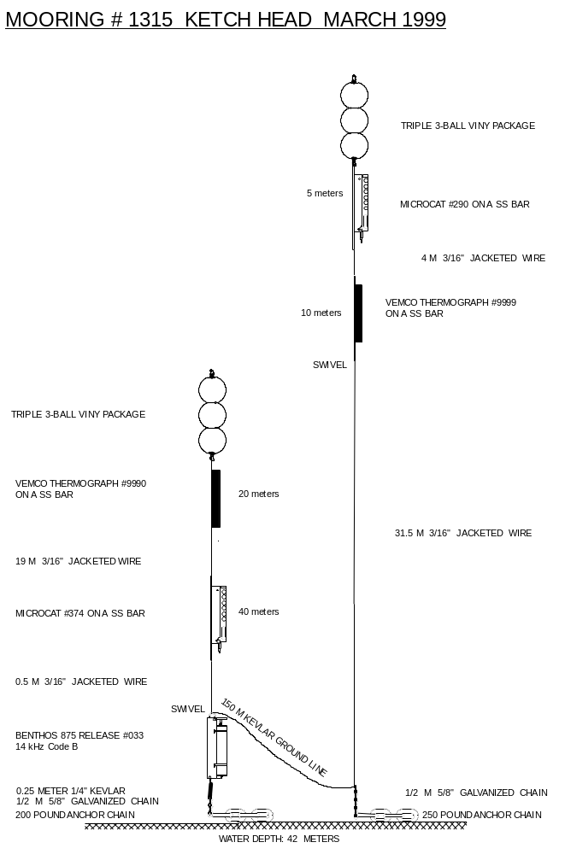

Figure 1a. Mooring diagram for Ketch Harbour mooring

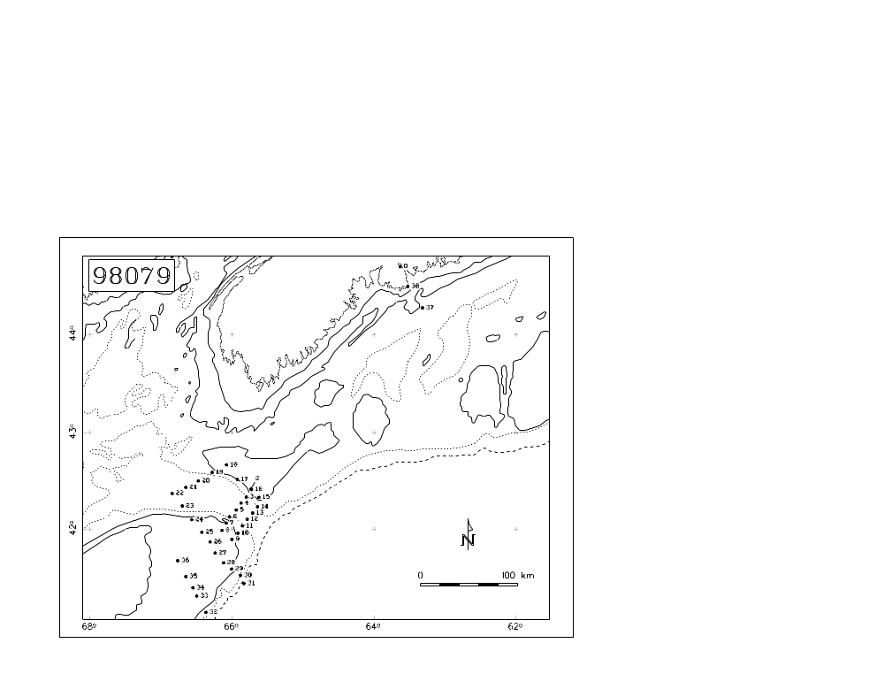
Figure 1b. CTD and biological station positions for C.C.G.S. Cygnus Cruise 98-079, 23-31 March 1999

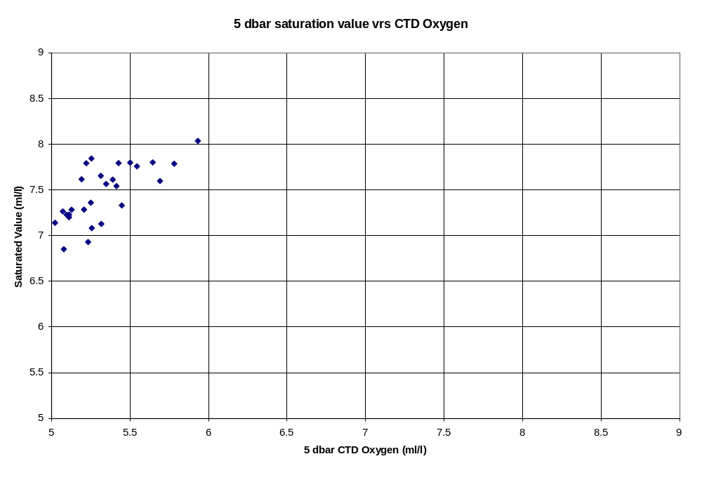
Figure 2a. Calibration data for near-surface saturation O₂ vs. YSI measured O₂. Regression line is defined in Table 2b.
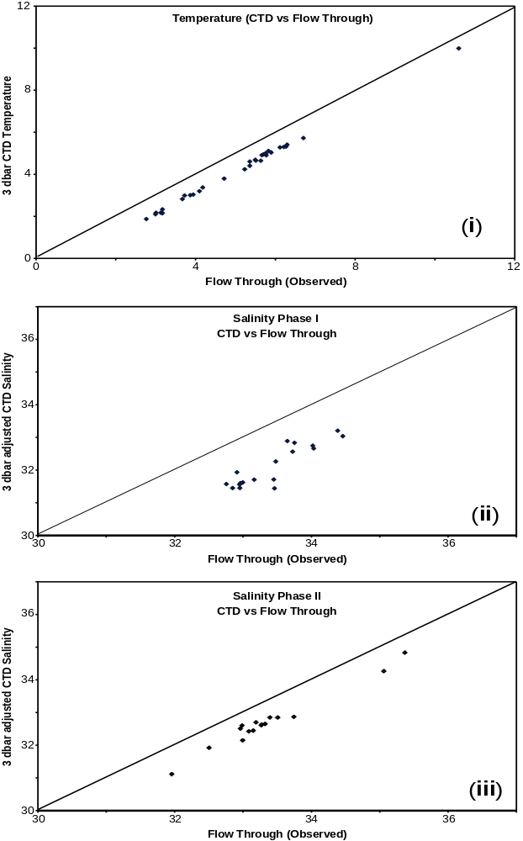

Figure 2b. Calibration data for CTD near-surface T,S vs. measurements from the flow-through system: (i) temperature, (ii) Phase I salinity, (iii) Phase II salinity. Regression lines are defined in Tables 2b and 2c.

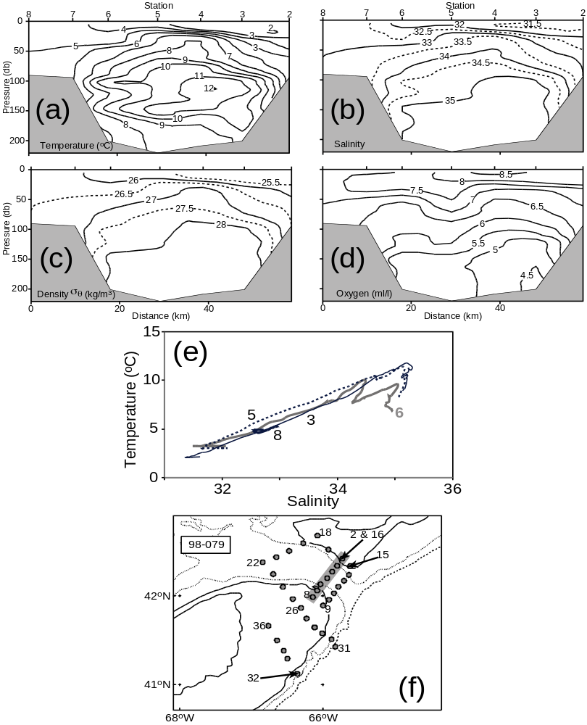
Figure 3 Hydrographic section Ia (CTD2-8) across Northeast Channel at the mooring line.
(a) temperature,
(b) salinity,
(c) sigma-θ,
(d) dissolved oxygen
(e) temperature vs. salinity, and
(f) station map

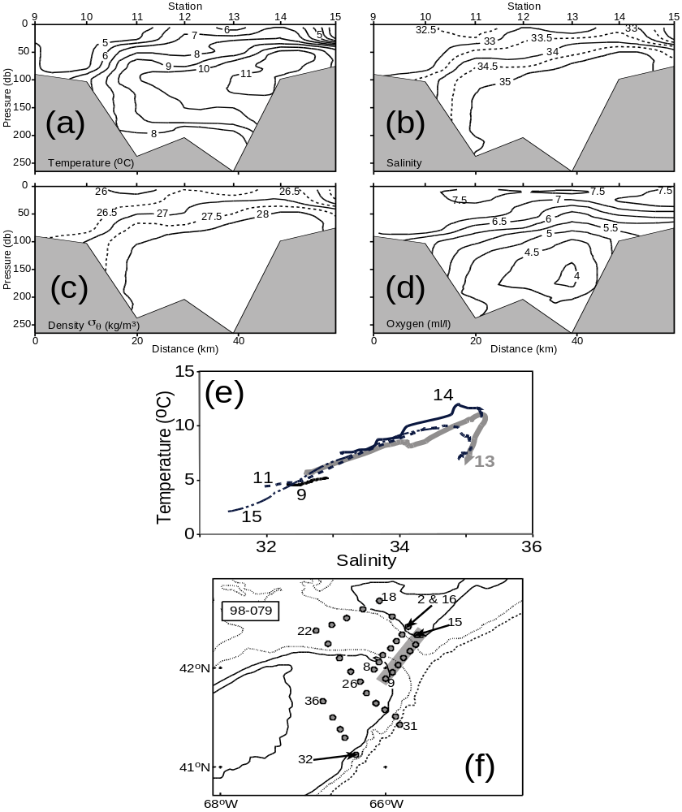
Figure 4 Hydrographic section Ib (CTD9-15) across Northeast Channel 10 km seaward of the mooring line.
(a) temperature,
(b) salinity,
(c) sigma-θ,
(d) dissolved oxygen,
(e) temperature vs. salinity, and
(f) station map
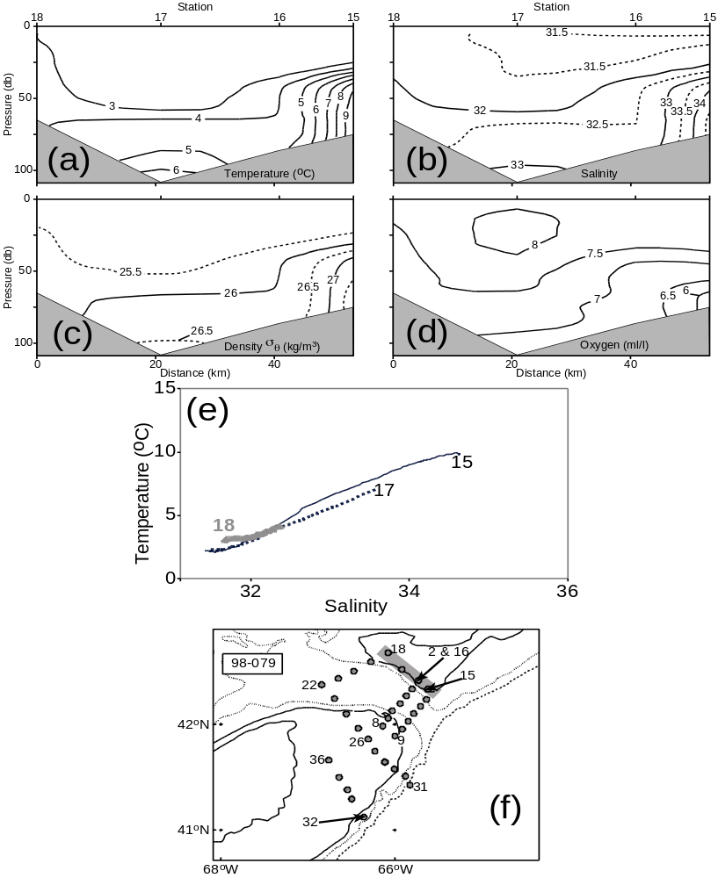
Figure 5 Hydrographic section II (CTD15-18) along the western flank of Browns

Bank
(a) temperature,
(b) salinity,
(c) sigma-θ,
(d) dissolved oxygen,
(e) temperature vs. salinity, and
(f) station map

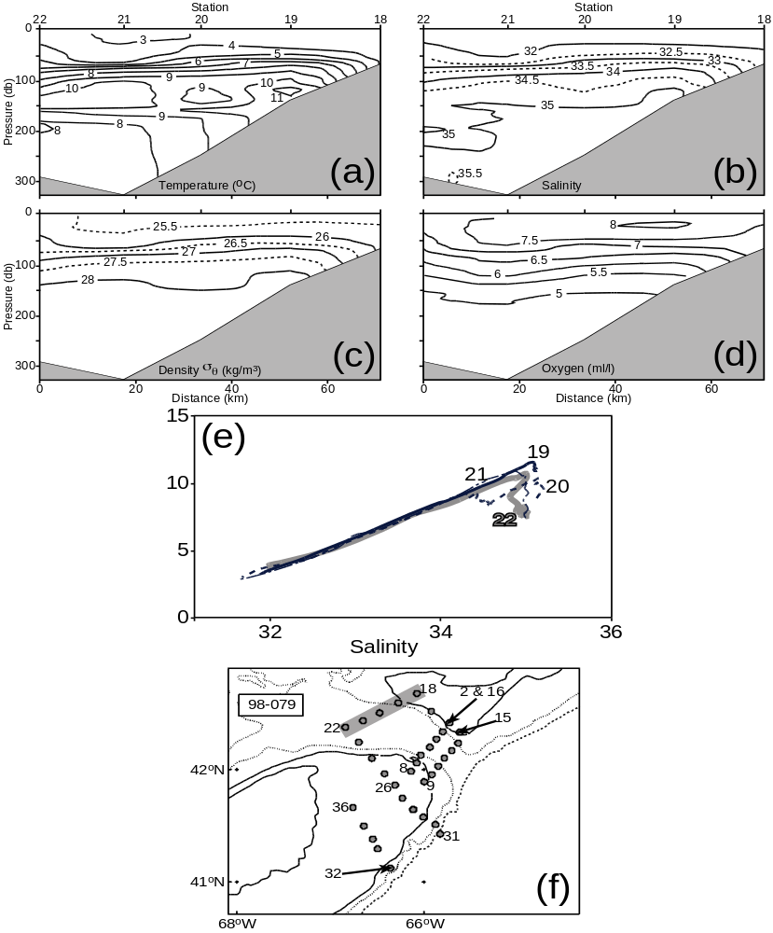
Figure 6 Hydrographic section III (CTD18-22) from Browns Bank to central Georges Basin.
(a) temperature,
(b) salinity,
(c) sigma-θ,
(d) dissolved oxygen,
(e) temperature vs. salinity, and
(f) station map
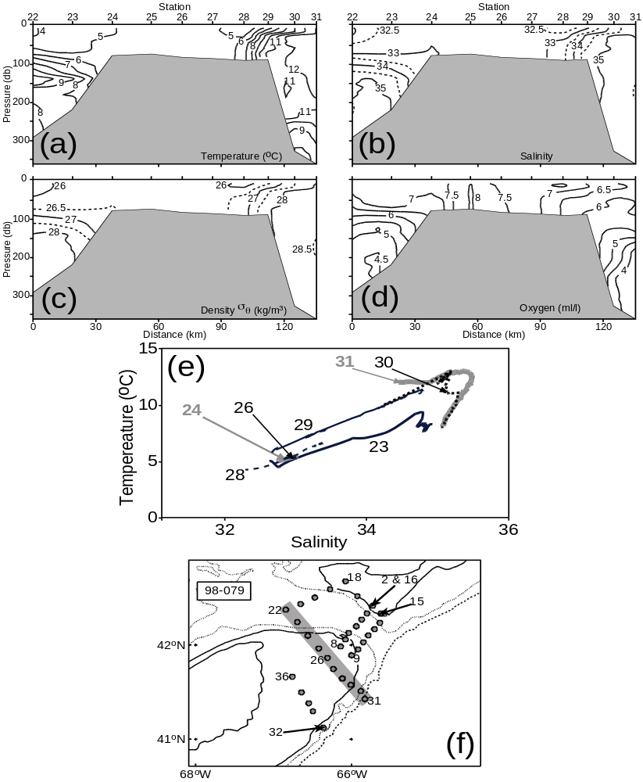

Figure 7 Hydrographic section IV (CTD23-31) across the eastern tip of Georges Bank from Georges Basin to the slope water.
(a) temperature,
(b) salinity,
(c) sigma-θ,
(d) dissolved oxygen,
(e) temperature vs. salinity, and
(f) station map

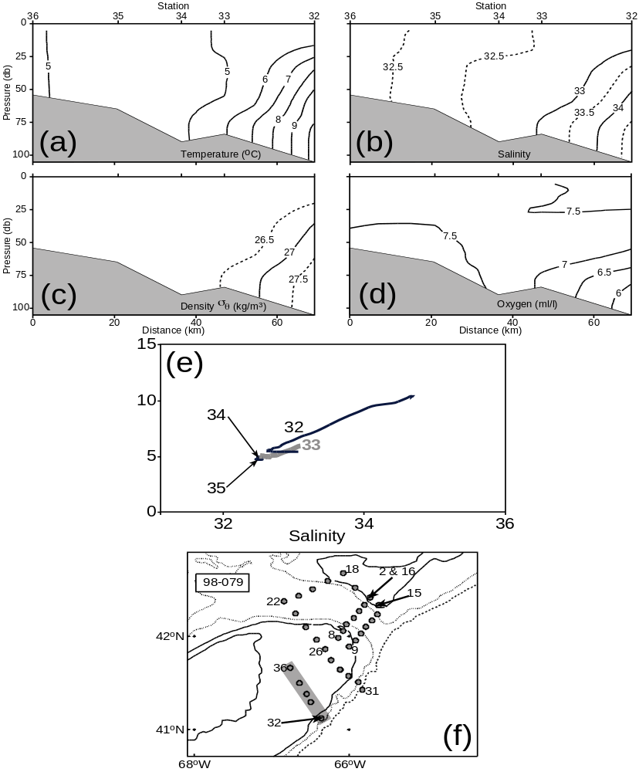
Figure 8 Hydrographic section V (CTD32-36) across the southeastern flank of Georges Bank.
(a) temperature,
(b) salinity,
(c) sigma-θ,
(d) dissolved oxygen,
(e) temperature vs. salinity, and
(f) station map
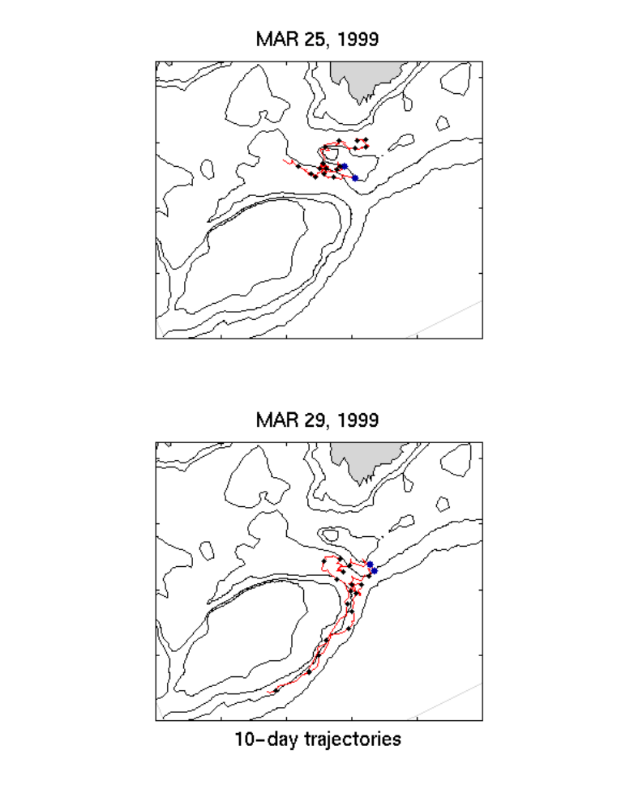

Figure 9 Ten-day drift trajectories for drifters deployed during voyage (a) March 25, and (b) March 29, 2000.

