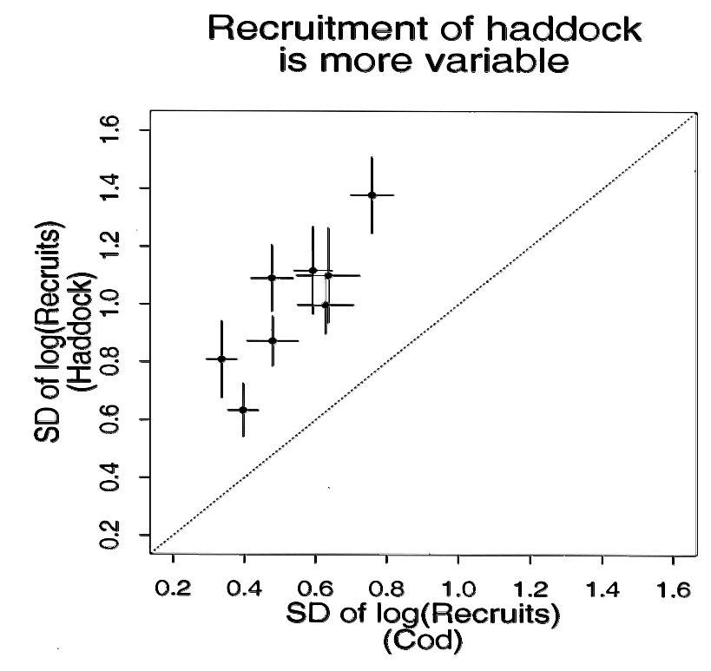
Figure 3.4.2. Standard deviation (SD) of log (recruitment) of cod vs. haddock in 8 stock areas in the North Atlantic.
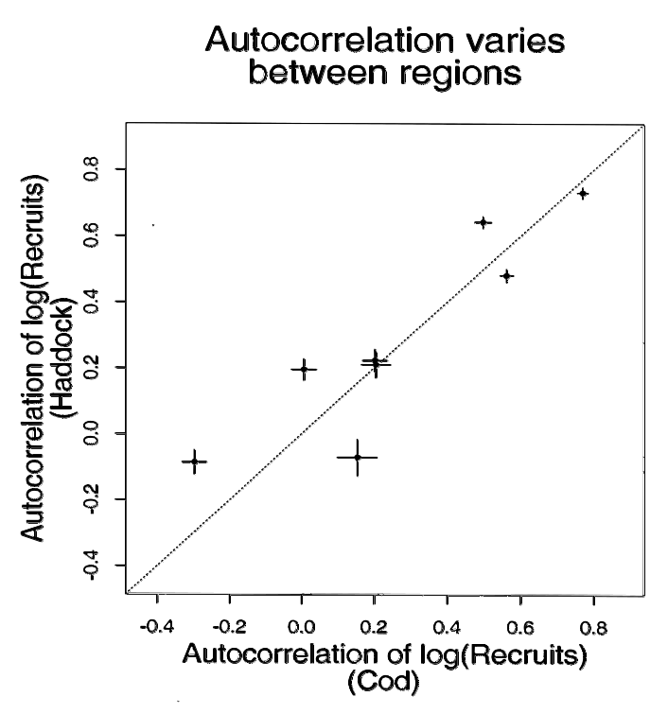
Figure 3.4.3. Autocorrelation of log(recruitment) of cod vs. haddock in 8 stock areas of the North Atlantic.
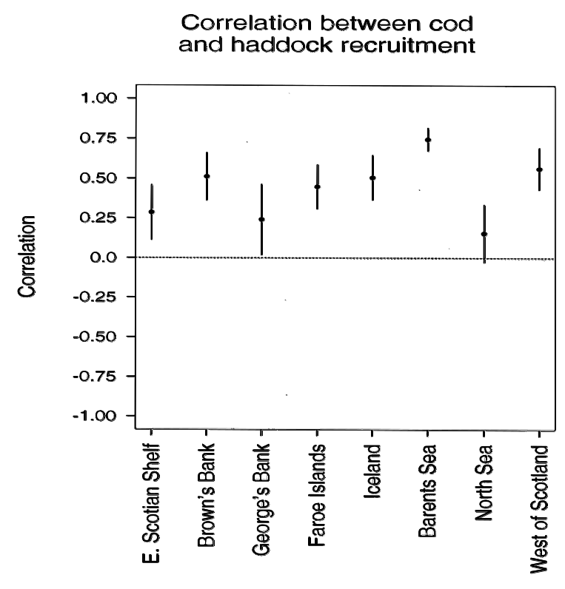
Figure 3.4.4. Correlation, r, between annual cod and haddock recruitment in 8 regions of the North Atlantic.

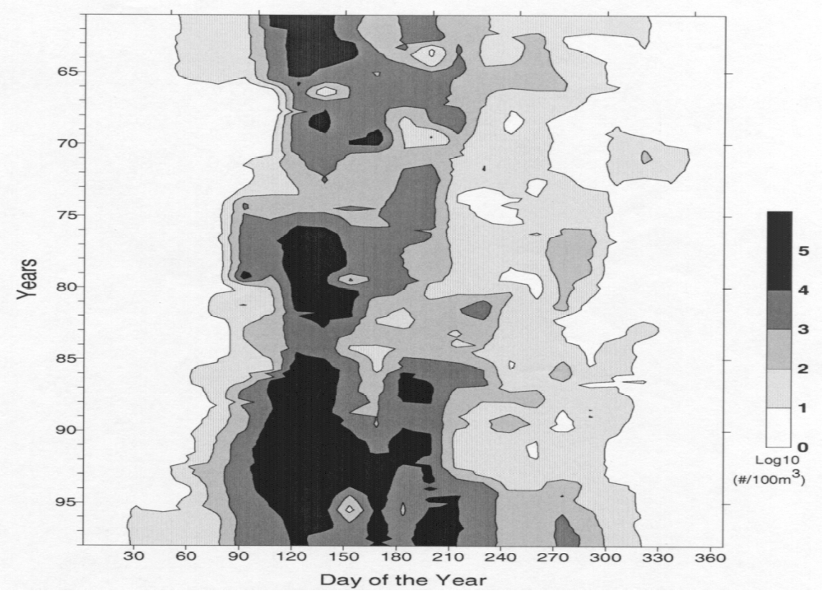
Figure 3.7.1. Abundance of Calanus finmarchicus, c1-4, between Massachusetts and Cape Sable (10 m), 1961–1997. Data are from NOAA/NEFSC CPR surveys.

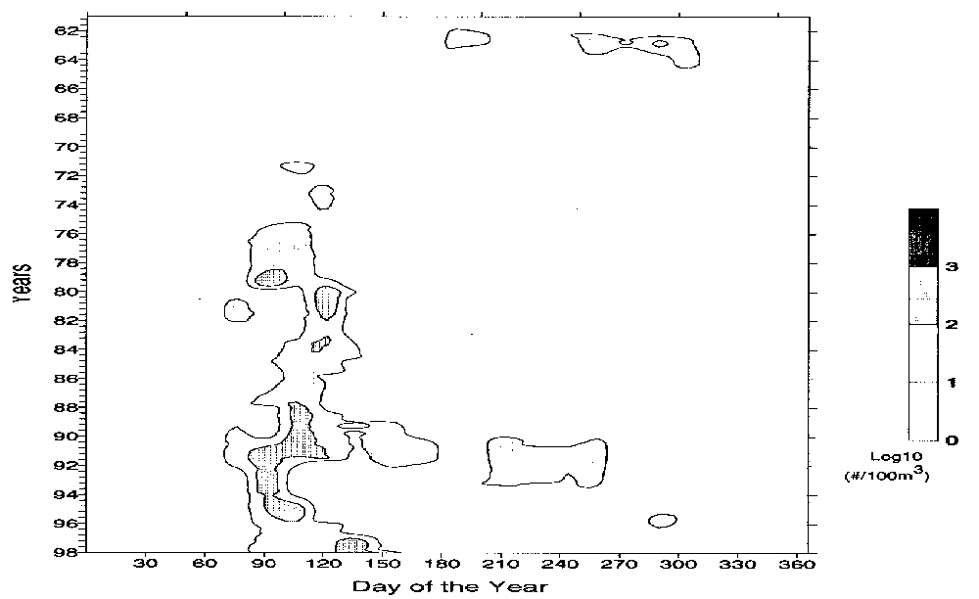
Figure 3.7.2. Abundance of copepod nauplii between Massachusetts and Cape Sable (10 m), 1961-1997. Data are from NOAA/NEFSC CPR surveys.
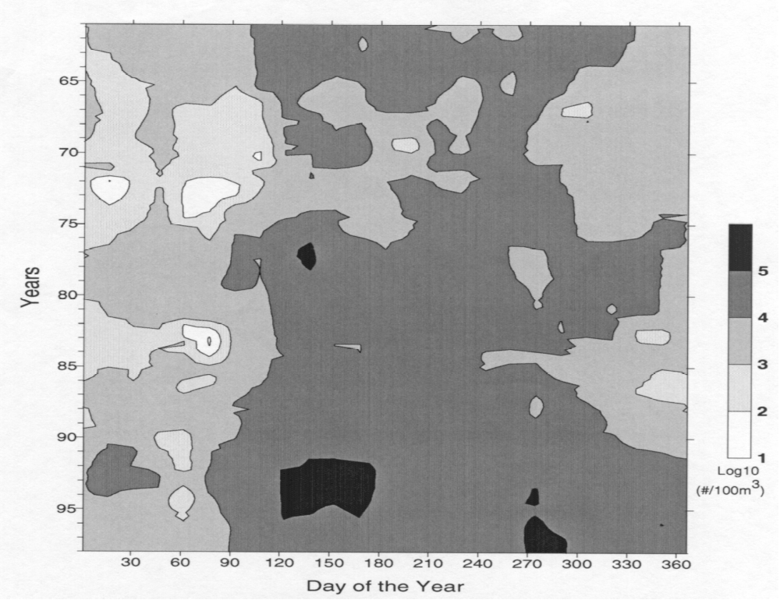
Figure 3.7.3. Abundance of total copepoda, all stages, between Massachusetts and Cape Sable (10 m), 1961-1997. Data are from NOAA/NEFSC CPR surveys.

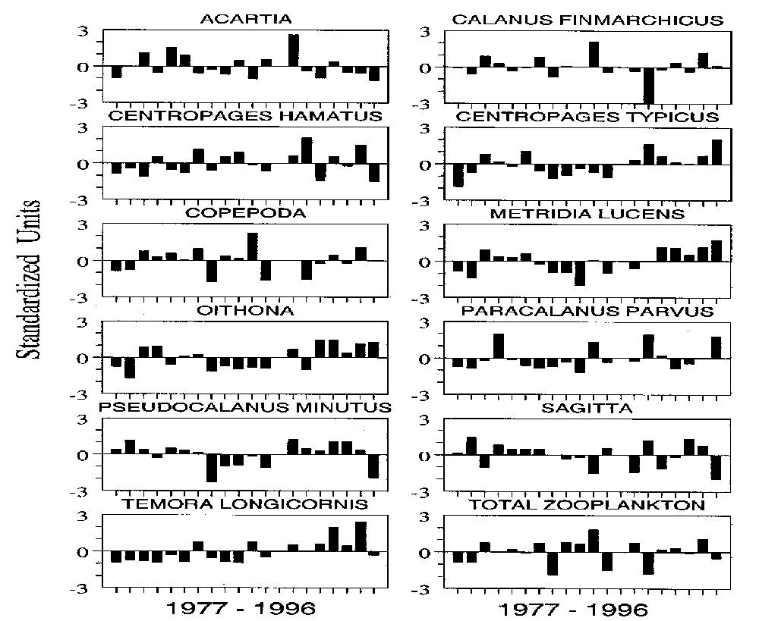
Figure 3.7.5. Standardized departures of mean annual plankton abundances for various species and groups during ‘spring’ (15 February-15 May) on Georges Bank, 1977-1996.
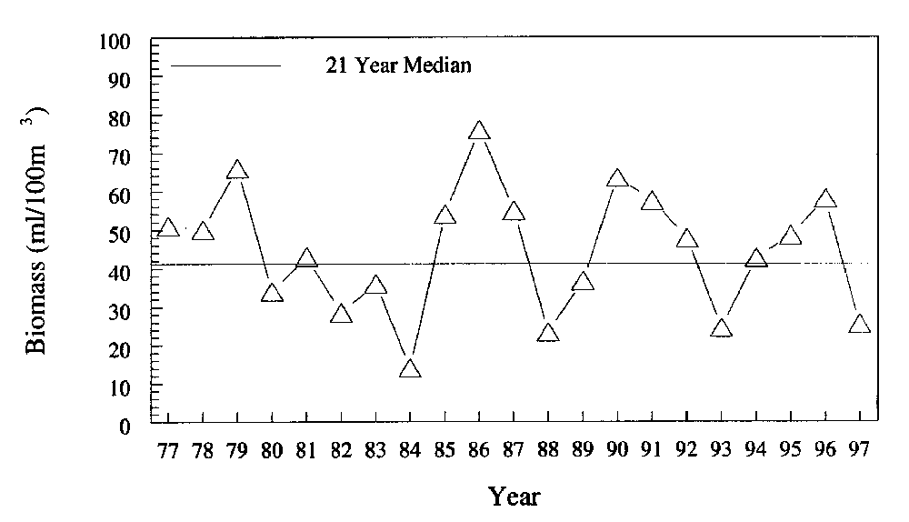
Figure 3.7.4. Annual median zooplankton biomass on Georges Bank during early spring. Data are from NOAA/NEFSC MARMAP surveys.
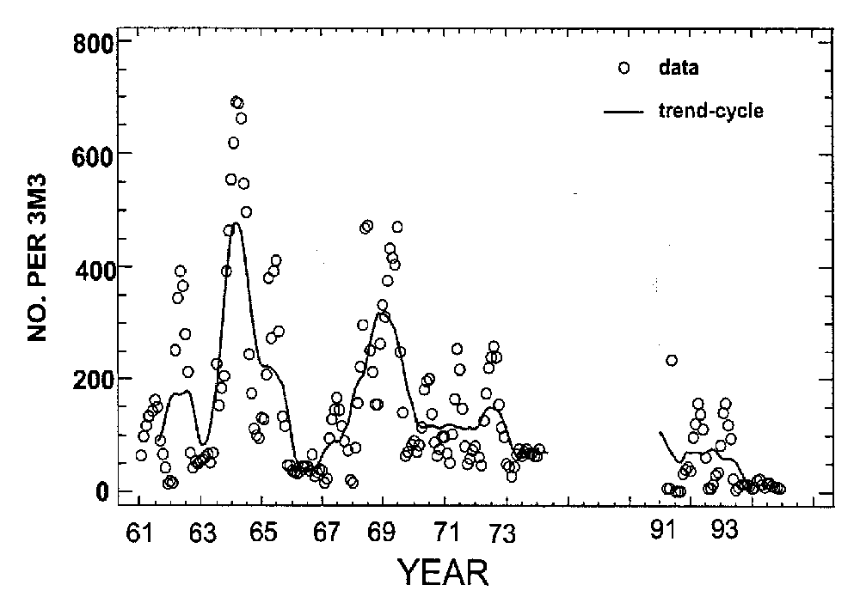
Figure 3.8.2. Monthly mean abundance of Calanus finmarchicus, stages 1-4 and trend cycle calculated from seasonal decomposition analyses. Data are based on Scotian Shelf CPR sampling

Figure 3.8.1. Seasonal cycles in abundance of various taxa on the eastern and western Scotian Shelf, for three different time periods. Dots represent data points and the lines are least squares cubic spline smoother fits.

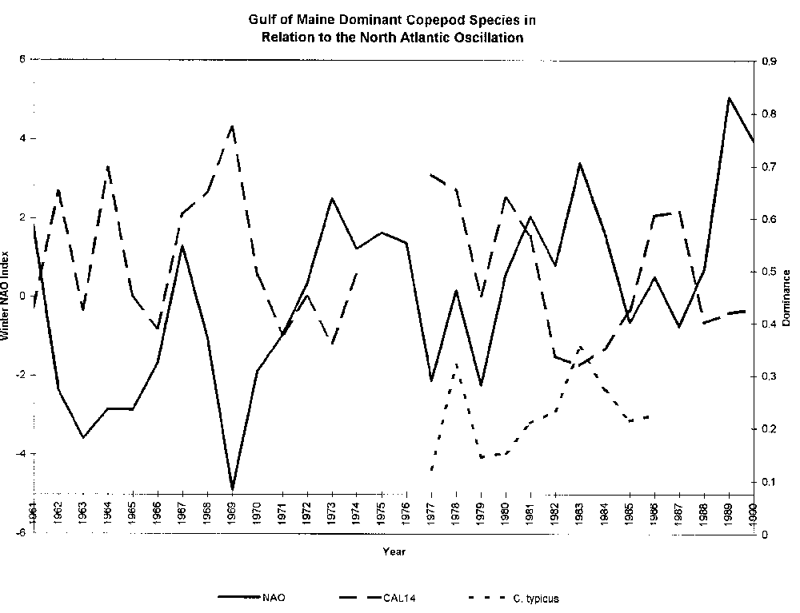
Figure 3.9. Trends in copepod species dominance vs. the winter NAO index, 1961-1990. Plankton data are from the NOAA/NEFSC CPR survey.
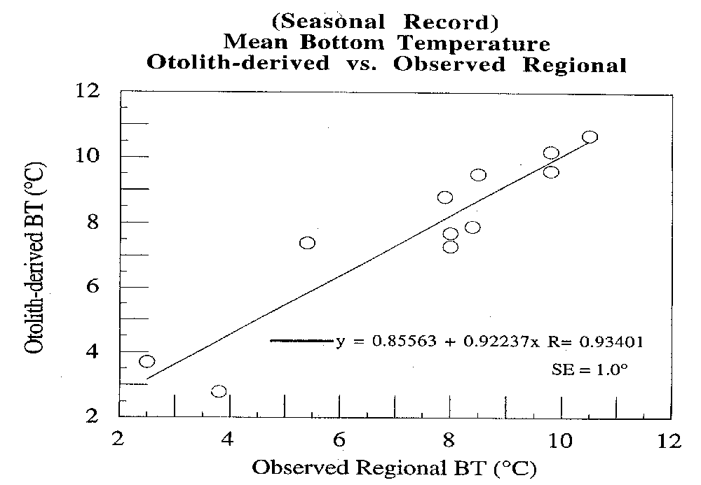
Figure 3.12.1. Relationship between observed and otolith-derived mean bottom water temperatures from Atlantic cod, based on seasonal sampling.

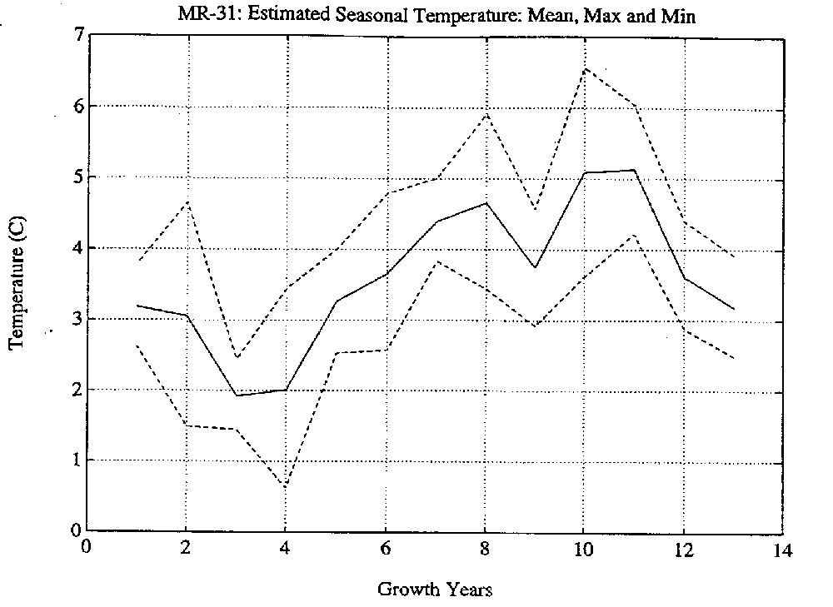
Figure 3.12.2 Seasonal bottom temperature (BT) record vs. growth year for Barents Sea cod, based on temperatures derived from oxygen isotope ratios. Solid line is the annual mean, upper and lower dashed lines are seasonal maxima and minima. First and last years are usually only partial seasonal records.

