12.0 Krill Predator Distribution and Krill Under Ice Distribution and Physiology
(Jose Torres)

12.1 Introduction

The objectives of our program were three-fold. First was to describe the distribution and abundance of larger size classes of krill and micronektonic species likely to prey on krill, primarily fishes. Second was to describe the distribution and abundance of krill larvae underneath sea ice at various locations within the survey grid, to collect larvae for physiological manipulation, and to collect samples of the under-ice surface to assess food availability for larval krill. This objective was a collaborative effort with the Daly program. Third was to describe the respiration, excretion, and physiological condition of all size classes of krill within the survey area, and to make similar measurements on other important micronektonic and zooplanktonic species as opportunities arose.
12.2 Materials and Methods

Micronekton was sampled using a 3 mm mesh, 10 m² mouth area, multiple opening closing net and environmental sampling system (MOC-10) towed at a speed of 1.5 to 2 kts, sea ice conditions permitting. The MOCNESS-10 was equipped with a strobe device to enhance catchability of highly mobile species. Vertical strata sampled during the course of the survey depended on bottom depth. For stations greater than 1000 m in depth, strata sampled were: 1000-500 m, 500-200 m, 200-100 m, 100-50 m, 50-0 m. For stations greater than 500 m in depth, depth strata sampled were 500-300 m, 300-200 m, 200-100 m, 100-50 m, 50-0 m. Sample depths for shallower bottoms were adjusted to make best use of the 5 sample nets. MOCNESS-10 samples were collected at survey stations 12, 13, 16, 19, 24, 34, 42, 46, and 87 (Figure 28D)
Krill furcilia were sampled underneath pack ice using SCUBA at stations 5, 9, 15, 26, 43, 50, and 75 (Figure 28C). Furcilia concentrations were estimated using videography along a 10-m transect line anchored at each end with ice screws. Furcilia were collected with hand-held nets for physiological manipulation (Figure 29). The under ice surface was sampled using a suction collector (see Section 11.0). Standard blue water diving techniques were used to maximize diver safety.
Oxygen consumption rates were measured on individuals using sealed vessel respirometry. To measure excretion rates, samples of incubation water were removed after each run for analysis of ammonia concentration. For measurements of condition, individuals were frozen for analysis of metabolic enzyme concentration, RNA/DNA, and proximate composition at our home laboratory. A list of respiration runs and frozen specimens collected during the course of the cruise is provided in Table 12.

12.3 Preliminary results

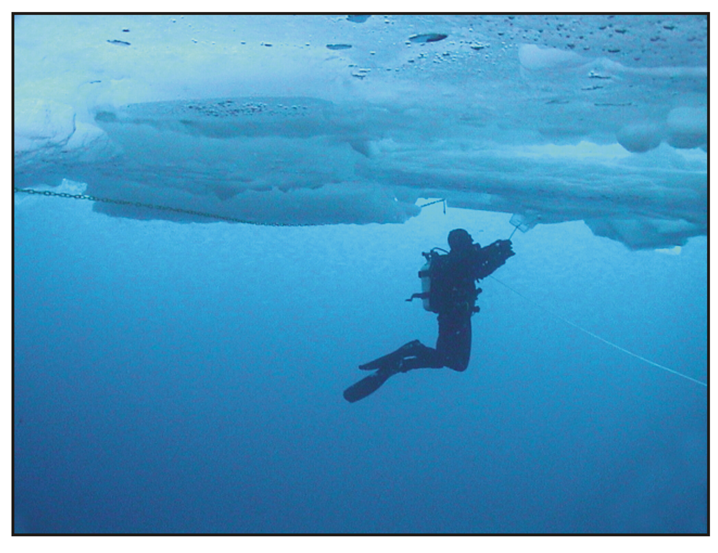
The four stations sampled at the shelf break contained a typical Antarctic midwater fauna. Examples of the fauna and depth strata they were found in are given below for tow 1, a day tow at the shelf break.
Figure 29. Christian MacDonald collecting krill during an under ice dive on NBP01-04. Photo by Joel Bellucci.
Table 12. List of respiration runs and frozen specimens collected during NBP01-04.

Species | Stage | Frozen | Respiration Runs
Calanoides acutus | CIV |  | 1
 | CV | 70 | 76
 | F | 3 | 7
 | M |  | 9
Calanus propinquus | CIV
 | CV |  | 17
 | F |  | 13
 | M |  | 5
Euaugaptilus laticeps | F |  | 1
Euchirella rostromagna | F |  | 1
Lucicutia macrocera | F |  | 1
Metridia gerlachei | CV |  | 3
Metridia gerlachei | F |  | 47
Pareuchaeta spp. | CIV | 1
Pareuchaeta spp. | CV | 30 | 28
Pareuchaeta antarctica | F | 10 | 38
Pareuchaeta bilobata | F | 1
Pareuchaeta erebi | F |  | 1
Pareuchaeta rasa | F |  | 1
Pareuchaeta similis | F |  | 1
Pseudochirella hirsuta | F |  | 1
Rhincalanus gigas | CIV
 | CV
 | F |  | 7
 | M
Bathylagus antarcticus |  | 16
Cyclothone microdon |  | 9
Electrona antarctica |  | 21
Gymnoscopelus braueri |  | 11
Lampanyctus achirus |  | 1
Pleurogramma antarcticum |  | 2 | 1
Protomyctophum boleni |  | 3
Eucopia australis |  | 2
Gennadas spp. |  | 3 | 1
Pasiphaea scotiae |  | 1
Arthromysis sp. |  | 5
Euphausia crystallorophias |  |  | 6
Euphausia superba | F4
 | F5 |  | 1
 | F6 | 43 | 113
 | A | 53 | 66
Euphausia triacantha |  | 9 | 13
Thysanoessa macrura |  | 41 | 18
Cyphocaris anonyx |  |  | 3
1000-500 m: The fishes Electrona antarctica, Gymnoscopelus braueri, Bathylagus antarcticus; the decapod shrimp Gennadas sp; the ostracod Gigantocypris; the mysid Gnathophausia; and the scyphomedusa Periphylla.

500-200 m: The fishes Electrona antarctica, Notolepis coatsi, and Cyclothone sp.; the euphausiids Euphausia triacantha and Thysanoessa macrura; the amphipods Eusirus and Themisto, and the scyphomedusa Atolla.

200-100 m: The fish Cyclothone sp., the euphausiid Thysanoessa macrura, the decapod Pasiphaea scotiae, and the worm Tomopterus

100-50 m: The euphausiid Thysanoessa macrura, unidentified cydippid ctenophore.

50-0 m: The fish Cyclothone sp., the euphausiid Thysanoessa macrura.

MOCNESS-10 stations on the shelf and within Marguerite Bay contained a subset of the oceanic fauna as limited by depth. The dominant lanternfish, Electrona antarctica, was present in all tows. Reliable indicators of oceanic influence were the euphausiid, Euphausia triacantha, and high abundances of T. macrura. Krill adults were captured in the MOCNESS-10 in high numbers only at station 34, within the Bay itself.
SCUBA sampling underneath the pack ice revealed a highly variable distribution of krill furcilia. Highest numbers of larvae were observed and captured at stations 5 and 26, but larvae were present at all dive stations.
Physiological measurements were highly successful in terms of quantity and quality (Table 12), but the results cannot be reported without data reduction at our home institution.

