Draft 4/12/01

CRUISE REPORT

R/V Gould– LMG01-3

Punta Arenas to Punta Arenas
Mar 18 – Apr 13, 2001

In support of NSF program

WinDSSOcK: WINter Distribution and Success of Southern OCean Krill: Moored Array, Drifter and Float Measurements

Richard Limeburner and Robert Beardsley
Department of Physical Oceanography
Woods Hole Oceanographic Institution
Woods Hole, MA 02543
rlimeburner@whoi.edu

Mark McDonald
2535 Sky View Lane
Laramie, Wyoming 82072

Sue Moore
NOAA National Marine Fisheries Service
National Marine Mammal Laboratory
Seattle, WA

Deborah Thiele
International Whaling Commission
Deakin University
Warrnambool, Australia

R/V Gould LMG01-3

Table of Contents

Table of Contents 2
- Purpose 3
- Accomplishment Summary 3
3. Cruise Results 4
3.1 Bathymetric Survey 4
3.2 Mooring Deployments 5
3.3 Hydrographic Data 7
3.3.1 Calibration 8
3.3.2 CTD Data 8
4. Meteorological Measurements 12
4.1 Introduction 12
4.2 Wind Measurements 12
4.3 Data Acquisition and Processing 14
4.4 Description of Cruise Weather 16
4.5 Description of Surface Fluxes 18
5. Marine Mammal Observations 20
5.1 Acoustic Census of Mysticete Whales 20
5.2 Visual Survey, Photo Id And Biopsy Summary 22
6. Chief Scientist’s Log of Daily Events 22
7. Cruise Personnel 25
Acknowledgements 26
Appendix 1 Bathymetric Surveys of the Mooring Sites 27 Appendix 2 Drifter Tracks 32

R/V Gould LMG01-3
Punta Arenas to Punta Arenas
Mar 18 – Apr 13, 2001

1. Purpose

The primary purpose of cruise R/V Gould LMG01-3 was to deploy a Woods Hole Oceanographic Institution (WHOI) array of six current meter moorings near Marguerite Bay, deploy a Scripps Institute of Oceanography (SIO) moored array of eight whale acoustic recording packages (ARPS) along the Western Antarctic Peninsula, deploy 6 near-surface satellite-tracked drifters, and to conduct a marine mammal survey of the Marguerite Bay region. This report summarizes the events that occurred during cruise LMG01-3 on the R/V Gould.

A central hypothesis of the Southern Ocean GLOBEC collaborative research program is that a unique combination of physical and biological factors contribute to the enhanced growth, reproduction, recruitment and survivorship of Antarctic krill (Euphausia superba) on the central Western Antarctic Peninsula (WAP) shelf. In particular, this region provides the following conditions that are especially favorable to winter survival of larval and adult krill: a) a clockwise shelf circulation that retains the krill population in a favorable environment for extended periods of time; b) an early and long-lasting ice cover that provides dependable food and protection for larval krill to grow and survive over winter; and c) on-shelf intrusions of warm, salty, nutrient-rich Upper Circumpolar Deep Water which affects hydrographic and ice properties and enhance biological production. The moored array, drifter and float component of the Southern Ocean GLOBEC program is investigating shelf circulation processes and their spatial and temporal variability using long-term moorings and satellite-tracked Lagrangian drifters and isobaric floats. Supporting data on the surface forcing (wind stress and heat flux) will also be obtained and the combined data set used to describe the shelf circulation and water property variability on vertical scales of 10’s of meters and time scales from hourly to seasonal.

2. Accomplishment Summary

The severe Antarctic weather was a potential limiting factor during cruise LMG01-3. Winds were often greater than 20 kt during the cruise and all science operations were halted when the winds were greater than 35 kt. However, only one day was spent waiting for an improvement in weather conditions. During the cruise we successfully deployed the 6 current meter and 8 whale acoustic moorings along the Western Antarctic Peninsula, deployed six near-surface drifters, made marine mammal observations in the region, and made 6 CTD casts at the WHOI moorings. The LMG01-3 cruise track is shown in Fig 1 and mooring deployment locations are shown in Figure 2.
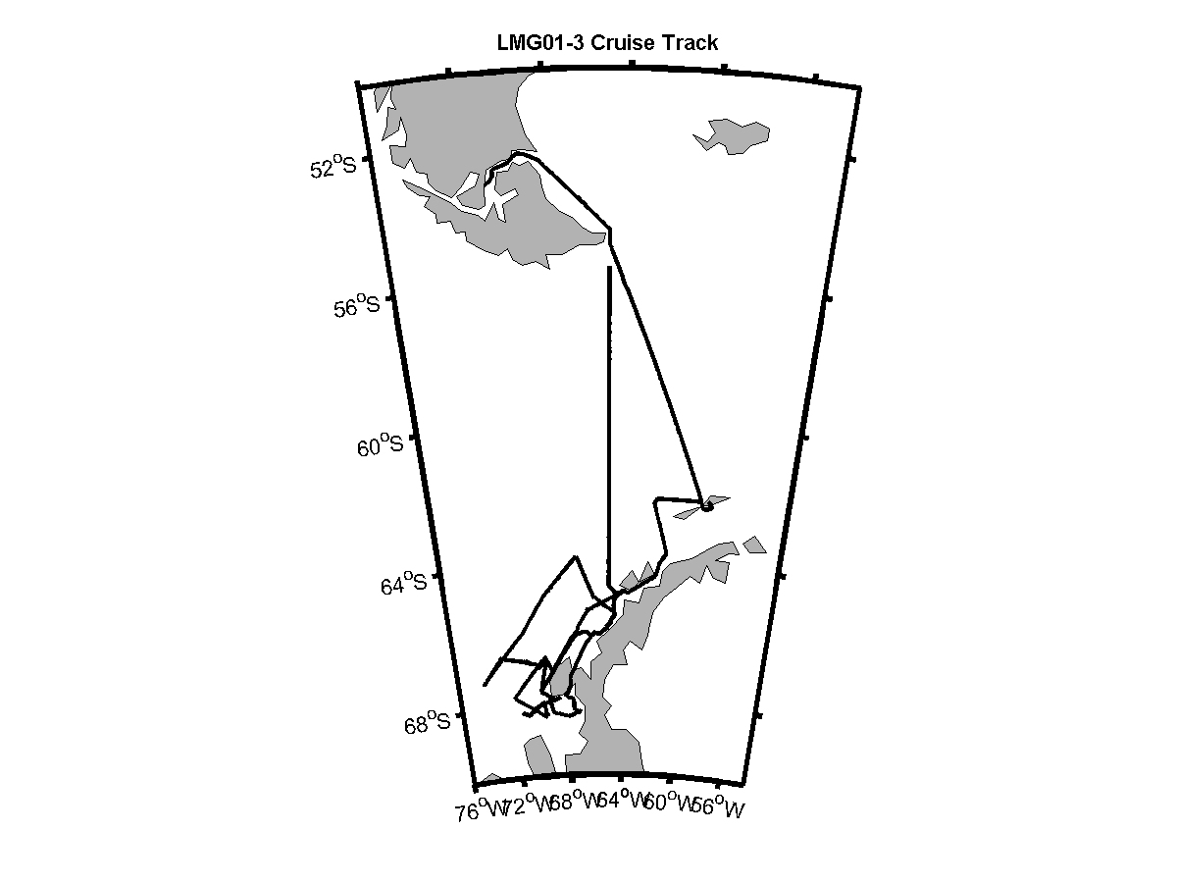
Figure 1. LMG01-3 cruise track
.

Cruise Results

We departed Punta Arenas, Chile at 1330 GMT on March 18, 2001 accompanied by 40 kt winds and steamed east through the Straits of Magellan, and then south to the Drake Passage. The passage to Antarctica took 4 days and the seas were typically rough with 20 to 40 kt winds, but relatively mild air temperatures. We arrived at King George Island on March 23 and offloaded 2 scientists and equipment by evening, then steamed to the northern whale acoustic mooring site S8 where we deployed the mooring in rough seas. The R/V Gould then steamed to Palmer Station and arrived early on March 24. The day at Palmer Ptation was spent offloading personnel and supplies and repositioning the mooring anchors and buoys on the ship in preparation for the upcoming mooring deployments.

  - Bathymetric Surveys

Digital depth data was collected with a Knudsen fathometer using a sound speed of 1500 m/sec from Punta Arenas to Palmer Station. The sound speed, based on CTD data collected in Marguerite Bay during the January 2001 LTER cruise, was changed to 1459 m/sec on March 25 just before leaving Palmer Station. The sound speed was changed to 1449 m/sec on March 28 at 1949 GMT and changed back to 1459 m/sec on March 29, 2000. We made a small-scale bathymetric survey at each of the mooring sites prior to deployment and the results of these surveys are shown in Appendix 1.

3.2 Mooring Deployments

The R/V Gould departed Palmer Station at 1400 GMT on March 25, 2001 and steamed to the whale acoustic mooring site S7. The mooring was successfully deployed at night under rough seas. A CTD station planned for the S7 site was cancelled due to 35 kt winds and the rough seas. The ship then arrived at the A1 mooring site at 1200 GMT on March 26 and we first made a detailed bottom survey of the local bathymetry. The moorings are designed for a specific depth and the A1 mooring site had very rough bathymetry, but a suitable site was found for the deployment (Appendix 1). The mooring locations are shown on Figure 2 and listed in Table 1.

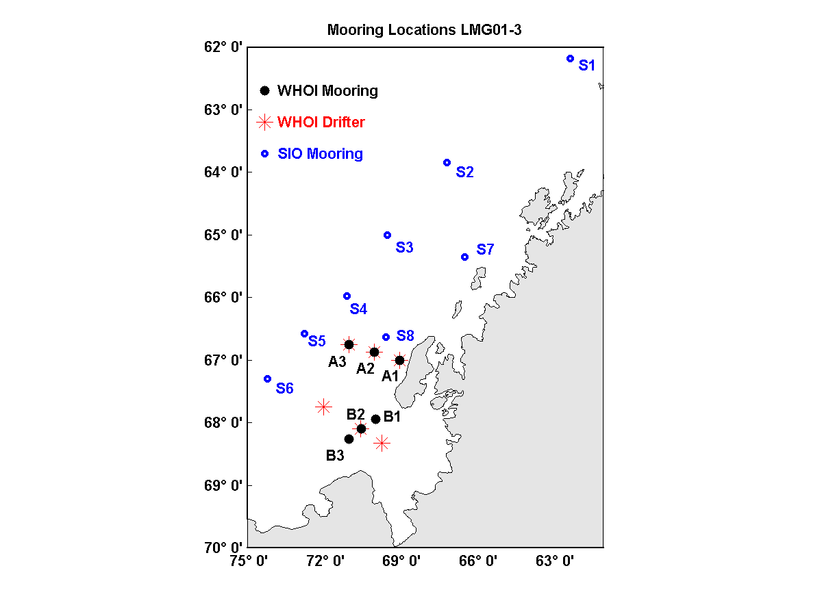
Figure 2. Locations of the moorings and drifters deployed on LMG01-3.

The A1 mooring was deployed on March 26 under difficult working conditions. Strong winds were diminishing and the wind was from a different direction than the swells. The deck was awash during the deployment and we were informed that those conditions were as good as we should expect. After the deployment we completed CTD 1 at the A1 mooring site and deployed a near-surface satellite tracked drifter.
During the night of March 26 we steamed to the whale-acoustic mooring site S8 and made a brief bottom survey of the region before deploying the S8 mooring. The bathymetry at the S8 site is shown in Appendix 1. After the S8 mooring deployment the barometer began to fall and the winds increased in strength. At sunrise on March 27 the winds were over 50 kt from the northeast and the barometer at 950 mb was dropping 3 mb/hr. We spent the day at the A2 mooring site waiting for the weather to improve. At 2000 GMT the winds were not decreasing, the barometric pressure was 948 mb and holding, and the seas were building to over 20 ft so the Captain decided to steam into Marguerite Bay and find some shelter from the seas.

The morning of March 28 we were in Marguerite Bay off the south end of Adelaide Island. The winds were still above 40 kt and the temperature had fallen to -5 C, but the seas were more moderate than offshore. We decided to bottom survey the 3 WHOI mooring sites located along the B line. Target mooring deployment positions were defined from the bathymetric surveys at the B line (Appendix 1).

The morning of March 29 was clear with 10 kt winds and mooring B3 was deployed at 1242 GMT. We then made a CTD cast, CTD 2, at the B3 mooring site. The B2 mooring was deployed at 2018 GMT on March 29 and CTD 3 was made at the B2 mooring site. The seas were still calm so we decided to deploy a third mooring that day and mooring B1 was deployed in the evening and CTD 4 was made at the B1 mooring site. During the night of March 29 we deployed 3 drifters near the B mooring line while steaming to the A line.

The afternoon of March 30 we made a bathymetric survey of the A2 mooring site. CTD 5 was completed in the late afternoon at the A2 mooring site, and we then deployed mooring A2 and a drifter. That evening we made a bathymetric survey of the A3 mooring site and on the following mooring we completed CTD 6 and deployed A3. During the afternoon of March 31, we began deploying the remaining 5 SIO whale acoustic moorings. S5 and S6 were deployed on March 31, S4 and S3 on April 1, and S2 on April 2. The mooring and CTD locations are both listed in Table 1.

Station | Date | Time UTC | Latitude | Longitude | Depth m
Deploy S1 Mooring | 3/23/01 | 0706 | 62° 16.470’ S | 62° 10.000’ W | 1651
Deploy S7 Mooring | 3/25/01 | 2349 | 65° 22.620’ S | 66° 28.210’ W | 450
Deploy A1 Mooring | 3/26/01 | 1940 | 67° 01.134’ S | 69° 01.217’ W | 450
CTD 1 | 2/26/01 | 2121 | 67° 01.970’ S | 69° 02.260’ W | 306
Deploy Drifter 30460 | 2/26/01 | 2149 | 67° 02.400’ S | 69° 03.000’ W | 400
Deploy S8 Mooring | 2/27/01 | 0132 | 66° 38.241’ S | 69° 33.095’ W | 407
Deploy B3 Mooring | 3/29/01 | 1242 | 68° 15.345’ S | 70° 59.853’ W | 450
CTD 2 | 3/29/01 | 1340 | 68° 15.610’ S | 70° 59.890’ W | 440
CTD 3 | 3/29/01 | 1637 | 68° 06.120’ S | 70° 31.950 W | 616
Deploy B2 Mooring | 3/29/01 | 2018 | 68° 06.091’ S | 70° 31.675’ W | 811
CTD 4 | 3/29/01 | 2237 | 67° 56.920’ S | 69° 54.380 W | 467
Deploy B1 Mooring | 3/30/01 | 0212 | 67° 56.890’ S | 69° 54.398’ W | 444
Deploy Drifter 26373 | 3/30/01 | 0456 | 68° 19.920’ S | 69° 42.109’ W | 256
Deploy Drifter 24406 | 3/30/01 | 0722 | 68° 06.162’ S | 70° 31.797’ W | 809
Deploy Drifter 30461 | 3/30/01 | 1132 | 67° 45.216’ S | 71° 58.957’ W | 340
CTD 5 | 3/30/01 | 2015 | 66° 51.’ S | 70° 00.’ W | 567
Deploy A2 Mooring | 3/30/01 | 2015 | 66° 51.883’ S | 70° 00.683’ W | 564
Deploy Drifter 30458 | 3/31/01 | 0018 | 66° 52.331’ S | 70° 01.168’ W | 569
CTD 6 | 3/31/01 | 1112 | 66° 45.010’ S | 70° 59.900’ W | 782
Deploy A3 Mooring | 3/31/01 | 1439 | 66° 45.002’ S | 70° 59.991 W | 490
Deploy Drifter 30459 | 3/31/01 | 1500 | 66° 44.543’ S | 71° 00.012’ W | 491
Deploy S5 Mooring | 3/31/01 | 1940 | 66° 35.197’ S | 72° 42.311’ W | 3450
Deploy S6 Mooring | 4/1/01 | 0250 | 67° 17.900’ S | 74° 10.800’ W | 3059
Deploy S4 Mooring | 4/1/01 | 1403 | 65° 58.400’ S | 71° 04.100’ W | 2962
Deploy S3 Mooring | 4/1/01 | 2153 | 64° 59.406’ S | 69° 28.795’ W | 2521
Deploy S2 Mooring | 4/2/01 | 0658 | 63° 50.799’ S | 67° 08.829’ W | 3056

Table 1. LMG01-3 mooring and CTD station locations.

3.3 Hydrographic Data

The ship’s CTD system consisted of a Seabird Electronics Model 911 Plus CTD sampling at 24 Hz with a quartz crystal pressure transducer, 2 temperature and conductivity sensor pairs, a PAR sensor, a fluorometer sensor, and a SeaTech 25 cm light transmission sensor. The CTD fish was lowered at 30 m/min and the data was logged with DOS Seabird Electronics software. The CTD data was averaged into 1 m bins and the averaged downcast data is presented in this report. The 2 conductivity sensors on the CTD agreed with each other within 0.003 mS/cm and thus only one of these sensors was used to process the data in this report.

3.3.1 Calibration

Approximately 4 water samples were collected at each station for calibration of the conductivity sensors on the SBE-911 CTD. Figure 3 below summarizes the comparison between the conductivity measured by the CTD and the in situ conductivity calculated from the measured salinity obtained from the water sample bottle using a Guildline Salinometer.

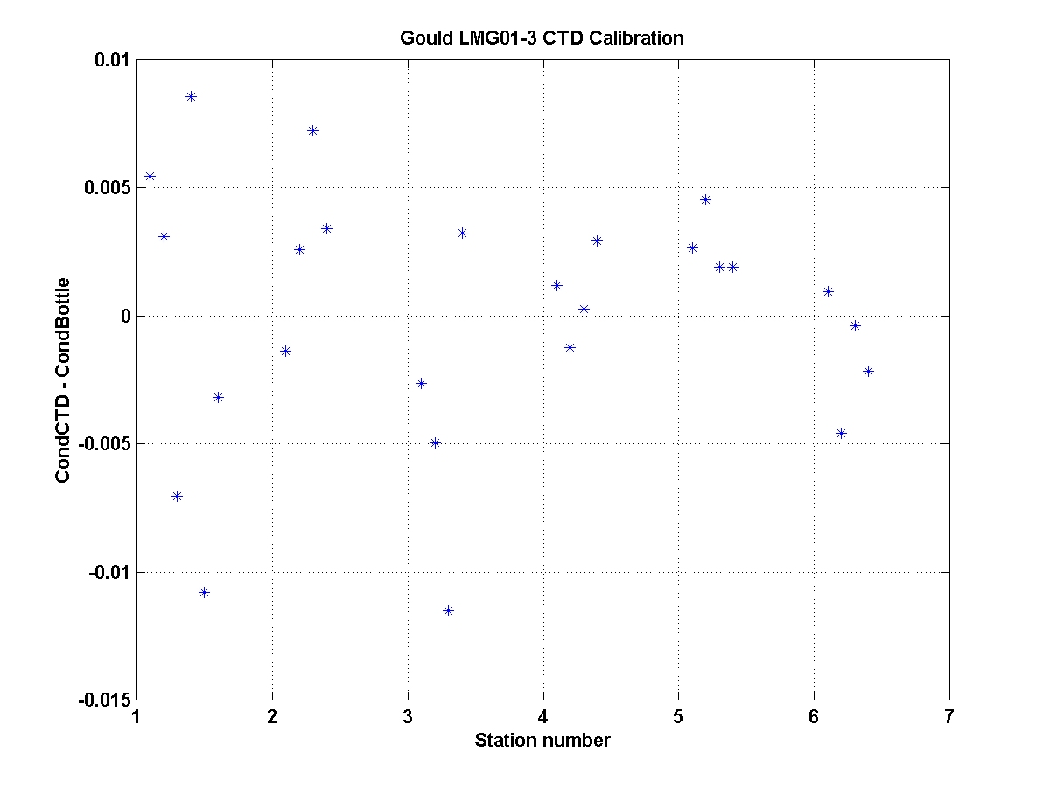
Figure 3. Differences between the CTD conductivity and the seawater sample conductivity during the cruise.

The RMS difference in conductivity between the CTD and the water sample bottles was 0.0048 mS/cm and no correction was made to the raw conductivity data. All CTD data in this report will be transmitted to NODC.

3.3.2 CTD Data

Temperature, salinity and sigma-t profiles and T/S diagrams are shown next for the 6 CTD casts (Figures 4-9).
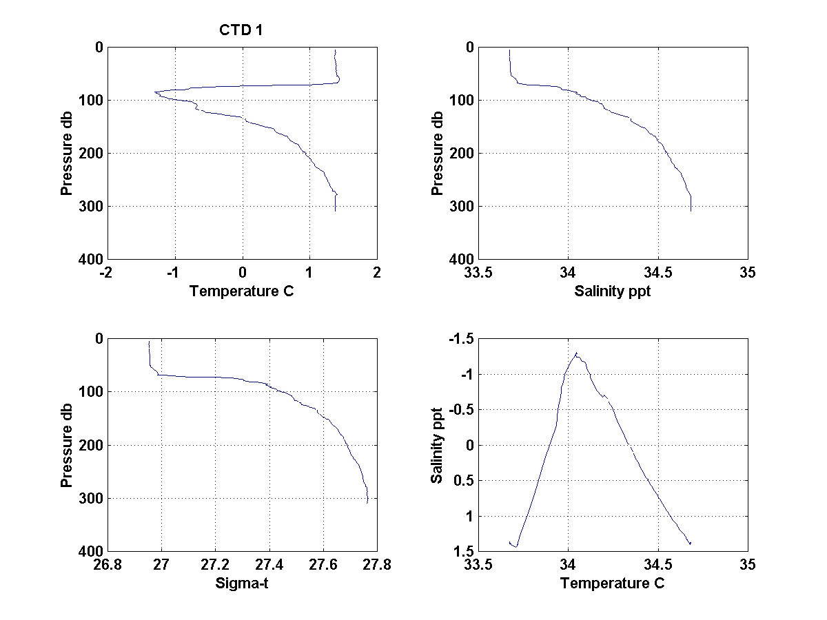
Figure 4. CTD 1 profiles located at WHOI mooring A1
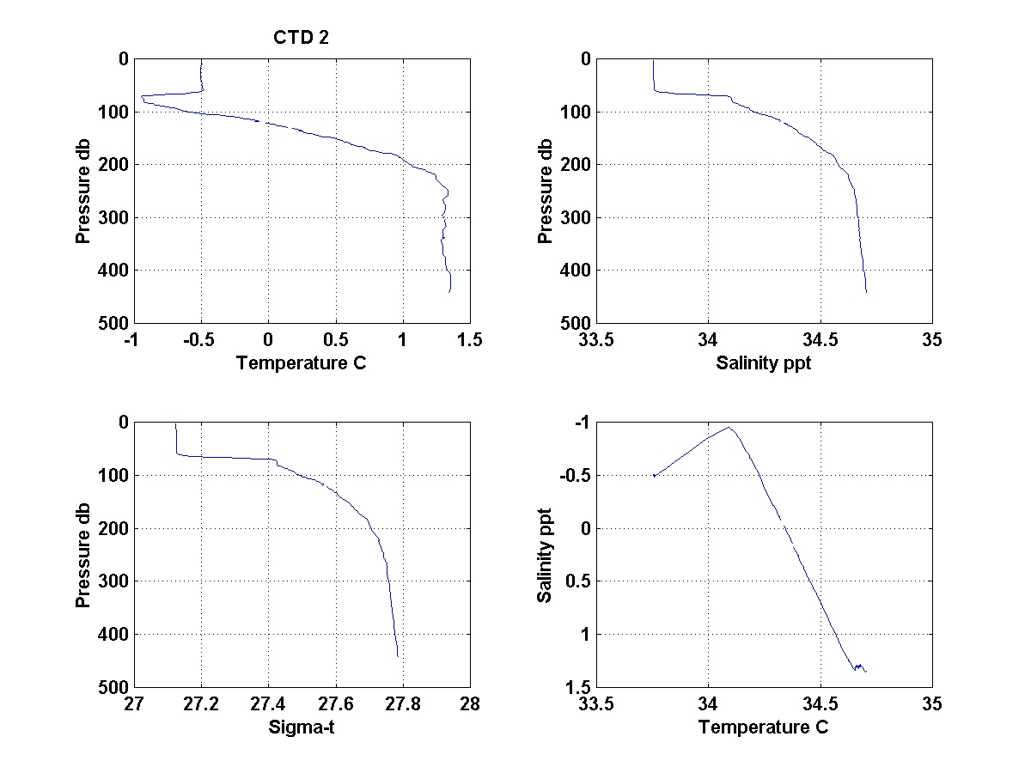
Figure 5. CTD 2 profiles located at WHOI mooring B3
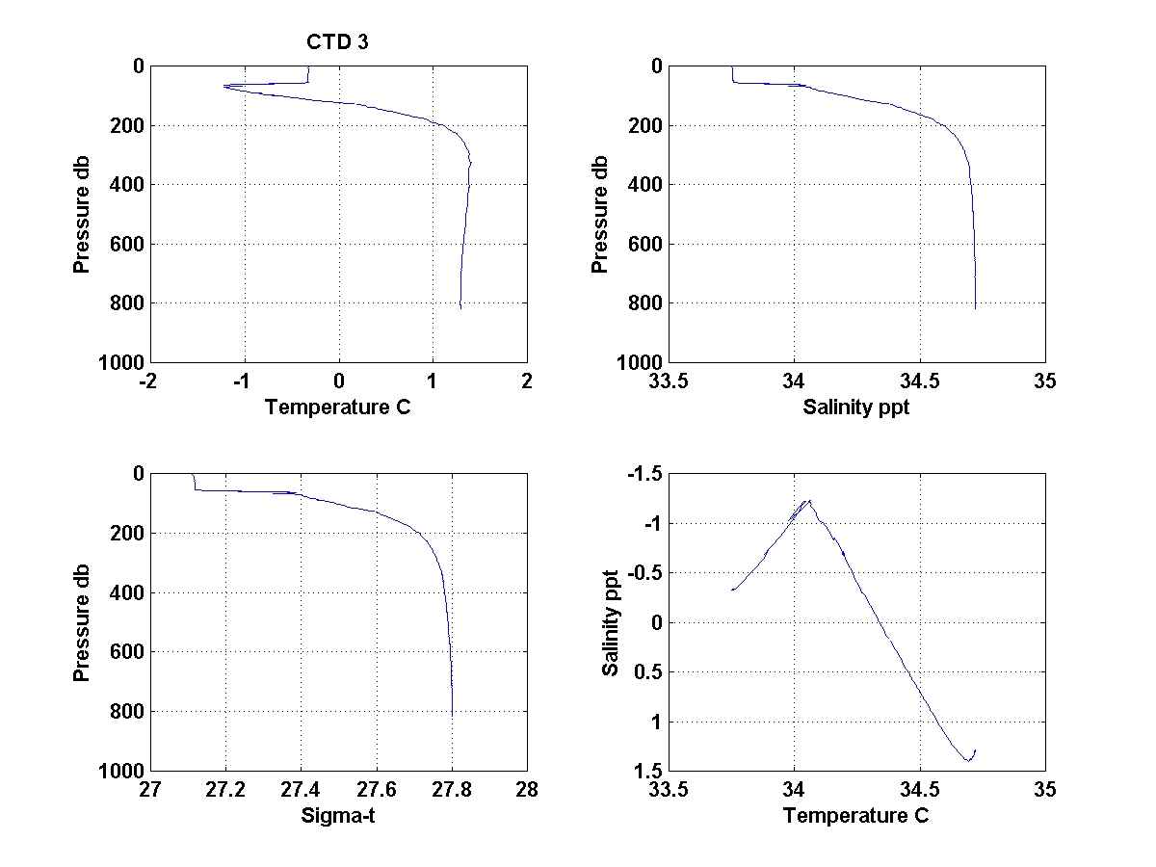
Figure 6. CTD 3 profiles located at WHOI mooring B2

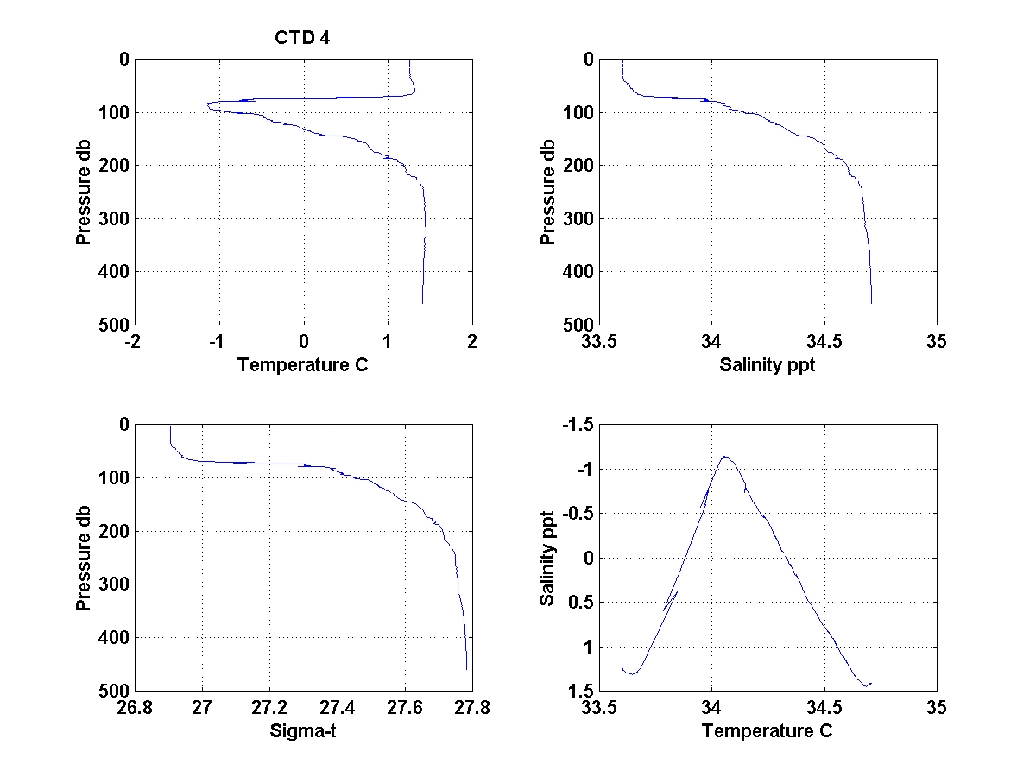
Figure 7. CTD 4 profiles located at WHOI mooring B1.
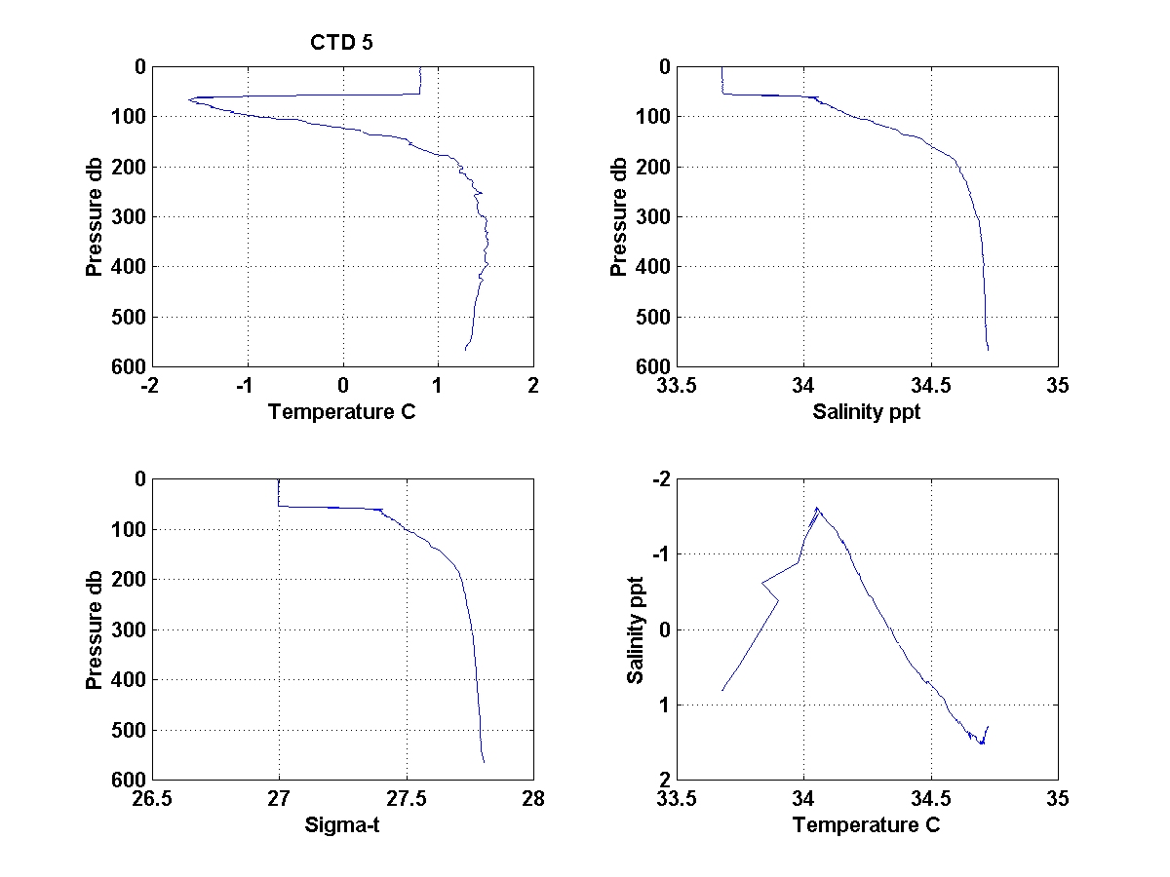
Figure 8. CTD 5 profiles located at WHOI mooring A2.

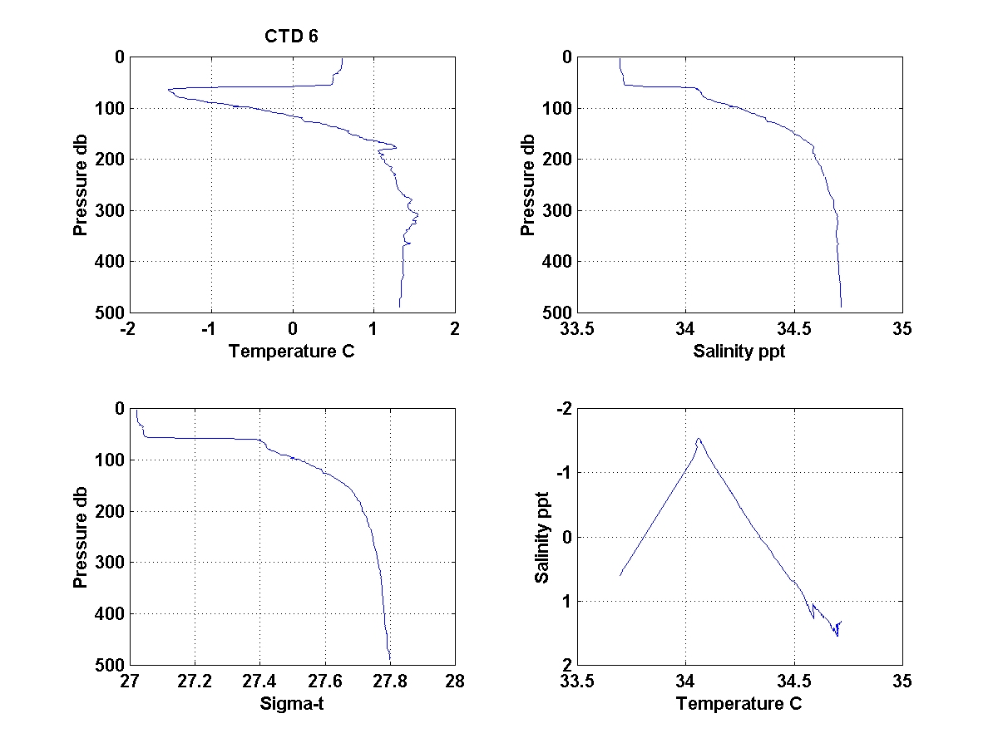
Figure 9. CTD 6 profiles located at WHOI mooring A3

Meteorological Measurements

4.1 Introduction

A good knowledge of the surface meteorological conditions during the Southern Ocean GLOBEC (SO-GLOBEC) program is essential to understand the role of surface momentum and heat flux forcing on the regional circulation and upper ocean properties. The surface meteorological data are also useful in interpreting other physical and biological data collected during the program.

The primary source of surface meteorological data during SO-GLOBEC will be that collected aboard the R/V Gould and R/V Palmer during their cruises in the study area. LMG01-3 is the first SO-GLOBEC cruise, and this report provides a preliminary description of the meteorological data collected on this cruise.

The R/V Gould left PA on March 18 and arrived at Palmer Station on March 2 (Leg 1). She left Palmer Station on the next day and returned to Palmer Station from the SO GLOBEC area to the south on April 8 (Leg 2). The LM Gould left Palmer Station on April 9 for PA and arrived on April 13 (Leg 3). A full suite of meteorological data was collected during the cruise with two exceptions. Neither sea surface temperature (SST) nor sea surface salinity (SSS) data were collected while the LM Gould was docked at Palmer Station. The ship uses GMT year day (yd) as given by GPS for time. Leg 2 corresponds to yd = 84.61 to 98.52.

4.2 Instrumentation

The meteorological sensors are mounted on the ship’s main mast (Figure 10). The sensors include a pair of wind monitors and other sensors to measure air temperature (AT), relative humidity (RH), barometric pressure (BP), and incident shortwave (SW) and longwave (LW) radiation. Sea surface temperature (SST) was measured using a remote sensor in the intake manifold, and sea surface salinity (SSS) was measured using a Thermosalinograph placed in the wet lab. The different sensors and their calibration history and installation dates are given in Table 2. Based on this table, the port wind monitor and the three radiation sensors (PAR, SW, and LW) are past their scheduled next calibration. In particular, the SW and LW sensors have not been recalibrated since September 1997.
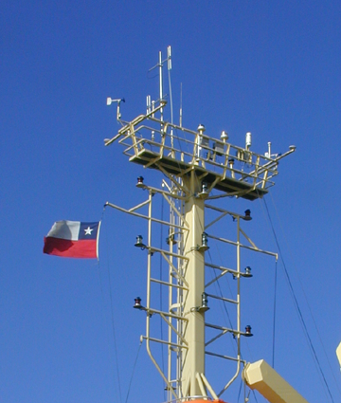

Figure 10. Meteorological sensors mounted on platform railing on top of mast.

Variable | Sensor | Serial Num. | Last Cal. | Next Cal. | Installed | Cal. Inv.
Star. Wind | RM Young 5106 | WM 28393 | 11/7/00 | 11/7/01 | 12/28/00 | A
Port Wind | RM Young 5106 | WM 35061 | 2/4/99 | 2/4/00 | 8/26/99 | A
AT, RH | RM Young 41372VC | 2904 | 11/30/99 | 11/29/01 | 7/23/00 | BA
BP | RM Young 61201 | BP 00873 | 11/30/99 | 11/29/01 | 7/22/00 | BA
PAR | Biosp. Inst.  QSR-240P | 6394 | 3/22/99 | 3/21/00 |  | A
SW | Eppley  PSP | 28933F3 | 9/21/97 | 9/21/98 |  | A
LW | Eppley  PIR | 32031F3 | 9/3/97 | 9/3/98 |  | A
SST | Sea-Bird  3-01S | 1619 | 7/27/99 | 7/26/00 |  | A
SSS | Sea-Bird 21 | 219209-1577 | 12/30/99 | 12/29/00 |  | A

Table 2. LMG01-3 meteorological sensors, their calibration history, and time ofinstallation. The last column indicates if the sensor is to be re-calibrated every year (A) or every two years (BA).

4.3 Data Acquisition and Processing

The raw LMG shipboard meteorological data were collected using the ship’s DAS. A 1-min processed subset of the raw data was saved at the end of each day in a flat ASCII text file on the ship’s DAS_DATA directory on drive Q (e.g., the data for yd=99 and yd=100 are located in Q:\.geopdata\JGOF\jg099.dat and jg100.dat respectively). This 1-min time series was produced using a JGOFS code that merged the met data with navigation and other data and combined the ship’s motion and the measured (relative to the ship) wind speed and direction data to make ”true” wind speed and direction relative to the ground.

The daily data was obtained from drive Q and converted into standard variables using the MATLAB m-file read_gould_met1m(yd). This program also edits the raw SST data and stores the final data set in a MATLAB mat-file for each day (e.g., jg100.mat for yd=100). The raw SST time series contains many values that were below the surrounding values by ~ 0.2 to 0.5 ºC or more. These data dropdowns occurred through the cruise, with the amplitude and frequency of the dropdowns varying but the character of the dropdown remaining the same. A simple filter was used (clean_gould_sst.m) to replace the dropdowns with linear interpolation. An example of the raw and edited SST is shown in Figure 11. Any additional hand editing of the SST and sea surface salinity (SSS) time series were done at this point, and the final edited series stored in each day’s mat-file (e.g., jg100.mat).
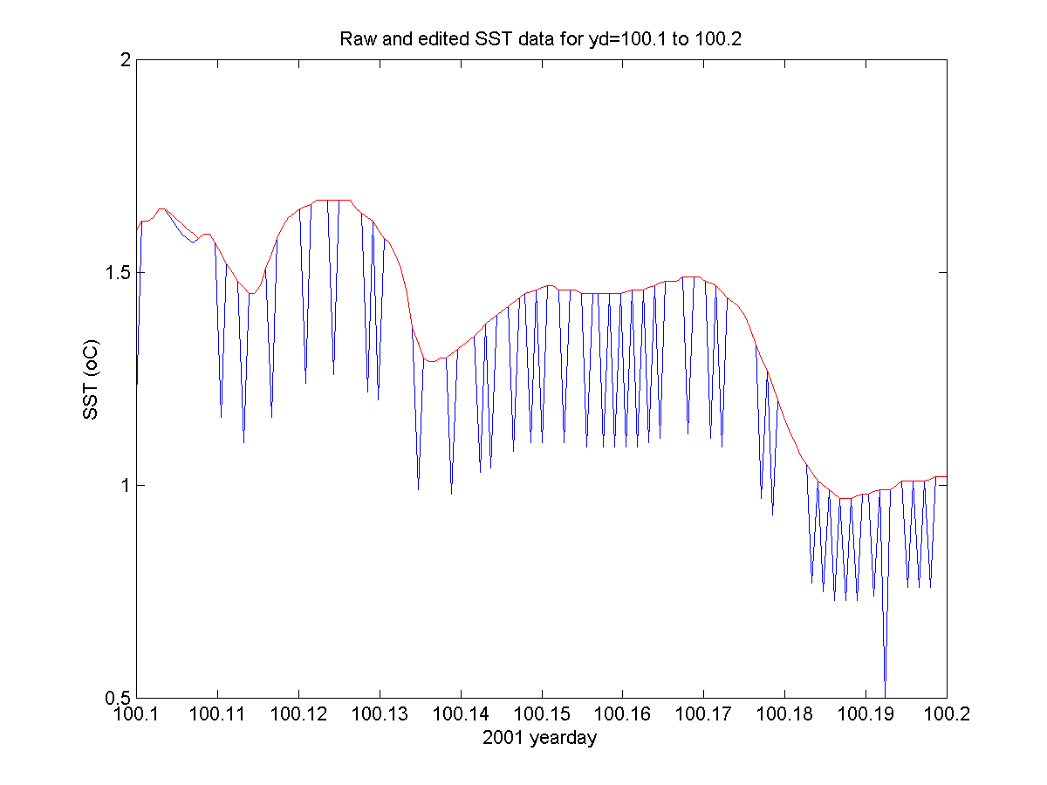
Figure 11. Raw (blue) and edited (red) SST time series for a 2.4-hour period on yd 100.

The m-files start_gould_met1m(first_yd) and merge_gould_met1m(last_yd) were used to combine the 1-day jgxxx.mat files into a single 1-min continuous time series for each variable. The merged data were then stored in gould_met1m.mat.

For further analysis, the 1-min data in gould_met1m were low-pass filtered and subsampled using make_gould_met5m into 5-min time series. The filter used is the pl66tn set with a half-amplitude period of 12 min. Both the shortwave radiation and PAR time series were corrected for small negative nighttime biases. The 5-min data were then used to estimate the surface wind stress and heat flux components using bulk methods called by compute_gould_wshf5m. Two gaps in SST (when the ship was at the Palmer Station dock) were filled using linear interpolation so that the surface fluxes could be computed for the entire period of the cruise. The errors introduced by using the approximate SST at Palmer Station are small enough to ignore. The surface wind stress and heat flux data were then added to the gould_met5m, so that this 5-min contains best versions of the surface meteorological conditions and forcing for the cruise.

As mentioned above, the JGOFS data file jgxxx.dat placed on drive Q presents only the “true” wind speed and direction. The actual raw wind measurements are stored each day in another directory, and will be included in the cruise data cd-rom. Without that data, it is difficult to make an accurate assessment of the JGOFS code that removes the ship’s motion from the relative wind measurements made on the mast. A preliminary look can be made by comparing wind speed and the ship’s speed over the ground (SOG), to see if sudden changes in SOG are reflected in the wind speed. The example shown in Figure 12 is not definitive, but does suggest that the JGOFS “true” wind still contains some ship motion. A full analysis of the raw data will be needed to check the JGOFS code and see if a better code for “true” wind can be developed. Until this analysis is done, the wind speed and direction data and those variables that are functions of wind speed (e.g., wind stress) contained in gould_met1m and gould_met5m must be considered as preliminary values.

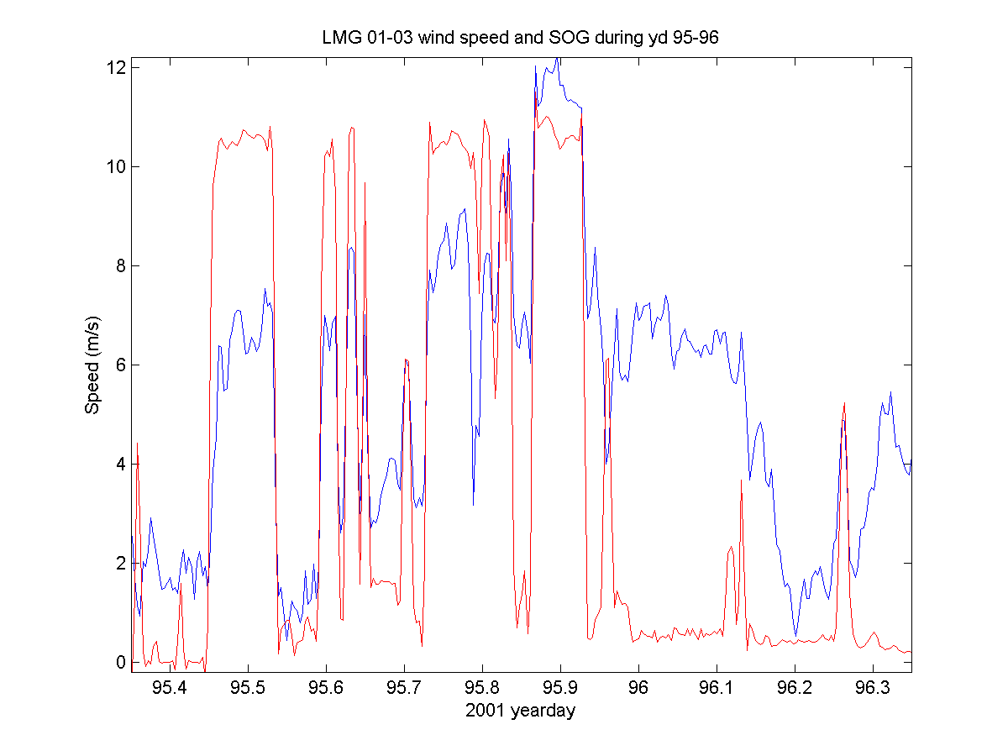
Figure 12. Plot of ship’s speed over the ground (SOG) from GPS in red and the JGOFS “true” wind speed. Note how the wind speed tends to jump when the ship stops and starts.

4.4 Description of Cruise Weather

Time series of the 5-min surface meteorological data are shown in Figure 13 for the entire cruise. During Leg 2 (yd =84.61 to 98.52), a deep low passed over the region on yd 87, with strong winds above 40 knots towards the southwest to south for almost two days (peak winds exceeded 50 knots for several hours). As the low passed, the winds dropped and a short 3-day period (yd 88-91) followed with winds 10-20 knots towards the north and northeast. This good weather window allowed the completion of the WHOI and SIO mooring deployment work. Winds became strong again on yd 91-93, with maximum winds between 30 and 40 knots during yd 92. The R/V Gould spent the rest of Leg 2 searching and studying whales in the inland passages and inside Marguerite Bay, until heading back to Palmer Station on yd 97. During Leg 2, the skies were usually overcast, with occasional snow, so that the downward flux of shortwave radiation was generally small (mean 28 W/m², with a maximum of 296 W/m² on yd 94. The downward flux of longwave radiation dropped from values near 280 – 300 W/m² to roughly 200 W/m² during the few periods with clear skies. Using this drop as an indicator of clear skies, there were clear skies for only about 12% of Leg 2.

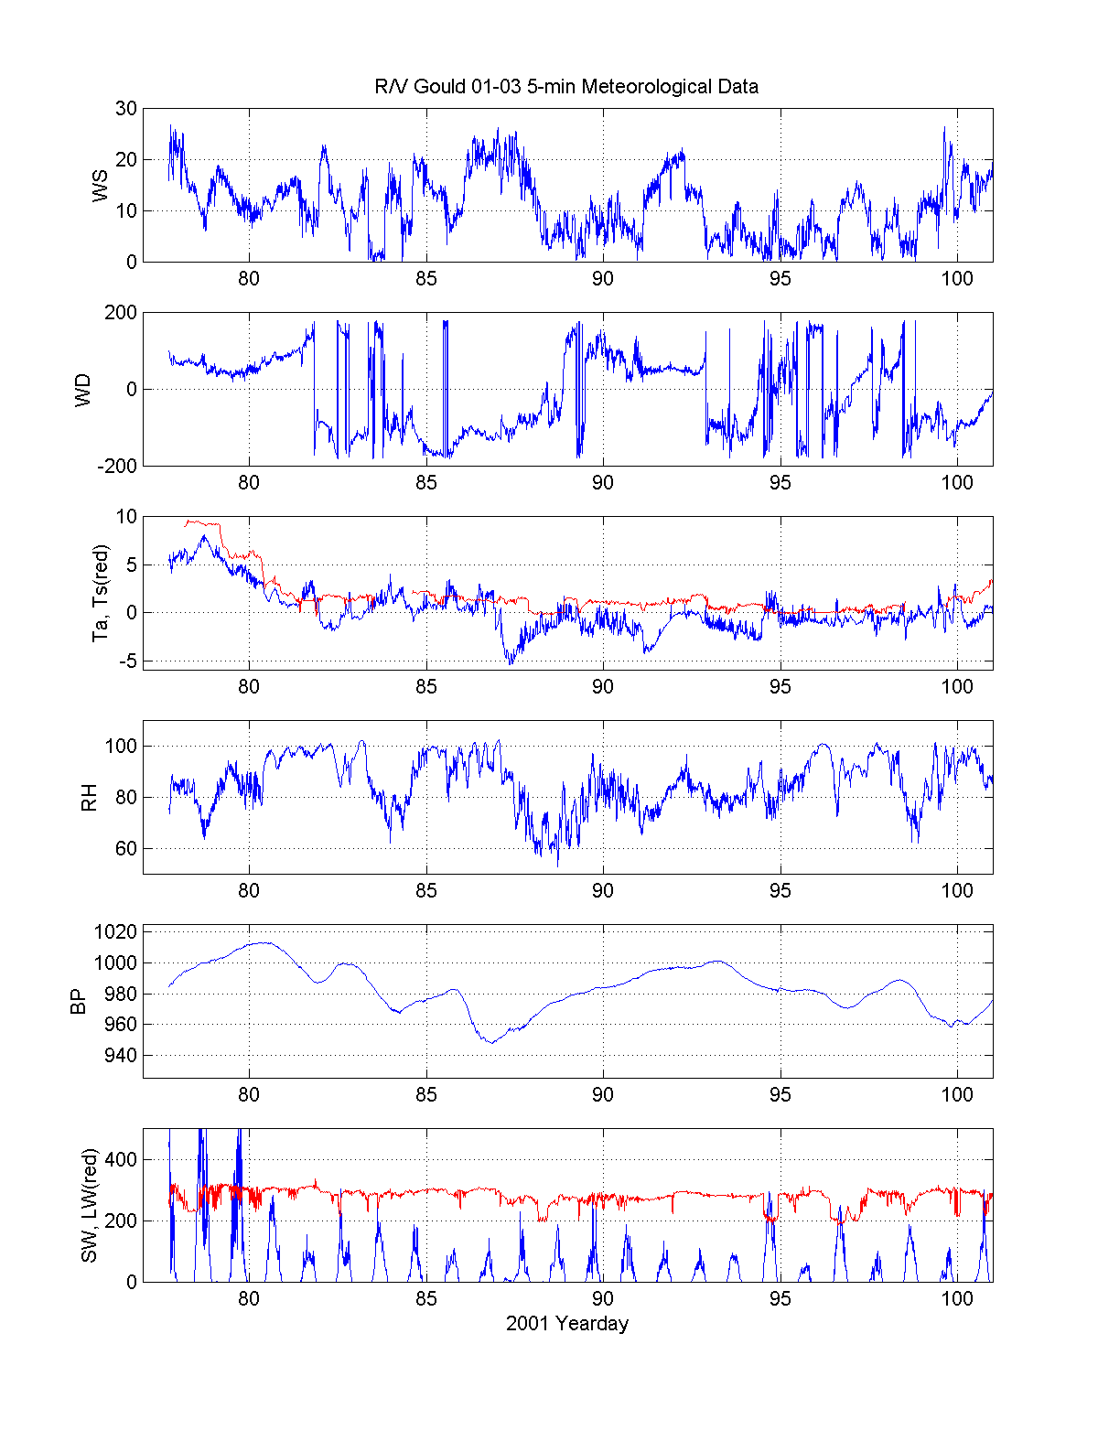
Figure 13. Surface meteorological measurements during LMG01-3.
5.5 Description of Surface Fluxes

The surface wind stress and heat flux components are shown in Figure 14. During Leg 2, the two periods of high winds produced wind stresses in excess of 0.7 to 1.0 N/m², while the wind stresses were much weaker (generally less than 0.1 N/m²) for the rest of Leg 2. Table 2 gives simple statistics for the east (Tx) and north (Ty) wind stress and the heat flux components for Leg 2.

Variable | Mean | St. Dev. | Min | Max
Tx | -0.006 | 0.185 | -0.703 | 0.655
Ty | -0.057 | 0.298 | -1.287 | 0.714
Qnet | -68.3 | 68.7 | -351.7 | 142.5
Qsw | 24.9 | 42.9 | 0 | 251.2
Qlw | -45.8 | 25.7 | -128.8 | -5.0
Qsen | -19.0 | 26.4 | -156.7 | 37.7
Qlat | -28.4 | 26.5 | -150.1 | 15.3

Table 3. Wind stress and heat flux statistics for LMG01-3 Leg 2.

The mean net heat flux into the ocean during Leg 2 was -68 W/m². The generally overcast conditions limited the incident shortwave flux but caused a decrease in the longwave heat loss. The resulting net radiation flux was –20.9 W/m², roughly comparable with the weak mean sensible and latent heat flux losses. This combined with the weak mean sensible and latent heat loss produced the net loss.
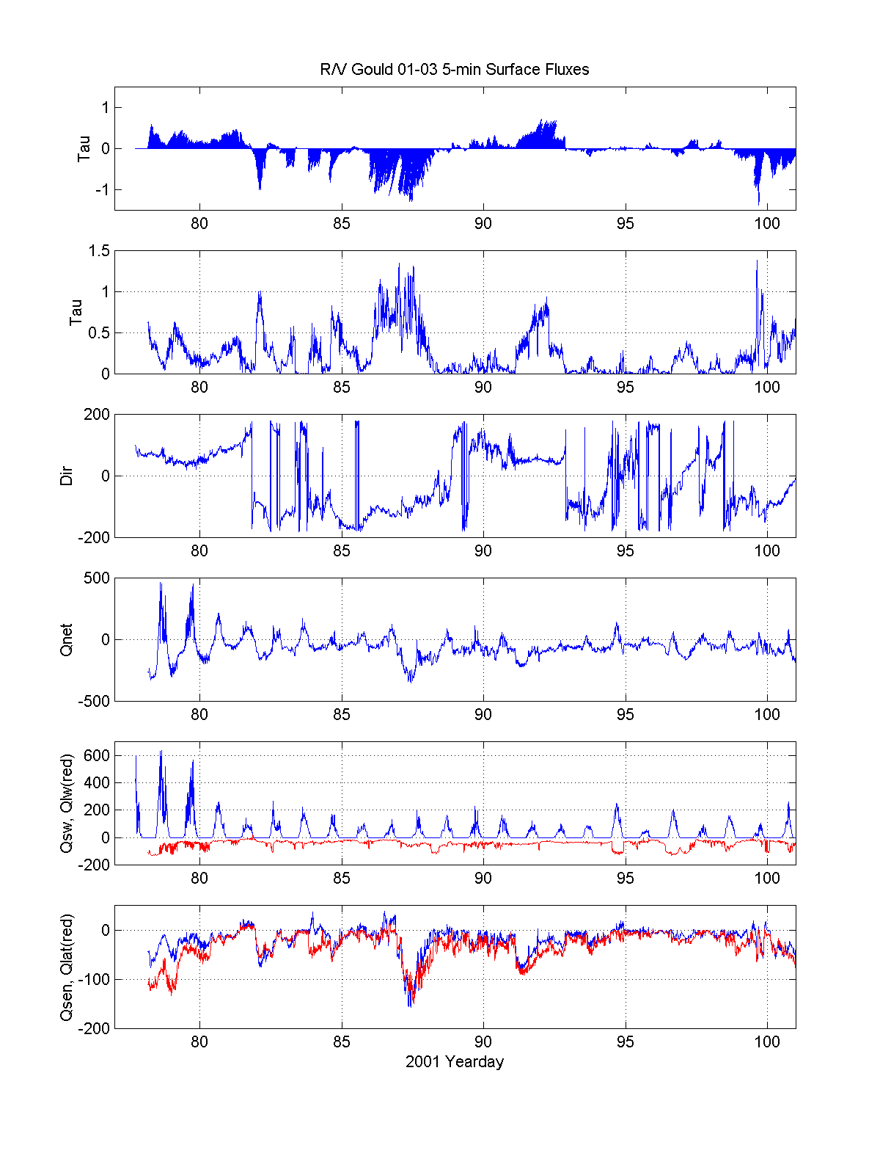
Figure 14. Surface wind stress and heat flux during LMG01-3. Units of wind stress are N/m² and heat flux W/m².

Marine Mammal Observations

5.1 Acoustic Census of Mysticete Whales

Most large whales produce distinctive calls such that passive acoustic methods can be used to study their distribution, behavior, and minimum absolute abundance. The repetitive call of the ordinary blue whale is ideal for long-range signal transmission. Although blue whale calls vary by geographic region, each population produces a characteristic low-frequency (~20 Hz) repetitive call of roughly 10 to 20 seconds duration, sometimes with multiple components. The detection range for blue whale calls from a simple bottom recorder is typically 20 km, with longer ranges possible if one applies matched filter techniques. The long-term nature of seafloor recorder deployments allows for a statistically significant number of acoustic encounters, even with a widely dispersed whale population, assuming whales call roughly ten to fifty percent of the time. The recordings will likely also include sounds from minke, right, fin and humpback whales.

Mysticete whales will be detected via reception of their calls on passive, bottom-mounted acoustic recorders. Detection of whale calls via moored passive acoustic recorders has proven quite effective during recent studies, especially for blue and fin whales. New technology, that of long-term deployments of autonomous low power recorders makes an acoustic survey of mysticete whales in remote locations practical. Deep water is desirable partly because the ambient noise, which largely is produced at the surface, is reduced at depth and also because acoustic travel paths will interact less with the seafloor which absorbs acoustic energy. The long-term nature of seafloor recorder deployments allows for a statistically significant number of acoustic encounters even with a widely dispersed whale population, assuming whales call roughly ten to fifty percent of the time.

Given the great uncertainty in the numbers of blue whales in the Southern Ocean (500 to 5000), and in the subspecies to which they belong, we believe the minimum census estimates which can be provided by acoustic monitoring is a key goal of the proposed project. If we were to have 800 acoustic contacts per season, for instance, it would be clear that current blue whale population estimates are severely underestimating the actual populations. Even in the case where we would obtain 80 acoustic contacts per season, in keeping with the current estimates, we should be able to provide some estimate of which geographic areas and or subspecies the animals are from. Application of the techniques of point transect theory to the results of the survey where each acoustic contact is assigned a range should allow a minimum census estimate, the primary factor which will remain to be answered from other combined visual and acoustic data being the percent of whales calling during a time constant.

The second fundamental goal of this work will be minimum population estimates and seasonal occurrence profiles for fin whales and humpback whales. Other species such as minke whales and sperm whales may be detected, but are expected to be so infrequent as to make population density estimates unreliable. Perhaps the most important overall result of this work will be to establish an acoustic detection baseline from which to measure future changes in relative abundance of Southern Ocean mysticete whales.

We deployed eight seafloor acoustic recorders, each with a hydrophone that is floated about 5 m above the seafloor. These instruments will record continuously at 500 samples per second for fifteen months, writing the data to 36 Gb of computer hard drive in each instrument. The recorders have a 16 bit dynamic range and are powered by lithium double D size batteries, which are placed inside high tensile aluminum pressure cases. The seafloor recorders use a system of drop weights, Benthos glass balls and an acoustic release for recovery.

Throughout the cruise we deployed and recorded 36 directional sonobuoys and two broadband sonobuoys both randomly and when whales were sighted, as a means to record and thereby `groundtruth’ mysticete whale calls in this remote region. Recordings were obtained from humpback, minke and fin whales during the cruise. No blue or right whales were sighted or heard during this cruise

5.2 Marine Mammal Visual Survey, Photo Id And Biopsy Summary

A visual survey for cetaceans was conducted on LMG01-3 during daylight hours on all days when weather conditions allowed. Searching was conducted by the IWC observer (Deb Thiele) and Sue Moore with assistance from the rest of the acoustic mooring team. Sightings were recorded on a laptop based Wincruz Antarctic program which also logged GPS position, course and ship speed automatically. Seals, seabird concentrations, ice concentration, SST and depth were also recorded on the program. Survey effort generally commenced at first light from the outside bridge wings and/or inside the bridge (weather dependent) and ceased at dark. Visual surveys alone were conducted during the oceanographic and acoustic mooring components of the cruise. Large numbers of humpback whales were observed during the afternoon transit across the Bransfield Strait.

Five days of ship time were allocated to conduct cetacean survey (including closing on sightings, biopsy, photo identification and sonobuoy deployment) from first light on Tuesday 3 April to end of day Saturday 7 April. The weather improved for this part of the survey, with calm seas and a lifting of the Peninsula cloud blanket providing us with some rare sunny days! During this time the ship traversed the inside channels to the north of, and including, Adelaide Island. In Matha Strait two large feeding groups of the dark shouldered minke whale were sighted (total of 80 animals). Photographs were obtained and biopsies of four minkes from the largest group were taken. On entering the northern end of Marguerite Bay, just near Rothera Station, a large group (30) of killer whales was sighted. The killer whales broke into sub groups and traveled north past the ship with many accompanying fur seals, and a minke whale. One humpback was also seen in the vicinity. The ship took a southwest course to Neny Island and then headed across the bay and towards Palmer Station on a course close to the coast and inside the islands from Matha Strait onwards. Two pairs of humpbacks were located late in the afternoon on 7 April, with photo id and biopsy obtained from one pair. Total biopsies taken: 5 minke (one from a group of 7 and 4 from the feeding group of 50) and 5 humpback (one from one pair and both animals from another two pairs).
Total species | Total sightings/animals
Fin whale | 1:3
Minke ordinary | 9:91
Like minke | 5:14
Hourglass dolphin | 1:4
Unidentified cetacean | 1:1
Unidentified large whale | 3:5
Killer whale | 4:53
Ziphiidae | 2:5
Humpback whale | 38:81
Humpback whale and like fin whale (mixed group) | 1:12
Undetermined minke whale | 18:40
Like fin whale | 1:3
Unidentified whale | 4:4
Total | 88:316

Table 4. LMG01-3 marine mammal observations.

Chief Scientist’s Daily Log

All times local time, GMT-4

Sunday – March 18, 2001
1330 – Depart Punta Arenas with West wind over 40 kt
Steaming eastward out the Straits of Magellan
1415 – Safety meeting with 2nd Mate

Monday – March 19, 2001
Steaming south to the Drake Passage

Tuesday – March 20, 2001
Steaming south in the Drake Passage

Wednesday – March 21
Steaming south in the Drake Passage
Deployed 2 test sonobuoys

Thursday – March 22, 2001 Day 81
0830 arrived King George Island
Offloaded Brenda Hall’s party and gear
1530 Departed King George Island
Steaming west to SIO mooring S1

Friday – March 23, 2001 Day 82
0306 deployed SIO whale acoustics mooring S1 in a snowstorm
Steaming to Palmer Station

Saturday – March 24, 2001 Day 83
0800 arrive Palmer Station
Offload PS gear
Move mooring gear

Sunday – March 25, 2001 Day 84
1000 depart PS
Steaming to SIO mooring S7

Monday – March 26, 2001
0730-1100 A1 bottom survey
0858 – Deploy sonobuoy
1130-1530 Deploy A1 rough seas, wind decreasing, deck awash
1700 – CTD 1
1749 – Deploy drifter 30460

Tuesday – March 27, 2001
56 kt winds and barometric pressure < 948 mb
unsafe to work on deck
1600 steam to Marguerite Bay for shelter

Wednesday – March 28, 2001
Winds > 40 kt, unsafe to work on deck
0930 Began bathymetry survey of B1 mooring site
1700 Began bathymetry survey of B2 mooring site
2000 Began bathymetry survey of B3 mooring site

Thursday – March 29, 2001
0530 Began mooring B3 preparation wind< 10k
0630 Deploy sonobouy
0842 Deployed B3 mooring
0915 CTD 2
1618 Deployed B2 mooring
1230 CTD 3 while hydraulics were being repaired

Friday – March 30, 2001
CTD 4
Deploy B1 mooring
Deploy drifter 26373

Deploy drifter 24406
Deploy drifter 30461
Deploy sonobuoy
CTD 5
Deploy mooring A2

Saturday – March 31, 2001
Deploy drifter 30458
CTD 6 at 0700
Deploy A3 mooring at 1039
Deploy drifter 30459 at 1100
Deploy S5 mooring
Deploy S6 mooring

Sunday – April 1, 2001
Deploy S4 mooring
Deploy S3 mooring
Deploy S2 mooring

Monday – April 2, 2001
Deploy S2
Steam to the Grandidier Channel
Begin marine mammal observations

Tuesday – April 3, 2001
Briscoe Islands marine mammal observations

Wednesday – April 4, 2001
North of Adelaide Island marine mammal observations
Sunny day, minke whales

Thursday – April 5, 2001
Off Rothera marine mammal observations
Killer whales

Friday – April 6, 2001
Marguerite Bay marine mammal observations
Minke whales

Saturday – April 7, 2001
Marguerite Bay marine mammal observations
1200 Steaming back to Palmer Station
Sunday – April 8, 2001
0800 Arrive Palmer Station

Monday – April 9, 2001
1000 Depart Palmer Station for Punta Arenas

Tuesday – Thursday – April 10 – 12, 2001
Steaming to Punta Arenas

Friday – April 13, 2001
0800 arrive Punta Arenas

7. Cruise Personnel

Science Party

Richard Limeburner Chief Scientist
Robert Beardsley Senior Scientist
Scott E. Worrilow Electronics Engineer
Ryan C. Schrawder Electronics Engineer
James R. Ryder Mooring Engineer
John Gunn Scientist
Claudia Cenedese Scientist
Mark A. McDonald Scientist
Sue E. Moore Scientist
Allan W. Sauter Scientist
Ana Sirovic Student
Deborah Thiele Scientist
Brenda Hall Scientist
Ethan Perry Scientist
Robert Farrell Palmer Station Manager
Kenneth Davis Palmer Station
Craig Bucher Palmer Station
Robert Moore Palmer Station
Roger Gorman Palmer Station
Cheryl Hansen Palmer Station
David Bunker Palmer Station
Michael Rogers Palmer Station
Daniel Naber Palmer Station
Thomas Leipart Palmer Station
Mark Williams Palmer Station
Jose Dominguez Palmer Station

Raytheon Polar Services
Harold H. Owen III Marine Project Coordinator
Jennifer Ann White Marine Technician
Andrew F. Nunn Electronics Technician
Jonnette Tuft Marine Science Technician

Ship Officers and Crew
Warren M Sanamo Jr. Master
Morris J Bouzigard Chief Mate
Jesse Gann 2nd Mate
Tracy Ruhl 3rd Mate
Paul B. Waters Chief Engineer
Gerald Tompsett 1st Engineer
Russel Lesser 2nd Engineer
Noli Tamayo Oiler
Donde Dasoy Oiler
Mark Stone Cook
David Steinberg Cook
Luciano Albornoz Galley Hand
Fernando Naraga Deck
Efren Prado Deck
Rafael Sabino Deck
Dionito Sabinas Deck

Acknowledgments

This cruise report was prepared by Richard Limeburner, Bob Beardsley, Mark McDonald, Sue Moore and Deb Thiele. We especially thank Captain Warren Sanamo and the officers and crew of the R/V Gould Cruise LMG01-3 for their skill and superb assistance that allowed deployment of the moorings and drifters under difficult weather conditions, observations of the marine mammals, and completion of the hydrographic survey. Often the moorings were deployed in heavy seas among icebergs and the ship’s officers were still able to navigate the ship to specified mooring deployment sites.

Special thanks to Skip Owens of Raytheon Polar Services (RPS) for coordinating the successful mooring deployment operations. The successful mooring planning, design and deployments were primarily due to the efforts of Scott Worrilow with assistance from Ryan Schrawder and Jim Ryder. Thanks also to Andy Nunn, Jenny White, and Jonette Tuft of RPS for helping on deck and maintaining and operating the shipboard scientific equipment and coordinating this instrumentation with the scientific party. Thanks to Claudia Cenedese for helping with the CTD stations and mooring deployments. This research effort is sponsored by the National Science Foundation, NSF research grant OCE-98-????. All data and results in this report are to be considered preliminary.

Appendix 1

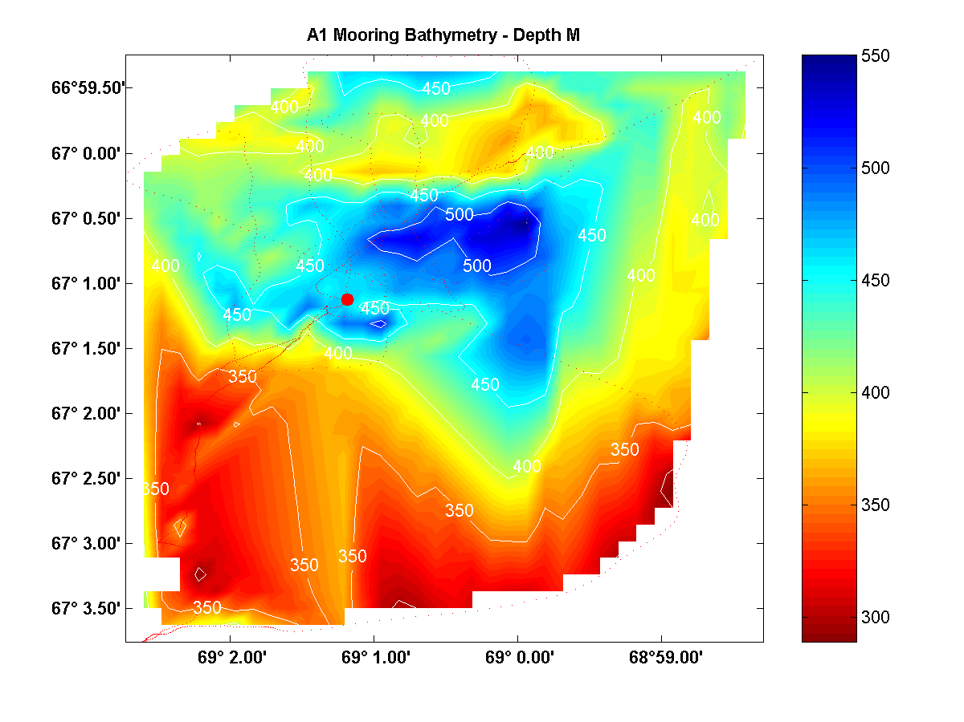
Figure 1. Bathymetry at the A1 mooring site.
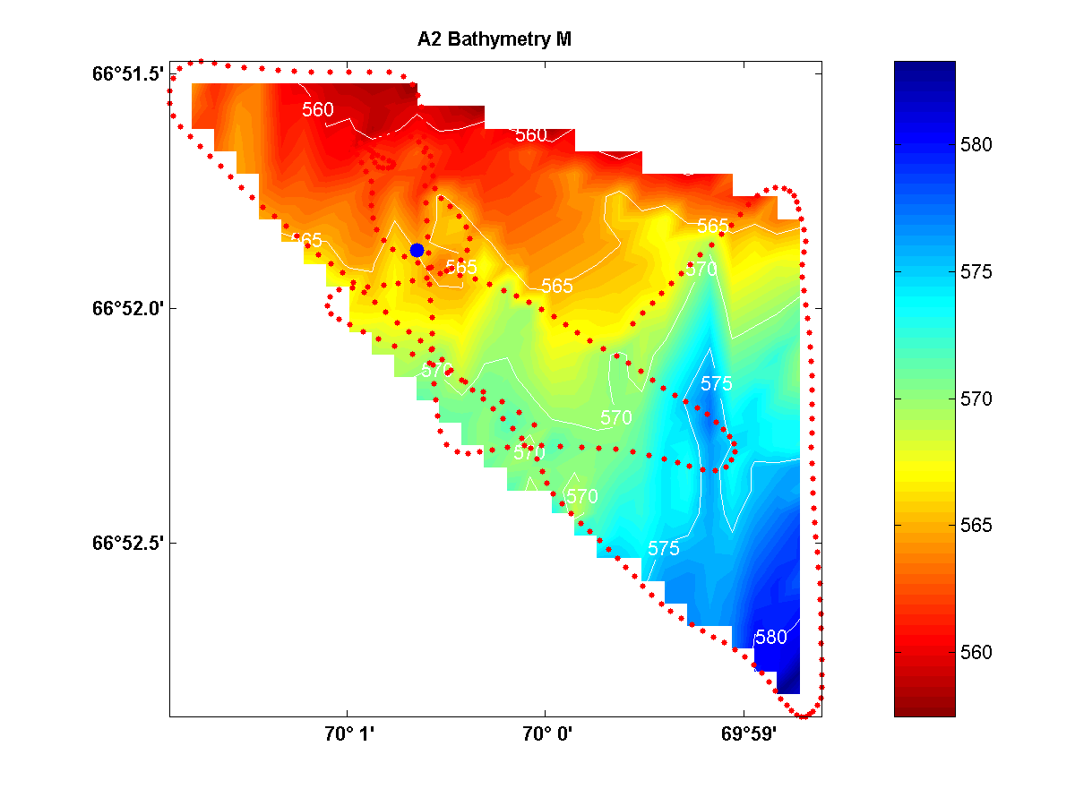
Figure 2. Bathymetry at the A2 mooring site.

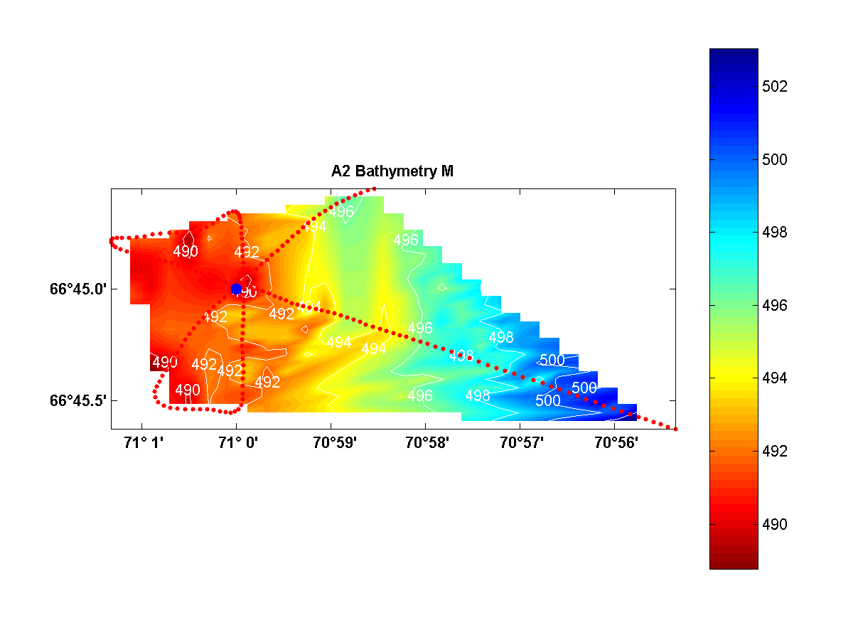
Figure 3. Bathymetry at the A3 mooring site.
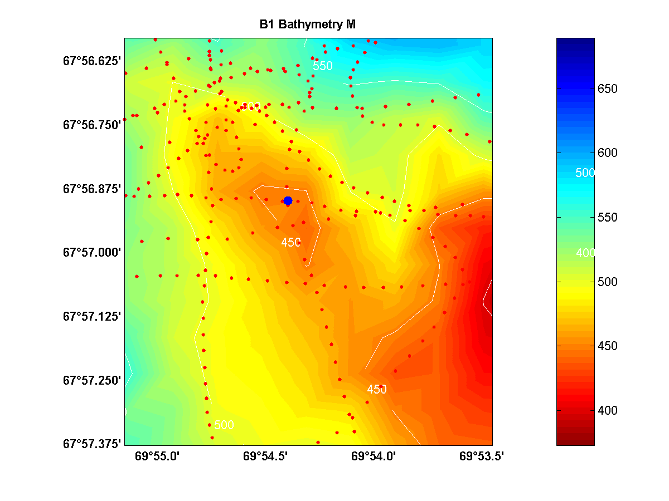
Figure 4. Bathymetry at the B1 mooring site.

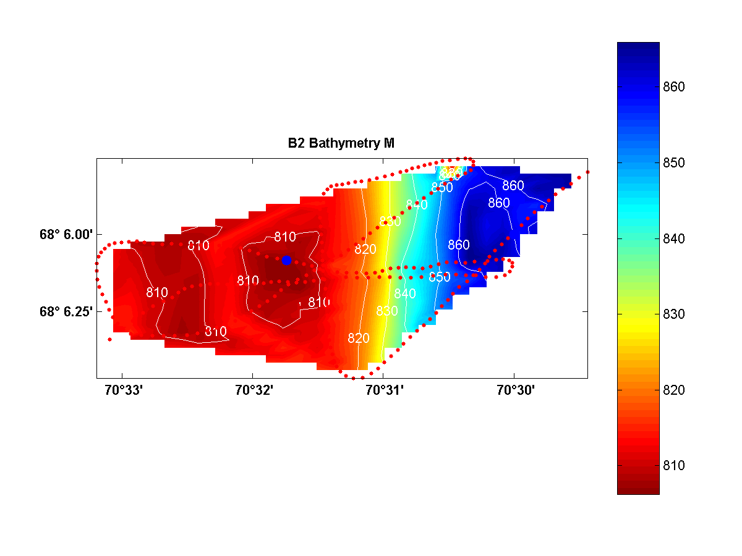
Figure 5. Bathymetry at the B1 mooring site.
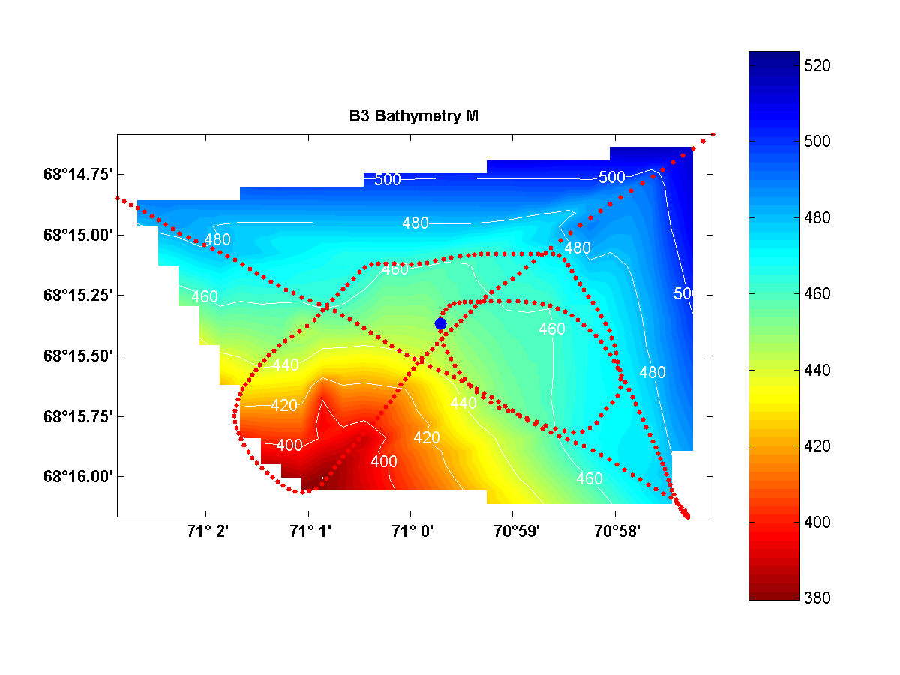
Figure 6. Bathymetry at the B3 mooring site.
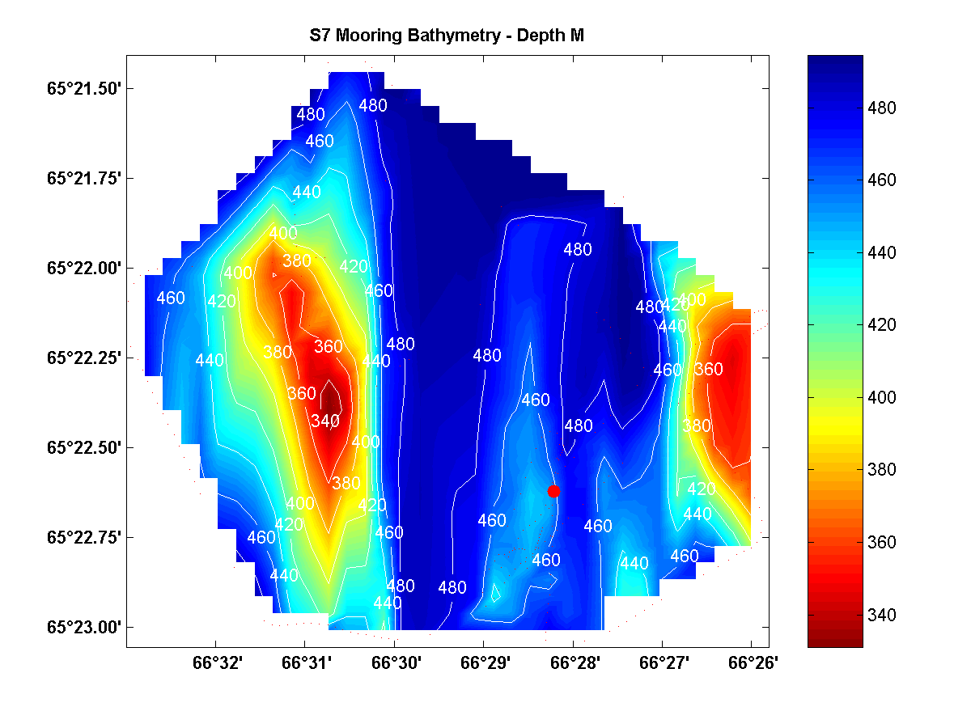
Figure 7. Bathymetry at the S7 mooring site.
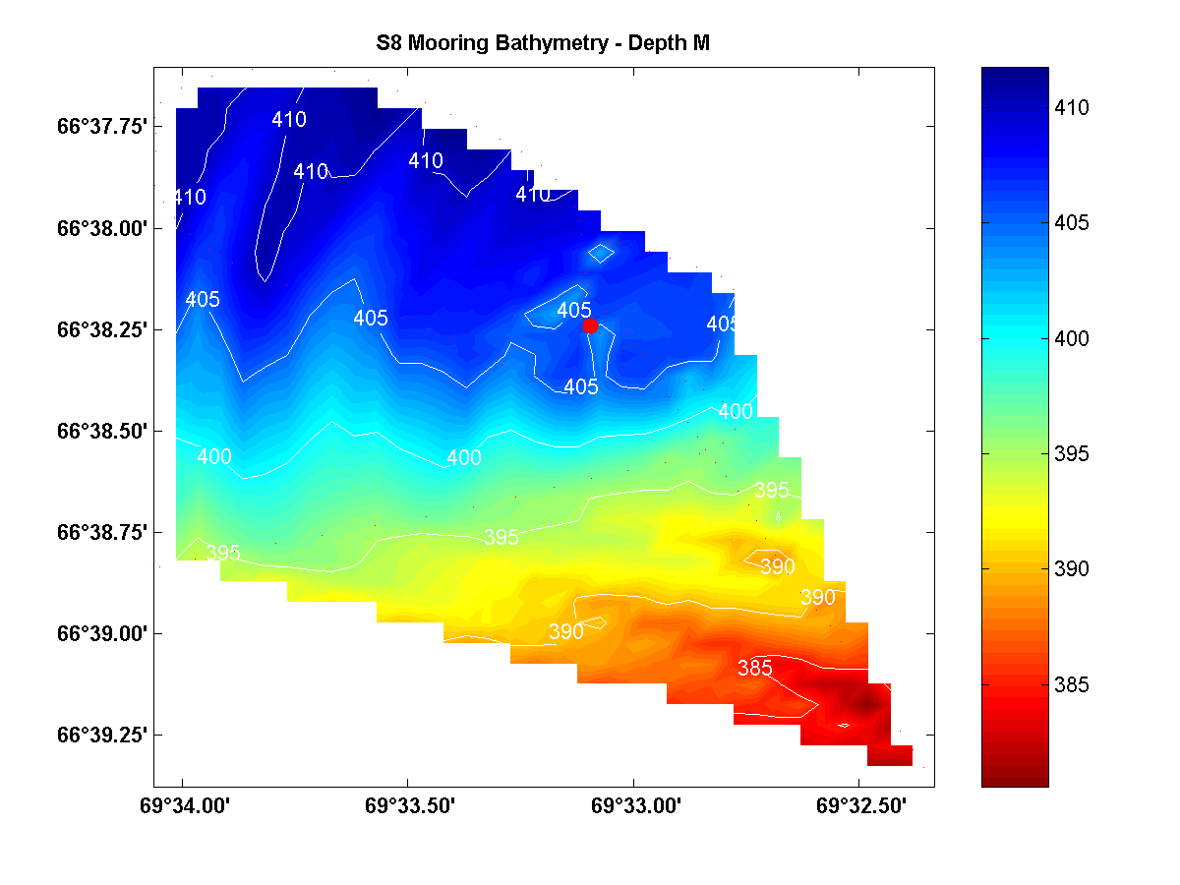
Figure 8. Bathymetry at the S8 mooring site.

Appendix 2 Drifter tracks

