Data Report
NBP0104
GLOBEC II
July 22 – August 31, 2001
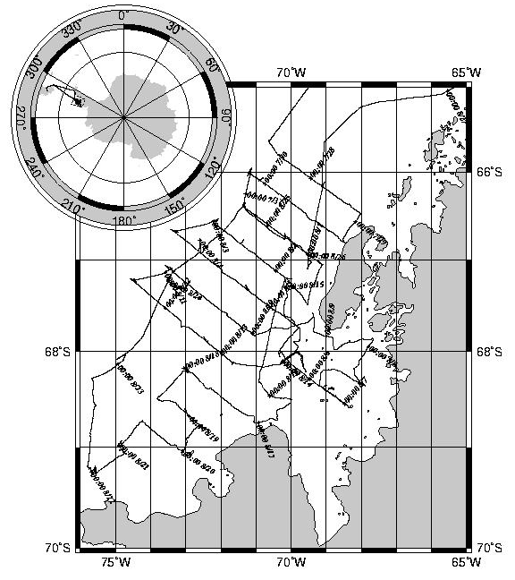
Prepared by: E. Joynt, T. Bolmer, and K. Gavahan

Introduction 1
Archive Data Extraction 2
Distribution Contents 3
ADCP 3
CTD 3
Cruise Tracks 4
GUV 4
Satellite Images 5
Science Report 5
NBP Data Products: MGD77 & JGOFS 5
JGOFS 5
MGD77 6
RVDAS 7
Data File Names and Structures 8
Ocean Data Files 14
Calculations 15
TSG 15
PAR 15
PIR 15
PSP 15
NBP0104 Sensors 16
Shipboard Sensors 16
NBP0104 CTD Sensors: 16
NBP0104 MOCNESS Sensors: 16
Acquisition Problems and Events 17
Calibrations 18
TSG CALIBRATION FILES 18
Conductivity Sensor 18
Temperature 19
Remote Temperature 20
Transmissometer 21
Meteorology System 22
Windbirds 22
PSP 25
PIR 26
GUV 27
CTD 29
Pressure Sensor 29
Temperature Sensors 30
Conductivity Sensors 32
Dissolved Oxygen Sensor 34
Fluorometer 35
CTD PAR 37
CTD Transmissometer 38
10 m² MOCNESS 39
Pressure Sensor 39
Temperature Sensor 40
Conductivity Sensor 41
1 m² MOCNESS 42
Pressure Sensor 42
Temperature Sensor 43
Conductivity 44
Transmissometer 45
Fluorometer 46
Optical Plankton Counter 47

Introduction
The NBP data acquisition systems continuously log data from several instruments throughout the cruise. This document describes the format of that data and its location on the distribution media. It also contains important information which may affect how this data is processed such as instrument failures or other known problems with acquisition.
The data collected during this cruise is distributed on a CD-ROM written in ISO9660 level-1 format. This data format has very strict requirements on filenames and organization. However, it is readable by virtually every computing platform.
The data is contained in a Unix tar archives (.tar extension). All of the data has been compressed using Unix “gzip” compression. Gzipped files have a “.gz” extension. Tools are available on all platforms for uncompressing and de-archiving these formats. On Macintosh, Stuffit Expander with DropStuff will open a tar archive and uncompress gzipped and Unix compressed files. For Windows, WinZip, a shareware utility included on this CD (remember, it is shareware) will open these files.
IMPORTANT: Read the last section in this document, Acquisition Problems and Events, for important information that may affect the processing of this data.

Archive Data Extraction
It is often useful to know exactly how an archive was produced when expanding its contents. The tar files on the CD were created on an SGI using the following commands:
tar cvLf archive-file files-to-be-archived
To create a list of the files in the archive:
tar tvf archive-file > contents.list
To extract the files from the archive:
tar xvf archive-file file(s)-to-extract
G-zipped files will have a “.gz” extension on the filename. These files can be decompressed after de-archiving, using:
gunzip filename.gz
The directories in the archive are structured in the following manner:
Volume 1 | Volume 2
geopdata/ 0104jgof.tar  0104mgd.tar  interim process files  NBP0104.trk  NBP0104.mgd  NBP0104.gmt  other/ 0104ess.tar  0104guv.tar  0104ice.tar  0104moc.tar  0104nutr.tar  0104opc.tar  0104snby.tar  plots/ Cruise Plots  report/ Data Report  rvdas/uw/ 0104bat.tar  0104flr.tar  0104grv.tar  0104met.tar  0104pco2.tar  0104sim.tar  0104svp.tar  0104tsg.tar  SciRep/Daily Cruise Reports  Utility/ WInZip | imagery/ TeraScan satellite images  ocean/ 0104ctd.tar  0104pco2.tar  0104tsgf.tar  0104xbt.tar  rvdas/nav/01043df.tar  0104adcp.tar  0104gyr.tar  0104ngl1.tar  0104PCOD.tar  seabeam/ daily plots  survey plots

Distribution Contents

ADCP
ADCP data during this cruise included additional data files that are not normally collected by this system. The additional size of these files necessitated distribution of the ADCP data on a separate CD set. Please refer to that CD data set.

CTD
The ctd data and report have been placed in the tar file 0104ctd.tar, which contains the flowing structure:
ctd.list (list of all ctd stations)  ctdsetup/ (batch files, cfg & con files)  data/ (raw datafiles)  plots/ (up & down trace postscript plots)  seasoft4.234/ (application for processing ctd data) | report/section/ (section plots)  casts/ (plots of individual casts)  text/ (ctd data report)  seacat/ (data structure for SeaCat ctd)

Individual CTD casts are represented by a set of four files containing a bottle-firing file (.bl), a configuration file (.con), a data file (.dat) and a header file (.hdr). Casts are numbered according to the cruise id number (0104) followed by the number of the cast. For example; the raw files associated with the third cast on this cruise are: 0104003.bl, 0104003.con, 0104003.dat, 0104003.hdr. The raw and processed data files are in binary format. The 1 db bin averaged up and down traces have been converted to ascii (.asc files).
SeaBird’s SeaSoft software used to acquire the data is included in the CTD data distribution in the “Seasoft” directory. SeaSoft is a DOS-based software package, but can be run in a DOS window under the Windows9X operating systems for cast playback and data analysis. The software package used to process this data (version 4.234) is included on this CD in the directory Seasoft. The configuration files and processing scripts (written by Suzanne O’Hara for the standard processing of the SBE 9/11plus) are also included in the Seasoft directory under in the ctdsetup directory. The directory report contains the CTD data report with folder for all plots produced during the cruise. The directory seacat gas a structure similar to the ctd directory and contains the data from the SeaCat CTD unit.
File extension definitions:
EXT | Description
ASC | The data portion of a .CNV converted data file written in ASCII by ASCIIOUT, or files written by TERM37.
BL | Created by SEASAVE when a bottle fire confirmation is received. Contains bottle sequence number, position, date, time, beginning and ending scan numbers.
BTL | Created by ROSSUM. This is a summary of the data in a .ROS file.
BSR | Bottle scan range file, used by DATCNV to create a .ROS file.
CFG | Used by SEASOFT modules to store the input filename, input data path, output data path, and other miscellaneous module specific parameters.
CTR | Density contour file generated by CONTOUR.
CNV | ‘Converted’ engineering unit data file. An ASCII header precedes the data.
CON | Contains instrument configuration and calibration coefficients, used by SEACON, SEASAVE, and DATCNV
DAT | Raw binary data, optionally with header information (SBE 9/11, 11X, 9/11plus, and data files created with previous versions of SEASOFT).
DSP | Used by SEASAVE to store data acquisition and display parameters.
HDR | - Header portion of a .CNV converted data file written by ASCIIOUT.  2) Header recorded when acquiring real time data or uploading archived data.
HEX | Raw HEX data with header information (SBE 16, 17, 19, 21, and 25)
MRK | Marker file created by SEASAVE during real time data acquisition.
PLT | Used by SEAPLOT to store display parameters
ROS | Scans marked with the bottle fire confirmation bit, or defined by a .BSR file, written by DATCNV.
*Note: This is a complete list of all file extensions. This data set may not contain ALL of the above extension files.
SEASOFT modules search the current directory for DSP, PLT, and CFG files. SEASOFT modules search the ‘input data path’ for CON, HEX, DAT, and CNV files. One exception is SEACON which searches the current directory for CON files.
For more information and updated software visit the web site at www.seabird.com; or contact (206) 643-9866, seabird@seabird.com, Sea-Bird Electronics 1808 – 136th Place NE Bellevue, WA 98005

Cruise Tracks
/plots
PostScript cruise track and station plots have been produced for this cruise:
- Cast locations: 0104casts.ps
- Tow Locations: 0104tows.ps
- Cruise Track: 0104trk.ps
- Letter size, all stations: 0104all.ps
- Letter Size, bathymetry: bathsmall.ps
- Poster size, all stations: posterall.ps
- Poster size, bathymetry: posterbat.ps

GUV
All files are placed in two zip-archives named puv.zip and guv.zip. The contents of the archives are in the files puvlst.txt and guvlst.txt respectively. GUV data was acquired continuously from the instrument mounted on the top of the science mast until the end of data collection fo rthe cruise. PUV data consists of a single cast on most days. A copy of the PUV/GUV calibration file used for Biospherical Instruments’ PUV500 acquisition software is included in the puvguv directory on CD1 as calibr8.puv.
The PUV files were converted to CSV (Comma Separated Value) format using the Biospherical Instruments’ PUVLOG program. Similarly, the GUV files were converted to CSV format using the Biospherical Instruments’ PUVPROF program. For additional information on the PUV/GUV data collected during NBP9901, contact:
Dr. Chris Fritzen, at cfritsen@dri.edu cfritsen@dri.edu or at: University and Community College System of Nevada, Desert Research Institute, Biological Sciences Center, 7010 Dandini Blvd, Reno, NV 89512, USA (715) 673-7487.
The columnar format of the CSV file is listed below:
Field | PUV Data |  | Field | GUV Data
1 | Depth |  | 1 | Depth
2 | 308 U |  | 2 | 306 U
3 | 320 U |  | 3 | 320 U
4 | Temp U |  | 4 | Temp U
5 | MATFL |  | 5 | MATFL
6 | 340 U |  | 6 | 340 U
7 | 380 U |  | 7 | 380 U
8 | PAR U |  | 8 | PAR U
9 | Temp U |  | 9 | Temp S
10 | 308 S |  | 10 | 300 S
11 | Batt S |  | 11 | Batt S
12 | 320 |  | 12 | 320 S
13 | 340 |  | 13 | 340 S
14 | 380 |  | 14 | 380 S
15 | Gnd |  | 15 | Gnd S
16 | PAR |  | 16 | PAR S
17 | K308
18 | K320
19 | K340
20 | K380
21 | Kpar
22 | Chl
23 | Prod

Satellite Images
/imagery
Satellite Images processed for this cruise were organized into three folders cwifs, ice and wx for the different types of TeraScan products. Files were named in the following convention:
IDJJJYYA.jpg where:
ID = imge type (is = ice ssmi, iv = ice visible, cw = seawifs, wx = weather)
JJJ = Julian day
YY = year
A = used to allow for multiple images of type for that day

Science Report
/reports
The daily science reports in html format.

NBP Data Products: MGD77 & JGOFS
NBP0104.mgd
NBP0104.gmt
/geopdata/0104jgof.tar
/geopdata/0104mgd.tar
Two data products are created on each cruise of the NBP: JGOFS and MGD77. Also, included in the PROC directory are interim process files of some of the data. These are useful if it is necessary to reporcess the data through the RVDAS daily processing routines.

JGOFS
The JGOFS data set consists of a single file produced each day named jgDDD.dat.gz where DDD is the Julian day the data was acquired. The “.gz” extension indicates that the individual files are compressed before archiving. The daily file consists of 20 separate columnar fields in text format, which are described below. The JGOFS data set is obtained primarily by applying calibrations to raw data and decimating to whole minute intervals. However, several fields are derived measurements from more than a single raw input. For example, Course Made Good (CMG) and Speed Over Ground (SOG) are calculated from gyro and GPS inputs by the NGL software package. Similarly, the wind direction field is the vector sum of the separate X and Y inputs received from the wind instrument. The JGOFS data set was used to produce the daily data plots during the cruise. Note: Null, unused, or unknown fields are filled with 9’s in the JGOFS data. TSG data is processed by RVDAS.
Field | Data | Units
01 | GMT date | dd/mm/yy
02 | GMT time | hh:mm:ss
03 | NGL latitude (negative is South) | dd.dddd
04 | NGL longitude (negative is West) | ddd.dddd
05 | Speed over ground | Knots
06 | GPS HDOP | -
07 | Gyro Heading | Degrees (azimuth)
08 | Course made good | Degrees (azimuth)
09 | mast PAR | μEinsteins/meters² sec
10 | sea surface temperature | °C
11 | sea surface conductivity | siemens/meter
12 | sea surface salinity | PSU
13 | sea depth (uncorrected, calc. sw sound vel. 1500 m/s) | meters
14 | true wind speed (port windbird) | meters/sec
15 | true wind direction (port windbird) | degrees (azimuth)
16 | Ambient air temperature | °C
17 | Relative humidity | %
18 | Barometric pressure | mBars
19 | sea surface fluorometry | volts (0-5 FSO)
20 | not used | -
21 | PSP | W/m²
22 | PIR | W/m²

MGD77
The MGD77 data set is contained in a single file for the entire cruise named NBP0104.mgd, There is also a file named NBP0104.gmt. This file is the output of the mgd77togmt utility using NBP0104.mgd as input. The “gmt” file can be useful for plotting data using the GMT plotting package. The directory /geopdata/PROC contains a file from each day of data acquisition named: Dddd.fnl.gz, where ddd is the Julian day. These files contain all the data used to produce the “mgd” file, but in a space-delimited columnar format that may be more accessible for some purposes. In addition, these files contain data at one-second intervals rather than one minute and are individually “gzipped” to save space. Below is a detailed description of the MGD77 data set format.
All decimal points are implied. Leading zeros and blanks are equivalent. Unknown or unused fields are to be filled with 9’s. All “corrections”, such as time zone, diurnal magnetics, and Eotvos, are understood to be added.
Col | Len | Type | Description
1 | 1 | int | DATA RECORD TYPE Set to “3” for data record.
2-9 | 8 | char | SURVEY IDENTIFIER
10-14 | 5 | int | TIME-ZONE CORRECTION: In hundredths of hours. Corrects time (in characters 13-27) to GMT when added: equals zero when time is GMT.
15-16 | 2 | int | YEAR 2 digit year
17-18 | 2 | int | MONTH (e.g. May is represented as 05)
19-20 | 2 | int | DAY Day of month
21-22 | 2 | int | HOUR
23-27 | 5 | real | MINUTES X 1000
28-35 | 8 | real | LATITUDE X 100000 + = North; - = South. (–9000000 to 9000000)
36-44 | 9 | real | LONGITUDE X 100000 + = East; - = West. (–18000000 to 18000000)
45 | 1 | int | POSITION TYPE CODE: 1=Observed fix; 3=Interpolated; 9=Unspecified
46-51 | 6 | real | BATHYMETRY, 2- WAY TRAVELTIME: In 10,000th of seconds. Corrected for transducer depth and other such corrections
52-57 | 6 | real | BATHYMETRY, CORRECTED DEPTH: In tenths of meters.
58-59 | 2 | int | BATHYMETRIC CORRECTION CODE: This code details the procedure used for determining the sound velocity correction to depth
60 | 1 | int | BATHYMETRIC TYPE CODE: 1 = Observed; 3 = Interpolated (Header Seq. 12); 9 = Unspecified
61-66 | 6 | real | MAGNETICS TOTAL FIELD, 1ST SENSOR: In tenths of nanoteslas (gammas).
67-72 | 6 | real | MAGNETICS TOTAL FIELD, 2ND SENSOR: In tenths of nanoteslas (gammas). For trailing sensor.
73-78 | 6 | real | MAGNETICS RESIDUAL FIELD: In tenths of nanoteslas (gammas). The reference field used is in Header Seq. 13.
79 | 1 | int | SENSOR FOR RESIDUAL FIELD  1 = 1st or leading sensor; 2 = 2nd or trailing sensor; 9 = Unspecified
80-84 | 5 | real | MAGNETICS DIURNAL CORRECTION: In tenths of nanoteslas (gammas). (In nanoteslas) if 9-filled (i.e., set to “+9999”), total and residual fields are assumed to be uncorrected; if used, total and residuals are assumed to have been already corrected.
85-90 | 6 | F6.0 | DEPTH OR ALTITUDE OF MAGNETICS SENSOR: In meters. + = Below sea level 3 = Above sea level
91-9 | 7 | real | OBSERVED GRAVITY: In 10th of mgals. Corrected for Eotvos, drift, tares.
98-10 | 6 | real | EOTVOS CORRECTION: In tenths of mgals.  E = 7.5 V cos phi sin alpha + 0.0042 V*V
104-108 | 5 | real | FREE-AIR ANOMALY In tenths of milligals  Free-air Anomaly = G(observed) – G(theoretical)
109-113 | 5 | char | SEISMIC LINE NUMBER: Used for cross-referencing with seismic data.
114-119 | 6 | char | SEISMIC SHOT-POINT NUMBER
120 | 1 | int | QUALITY CODE FOR NAVIGATION: 5=Suspected, by the originating institution;6=Suspected, by the data center, 9=No identifiable problem found

RVDAS
/rvdas/uw
/rvdas/nav
RVDAS (Research Vessel Data Acquisition System) was developed at Lamont-Doherty Earth Observatory of Columbia University and has been used on the R/V Maurice Ewing for several years. It was adapted for use on the Nathaniel B. Palmer and her sister ship, the R/V Laurence M. Gould.
Daily data processing of the RVDAS data is performed to convert values into uasable units and as a check of the proper operation of the DAS. Both the raw and processed data sets from RVDAS are included in the data distribution. Below you will find detailed information on the data included. Be sure to read the “Significant Acquisition Events” section below for important information about data acquisition during this cruise.

Meteorological and Light Data
Measurement | File ID | Collect. Status | Rate | Instrument
Air Temperature | met1 | continuous | 1 sec | R. M. young 41372LC/LF
Relative Humidity | met1 | continuous | 1 sec | R. M. young 41372LC/LF
Wind Speed/Direction | met1 | continuous | 1 sec | R.M. Young 05106
Barometer | bar1 | continuous | 1 sec | R.M. Young 61201
PIR (LW radiation) | met1 | continuous | 1 sec | Eppley PIR
PSP (SW radiation) | met1 | continuous | 1 sec | Eppley PSP
PAR | met1 | continuous | 1 sec | BSI QSR-240
GUV |  | continuous |  | BSI PUV-511A

Navigational Data
Measurement | File ID | Collect. Status | Rate | Instrument
Attitude GPS | 3df1 | continuous | 1 sec | Ashtec 12
P-Code GPS | PCOD | continuous | 1 sec | Trimble 20636-00SM
Gyro | gyr1 | continuous | 0.2 sec | Yokogawa Gyro
NGL | ngl1 | continuous | 1 sec | NGL Processed Nav Data

Geophysical Data
Measurement | File ID | Collect. Status | Rate | Instrument
Gravimeter | grv1 | continuous | 10 sec | Lacoste & Romberg Gravity
Magnetometer | mag1 | not collected | 15 sec | EG&G G-866
Bathymetry | bat1 | continuous | Varies | ODEC Bathy 2000
Bathymetry | sim1 | depth < 2500 m | Varies | Simrad EK200 Sonar
Bathymetry | knu1 | not collected | varies | Knudsen

Oceanographic Data
Measurement | File ID | Collect. Status | Rate | Instrument
Conductivty | tsg1 | continuous | 6 sec | SeaBird 21
Salinity | tsgfl | continuous | 6 sec | calculated PSS78
Sea Surf. Temperature | tsg1 | continuous | 6 sec | SeaBird 3-01/S
Fluorometry | flr1 & tsg1 | continuous | 6 sec | Turner 10-AU-005
Transmissometry | tsg1 | continuous | 6 sec | WET Lab C-Star
pCO₂ | pco2 | continuous | 70 sec
ADCP | adcp | continuous | varies | RD Instruments

Data File Names and Structures
RVDAS data is divided into two broad categories, Underway and Navigation. The groups are abbreviated “uw” and “nav”. These two subdirectories exist under the top-level rvdas directory. The instruments are broken down as shown. Each data file is gzipped to save space on the distribution. Not all data types are collected every day or on every cruise.
RVDAS data files are named following the convention: NBP[CruiseID][FileID].dDDD.
- The CruiseID is the numeric name of the cruise, for example: NBP0104.
- The FileID (aka Channel ID) is a 4-character code representing the system being logged, for example: met1 (for meteorology)
- DDD is the year day of the data collection

Underway Data | Channel ID |  | Navigation Data | Channel ID
Barometer | bar1 |  | Ashtech GPS | 3df1
Bathy 2000 | bat1 |  | Trimble GPS (P-Code) | PCOD
Fluorometer | flr1 |  | Gyro Compass | gyr1
Gravimeter | grv1 |  | Furuno GPS | gp02
Magnetometer | mag1 |  | NGL | ngl1
Meteorological | met1 |  | ADCP course | adcp
Simrad | sim1
Thermosalinograph | tsg1
PCO₂ | pco2
Knudsen | knud

Data is received by the RVDAS system via RS-232 serial connections. The data files that comprise the rvdas data set are described below. A time tag is added to each line of data received and the data is written to disk.
YY+DDD:HH:MM:SS.SSS [data stream from instrument]
Where, YY: two-digit year, DDD: Julian Day, HH: 2 digit hours, MM: 2 digit minutes SS.SSS: seconds. All times are UTC.
The delimters used to separate fields in the raw data files are usually spaces and commas, but other delimiters are used (::, =, @) and occasionally there is no delimiter. Care should be taken when reprocessing the data that the field’s separations are clearly understood. An example data

bat1
00+019:23:59:53.901 ;I04485.3ME-23.0,I00000.0,-99.9, 0000@01/11/00,23:59:52.08 PW2 PF1 SF1 PL3 MO4 SB3 PO0 TX1 TR: GM5 1500 06.7 -72.1
Field | Data | Units
1 | RVDAS Time Tag
2 | Flagged Low Freq. Chn. Depth w/ units ;FDDDDD.DUN F= V valid, I invalid | meters
3 | Low Freq. Echo Strength EEE.EE | dB
4 | Flagged High Freq. Chn. Depth – unused
5 | High Freq. Echo Strength – unused
6 | Signed Heave Data SHHHH | cm
7 | Date | mm/dd/yy
8 | Time | hh:mm:ss
9 | transmit pulse window type: PW1 Rectangular, PW2 Hamming, PW3 Cosine, PW4 Blackman
10 | Primary transmit frequency PF1 3.5 kHz, PF2 12.0 kHz
11 | Parametric mode secondary freq. SF1 3.5 kHz, SF2 12.0 kHz
12 | pulse length: PL1 200usec, PL2 500usec, PL3 1msec, PL4 2msec, PL5 5msec, PL6 10msec, PL7 25msec. If transmit mode is FM: PL1 25msec, PL2 50msec, PL3 100msec.
13 | Operating Mode: MO1 CW parametric, MO2 CW, MO3 FM parametric, MO4 FM
14 | Frequency sweep bandwidth: SB1 1 kHz, SB2 2 kHz, SB3 5 kHz
15 | power level: PO1 0dB, PO2 -6dB, PO3 -12dB, PO4 -18dB, PO5 -24dB, PO6 -30dB, PO6 -30 dB, PO7 -36dB, PO8 -42dB
16 | Transmit Mode: TX1 single ping active, TX2 pinger listen, TX3 multipinging TR, TX4 multipinging TR, TX5 multipinging TTRR, TX6 mulitpinging TTTTRRRR, TX7 mulitpinging TTTTTRRRRR
17 | Transmit Rate: TR3 4Hz, TR4 2Hz, TR5 1Hz, TR6 .5Hz, TR7 .33Hz, TR8 .25Hz, TR9 .20Hz, TR: = .10Hz, TR; = .05Hz
18 | System Gain Mode: GM0 hydrographic AGC, GM1 to GM9 hydrographic +3db to + 27db manual. GMA to GMD hydrographic + 30db through + 60db manual, GME to GMK sub-bottom 1 through sub-bottom 7
19 | speed of sound | m/sec
20 | depth of sonar window below sea-level | meters
21 | background noise level in fixed point reference | dB/V

flr1
00+019:23:59:58.061 0 0818 :: 1/19/00 17:23:17 = 0.983 (RAW) 1.2 (C)
Field | Data | Units
1 | RVDAS Time Tag
2 | marker 0 to 8
3 | 4-digit index
4 | date | mm/dd/yy
5 | time | hh:mm:ss
6 | signal
7 | signal units of measurement
8 | cell temperature
9 | temperature units

grv1
99+099:00:18:19.775 your_line#1999 99 01818 9735.4
Field | Data | Units | Conversion
1 | RVDAS Time Tag
2 | text string
3 | gravity device date | yyyyjjjhhmmss
3 | gravity count | count | mgal = count x 1.0047 + offset

knud
99+099:00:18:19.775 hf,305.2,lf,304.3
Field | Data | Units
1 | RVDAS Time Tag
2 | hf – high frequency flag (12 kHz)
3 | high fequency depth | meters
4 | lf – low frequency flag (3.5 kHz)
5 | low frequency depth | meters

mag1
99+099:00:00:23.203 % 0 98 235928 0?372453
Field | Data | Units
1 | RVDAS Time Tag
2 | % 0 denotes G-866 magnetometer
3 | Julian Day
4 | Time
5 | 0? denotes high noise condition
6 | Magnetic Data (last digit is 10th’s place) | nT

met1
00+019:23:59:59.761 $MET: 0.84, 1.12, 0.76, 1.06, 4.98, 0.26, 1.49, 3.93, 8.94, 0.80, 0.01, 0.01, 0.01, 0.22, 0.02, 0.1,40.11,4.96
Field | Data | Units | Conversion
1 | RVDAS Time Tag
2 | Port windbird Speed (relative) | m/s
3 | Port windbird Direction (relative) | deg
4 | Port windbird standard deviation | deg
5 | Starboard windbird Speed (relative) | m/s
6 | Starboard windbird Direction (relative) | deg
7 | Starboard windbird standard deviation | deg
8 | Barometer | mBar
9 | Air Temperature | °C
10 | Relative Humidity | %
11 | PSP (short wave radiation) | mV | see calc. section
12 | PIR (long wave radiation) | mV | see calc. section
13 | PAR (photosyntheticly available radiation) | mV | see calc section

pCO₂
00+021:23:59:43.190 2000021.9992 2382.4 984.2 30.73 50.8 345.9 334.1 -1.70 -68.046 -144.446 Equil
Field | Data | Units
1 | RVDAS Time Tag
2 | pCO₂ Time Tag (decimal is time of day) | yyyjdd.fod
3 | raw voltage | mV
4 | barometer | mBar
5 | cell temperature | °C
6 | flow rate | cm³/min
7 | concentration | ppm
8 | pCO₂ pressure | microAtm
9 | Equilibrated temperature | °C
10 | Latitude | degrees
11 | Longitude | degrees
12 | Flow Source (Equil = pCO₂ measurement)

sim1
00+005:00:00:52.388 D1,23583509,1479.6, 17, 1, 0
Field | Data | Units
1 | RVDAS Time Tag
2 | Header
3 | Time Tag | hhmmss.sss
4 | Depth | m
5 | bottom surface backscattering strength | dBar
6 | Transducer number ( 1 = 38 kHz )
7

stc1
00+019:23:59:46.976 ##ryyyydddhhmmssuuuuuuSSCC
00+347:00:00:05.013 ##BFFFF3470000049568311529
Field | Data | Units
1 | RVDAS Time Tag
2 | r is the input time code "B" for IRIG-B
3 | yyyy is the year (FFFF if IRIG input)
4 | ddd is the 3 digit day of the year
5 | hh is 2 digit hour of day
6 | mm is 2 digit minute of hour
7 | ss is 2 digit second of minute
8 | uuuuuu is 6 digits for microseconds digits
9 | SS is 2 hex character DP-Extd_Sts dual port RAM value
10 | CC is checksum

svp1
00+348:01:59:52.128 1539.40
Field |  | Data | Units
1 | RVDAS Time Tag
2 | Sound velocity |  | m/s

syn1
00+120:10:46:30.665 *GCS900228 005 811.00001E00/04/29:10:45:5311060600000000403000-0.050.023 00000000-00101AP1N 000156498-0100002AP1N 00016350100100003AP1N 000162497-0200004AP1N 00015850000000005AP1N 00015550100100006AP1N 000157500000000
Field | Data | Units
1 | RVDAS Time Tag
2 | String tag
3 | Number of bytes
4 | Line number
5 | Shotpoint number

tsg1
00+019:23:59:46.976 15A16CFC163F8C2C100
Field | Data | Units
1 | RVDAS Time Tag
2 | Seabird Hex string (see notes on converting to real units)

3df1

PBEN: Measurement Data
00+019:23:59:57.054 $PASHR,PBN,345609.00,-1695527.0,-1569301.4,-5925126.0,-068:49.6968,-137:12.8448,00047.7,-000.69,000.67,-000.51,08,????,02,01,02,01*32
Field | Data | Units
1 | RVDAS Time Tag $PASHR
2 | PBN
3 | GPS Time sec. of the week | seconds
4 | Station Postion: ECEF X | meters
5 | Station Postion: ECEF Y | meters
6 | Station Postion: ECEF Z | meters
7 | Latitude ( - = South ) | deg:min
8 | Longitude ( - = West ) | deg:min
9 | Altitude | meters
10 | Velocity in ECEF X | m/sec
11 | Velocity in ECEF Y | m/sec
12 | Velofity in ECEF Z | m/sec
13 | Number of satellites used
14 | Site name
15 | PDOP
16 | HDOP
17 | VDOP
18 | TDOP

ATTD: Attitude Data
00+019:23:59:57.854 $PASHR,ATT,345610.0,252.82,+000.52,+001.95,0.0011,0.0068,0
Field | Data | Units
1 | RVDAS Time Tag $PASHR
2 | ATT
3 | GPS Time sec. of the week | seconds
4 | Heading (rel. to true North) | degrees
5 | Pitch | degrees
6 | Roll | degrees
7 | Measuremnet RMS error | meters
8 | Baseline RMS error | meters
9 | Attitude reset flag

GGA: GPS Position Fix – Geoid/Ellipsoid
00+019:23:59:57.134 $GPGGA,235956.00,6849.6968,S,13712.8448,W,1,08,01.0,+00048,M,,M,,
Field | Data | Units
1 | RVDAS Time Tag $GPGGA
2 | UTC time at position | hhmmss.ss
3 | Latitude | ddmm.mmm
4 | North (N) or South (S)
5 | Longitude | ddmm.mmm
6 | East (E) or West (W)
7 | GPS quality (1=GPS 2=DGPS)
8 | Number of GPS satellites used
9 | HDOP
10 | Antenna Height | meters
11 | M for Meters
12 | Geoidal height | meters
13 | M for meters
14 | Age of diff. GPS data
15 | Differential reference station ID

gyr1
00+019:23:59:59.952 $HEHRC25034,-020*73
Field | Data | Units
1 | RVDAS Time Tag
2 | $HEHRC
3 | Heading XXXXX = ddd.dd | degrees
4 | Rate of Change SYYY S = +/-, YYY = r.rr
5 | Checksum

ngl1
00+019:23:59:59.857 -68.82822,-137.21416,1.10,279.27,251.10,0.00,0.00,0,18.2587,1,1146973
Field | Data | Units
1 | RVDAS Time Tag
2 | Latitude (south is negative) | degrees
3 | Longitude (west is negative) | degrees
4 | Ship Speed | knots
5 | Course made good | degrees
6 | Gyro Heading | degrees
7 | PDOP
8 | HDOP
9 | Quality
10 | GPS up
11 | Fix Number

PCOD

GGA: GPS Position Fix – Geoid/Ellipsoid
00+019:23:59:59.301 $GPGGA,235958.409,6849.6944,S,13712.8472,W,1,06,1.2,092.4,M,047.3,M,,*67
Field | Data | Units
1 | RVDAS Time Tag
2 | $GPGGA
3 | UTC time at position | hhmmss.sss
4 | Latitude | ddmm.mmm
5 | North (N) or South (S)
6 | Longitude | ddmm.mmm
7 | East (E) or West (W)
8 | GPS quality (1=GPS 2=DGPS 3=P-CODE)
9 | Number of GPS satellites used
10 | HDOP
11 | Antenna Height | meters
12 | M for Meters
13 | Geoidal height | meters
14 | M for meters
15 | Age of diff. GPS data
16 | Differential reference station ID
17 | Checksum

GLL: GPS Latitude/Longitude
00+019:23:59:59.381 $GPGLL,6849.6944,S,13712.8472,W,235958.409,A*35
Field | Data | Units
1 | RVDAS Time Tag
2 | $GPGLL
3 | Latitude | degrees
4 | North or South
5 | Longitude | degrees
6 | East or West
7 | UTC of position | hhmmss.sss
8 | Staus of data (A = valid)
9 | Checksum

VTG: GPS Track and Ground Speed
00+019:23:59:59.382 $GPVTG,238.7,T,182.3,M,001.8,N,003.3,K*41
Field | Data | Units
1 | RVDAS Time Tag
2 | $GPVTG
3 | Heading | degrees
4 | Degrees True (T)
5 | Heading | degrees
6 | Degrees magnetic (M)
7 | Ship speed | knots
8 | N = knots
9 | Speed | km/hr
10 | K = km per hour
11 | Checksum

adcp
00+019:23:59:59.099 $PUHAW,UVH,-1.48,-0.51,250.6
Field | Data | Units
1 | RVDAS Time Tag
2 | $PUHAW
3 | UVH (E-W, N-S, Heading)
4 | Ship Speed relative to reference layer, East vector | kn
5 | Ship Speed relative to reference layer, North vector | kn
6 | Ship heading | degrres

Ocean Data Files
ocean/

pCO2-merged
00+346:23:58:20.672 2000346.9991 2398.4 1008.4 0.01 45.4 350.3 342.6 15.77 Equil -43.6826 173.1997 15.51 33.90 0.33 5.28 9.05 1007.57 40.0 14.87 182.44
Field | Data | Units
1 | RVDAS Time Tag
2 | PCO₂ Time Tag (decimal is time of day) | yyyjdd.fod
3 | raw voltage | mV
4 | Barometer | mB
5 | cell temperature | °C
6 | flow rate | cm³/min
7 | Concentration | ppm
8 | PCO₂ pressure | microAtm
9 | Equilibrated temperature | °C
10 | Flow Source (Equil = pCO₂ measurement)
11 | RVDAS latitude | degrees
12 | RVDAS longitude | degrees
13 | TSG external temperature | °C
14 | TSG salinity | PSU
15 | TSG fluorometry | V
16 | RVDAS true wind speed | m/s
17 | RVDAS true wind direction | degrees
18 | Barometric Pressure | Mbars
19 | Uncontaminated seawater pump flow rate | l/min
20 | Speed over ground | Knots
21 | Course made good | Degrees

tsgfl
00+075:00:00:04.467 -01.488 -01.720 02.6783 33.63748 1.002442 0.002442
Field | Data | Units
1 | RVDAS Time Tag
2 | Internal water temperature | °C
3 | Sea Surface Temperature | °C
4 | Conductivity | μSiemens
5 | Salinity | PSU
6 | Fluorometry | V
7 | Transmissometer | V

xbt
0104xbt.tar
During the cruise Expendable Bathythermographs were used to obtain water column temperature profiles. These were used to adjust the sound velocity profile for the SeaBeam system. The data files from these launches are included.

Calculations

TSG
Raw TSG data is stored as a 20 byte (character) long hex string
Bytes | Data
1-4 | Sensor Temperature
5-8 | Conductivity
9-14 | Remote Temperature
15-17 | Fluorometer voltage
18-20 | Transmissometer voltage
The coefficients for temperature and conductivity sensors can be found in the calibrations section..
Calculating Temperature – ITS-90
T = decimal equivalent of bytes 1-4
Temperature Frequency: f = T/19 +2100
Temperature = 1/{g + h[ln(f₀/f)] + i[ln²(f₀/f)] + j[ln³(f₀/f)]} - 273.15 (°C)
Calculating Conductivity – ITS-90
C = decimal equivalent of bytes 5-8
Conductivity Frequency f = sqrt(C*2100+6250000)
Conductivity = (g + hf² + if³ + jf⁴)/[10(1 + δt + εp)] (siemens/meter)
t = temperature (°C); p = pressure (decibars); δ = Ctcor; ε = CPcor
Calculating Fluorometry Voltage
f = decimal equivalent of bytes 15-17
Fluorometry Voltage = f/819
Calculating Transmittance
V_{dark} = 0.058 V
V_{ref} = 4.765 V
t = decimal equivalent of bytes 18 – 20
Transmissometer Voltage (V_{signal}) = t/819
% Transmittance = (V_{signal} – V_{dark}) / (V_{ref} - V_{dark})

PAR
raw data = mV
calibration scale = 6.08 V/(μEinstiens/cm ²sec)
offset (V_{dark}) = 0.3 mV
(raw mV - V_{dark})/scale x 10⁴ cm²/m² x 10⁻³ V/mV= μEinstiens/m²sec
or
(data mV – 0.3 mV) x 1.65 (μEinstiens/m²sec)/mV = μEinstiens/m²sec

PIR
raw data = mV
calibration scale = 4.13 x 10⁻⁶ V/(W/m²)
data mV / (scale x 10³ mV/V ) = W/m²
or
data mV x 242.1(W/m²)/mV = W/m²

PSP
raw data = mV
calibration scale = 8.28 x 10⁻⁶ V/(W/m²)
data mV / (scale x 10³ mV/V) = W/m²
or
data mV x 120.7 (W/m²)/V = W/m²

NBP0104 Sensors

Shipboard Sensors
Sensor | Description | Serial # | Cal. Date | Status
Port Anemometer | RM Young 5106 | WM46262 | 4/11/01 | collect
Stbd Anemometer | RM Young 5106 | WM46263 | 4/11/01 | collect
Barometer | RM Young 61201 | 01705 |  | collect
Air Temp/Rel. Hum. | RM Young 41372LC | 06134
Mast PRR | BSI PRR-610 |  |  | not collect
UW PRR | BSI PRR-600 |  |  | not collect
Mast PAR | BSI QSR-240 | 6356 | 2/15/01 | collect
Pyranometer | Eppley PSP | 33090F3 | 11/7/00 | collect
Pyrgeometer | Eppley PIR | 32845F3 | 2/22/01 | collect
P-Code GPS | Trimble 20636-00 (SM) |  |  | PCD/CIV
Attitude GPS | Ashtech 12 | 700273F2114 FW 7B13-D1-C21 |  | collect
TSG | SeaBird SBE21 | 214857-0857 | 2/7/01 | collect
TSG Remote Temp | SeaBird 3-01/S | 032593 | 1/3/01 | collect
Fluorometer | Turner 10-AU-005 Lamp: daylight 10-045; ref. filter: 10-052, em. filter: 10-051, ex. filter: 10-050 | 5651 FRTD |  | collect
Transmissometer | WET Labs C-Star | CST-422PR | 1/2/01 | collect
Magnetometer | EG&G G-866 |  |  | not collect
Gravimeter | Lacoste & Romberg Gravity Meter |  |  | collect
Bathymetry | Simrad EK500 | 3001 | 11/1/95 | collect
Bathymetry | Bathy 2000 |  |  | collect

NBP0104 CTD Sensors:
Sensor | Description | Serial Number | Cal. Date
CTD Fish | SeaBird model SBE 9+ | 94857-0232
Pressure Sensor | Digiquartz 410K-105 | 43528 | 2/13/01
CTD Deck Unit | SeaBird model SBE 11+ | 11P7536-0317
Primary Temperature Sensor | SeaBird model 3plus 6800m | 03P2168 | 8/20/99
Secondary Temperature Sensor | SeaBird model 3plus | 03P2186 | 7/20/00
Primary Conductivity Sensor | SeaBird model 4-02/0 | 041143 | 9/19/00
Secondary Conductivity Sensor | SeaBird model 4C | 040924
Dissolved Oxygen Sensor | SeaBird model 13-02-B | 130295 | 7/21/00
Fluorometer | Chelsea model Mk III Aquatracka | 088080 | 7/16/01

NBP0104 MOCNESS Sensors:
Sensor | Description | Serial Number | Cal. Date
1 m² MOCNESS
Conductivity | Sea-Bird 4C | 42067 | 2/13/01
MOC. Electronics/Press. Sensor | B.E.S.S. 16Bit | 0148 | 2/24/01
Optical Plankton Counter | Focal Technologies OPC-1T | TOW031 | 8/1/96?
Temperature | Sea-Bird 3+ | 3P2438 | 2/14/01
Transmissometer | WET Labs C-Star | CST-439DR | 2/28/01
Fluorometer | WET Labs AFL | AFL-016D | 2/21/01
10 m² MOCNESS
MOC. Electronics/Press. Sensor | B.E.S.S. 16Bit | 0149 | 2/24/01
Conductivity | Sea-Bird 4C 6800m | 41852 | 2/13/01
Temperature | Sea-Bird 3plus 6800m | 03P2308 | 2/13/01

Acquisition Problems and Events
This section lists all known problems with acquisition during this cruise including instrument failures, data acquisition system failures and any other factor affecting this data set. The format is jjj:hh:mm (jjj is julian day, hh is hour, and mm is minute). All times are in GMT.
Start | End | Description
203: |  | Start of Nav and Met data collection
204:13:00 |  | Start of TSG and ADCP data collection
206:04:08 |  | Outside 200-mi limit
207:14:30 | 208:02:00 | Air Temp. reading failed. Cause was a misformatting of output string from RM Young translator. Output format has been modified.
207:14:30 | 208:02:30 | Rmeote and Intenral Seawater temperature readings were non-correleated. Cause was a mixing in of sea wtaer form another intake system in between the two temp. sensors.
217:02:00 | 218:03:00 | Rel. Humidity sesnor had frosted over giving readings > 100%
241: |  | 200-mi limit, end archive of geophysical data
242: |  | End of permit for ADPC/TSG data collection

Calibrations
The file instrument.coef contains the calibration factors for the shipboard instruments. This file is used by the RVDAS processing software in calculations of the using the raw data.

TSG CALIBRATION FILES

Conductivity Sensor
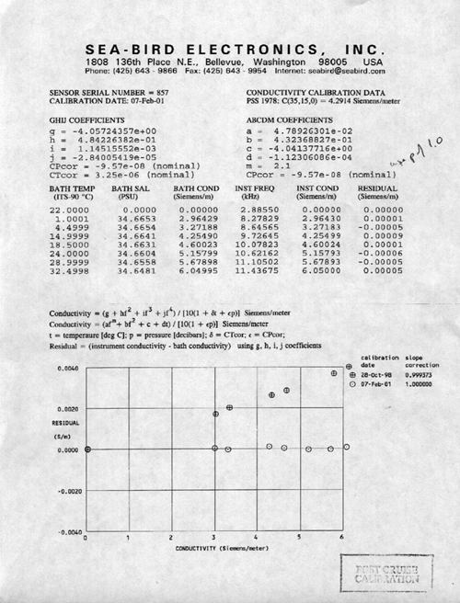

Temperature
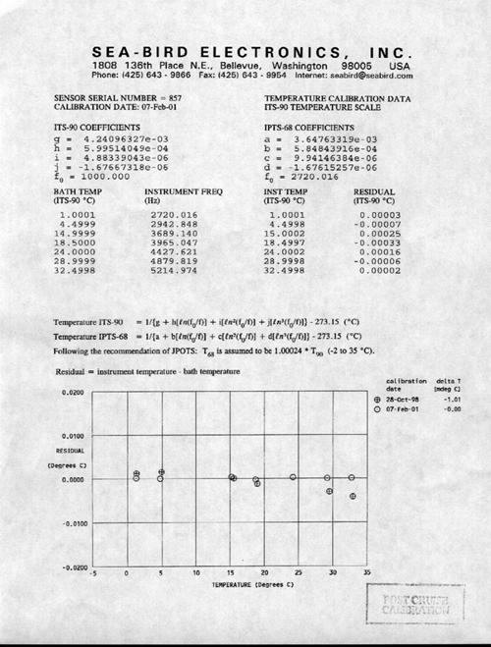

Remote Temperature
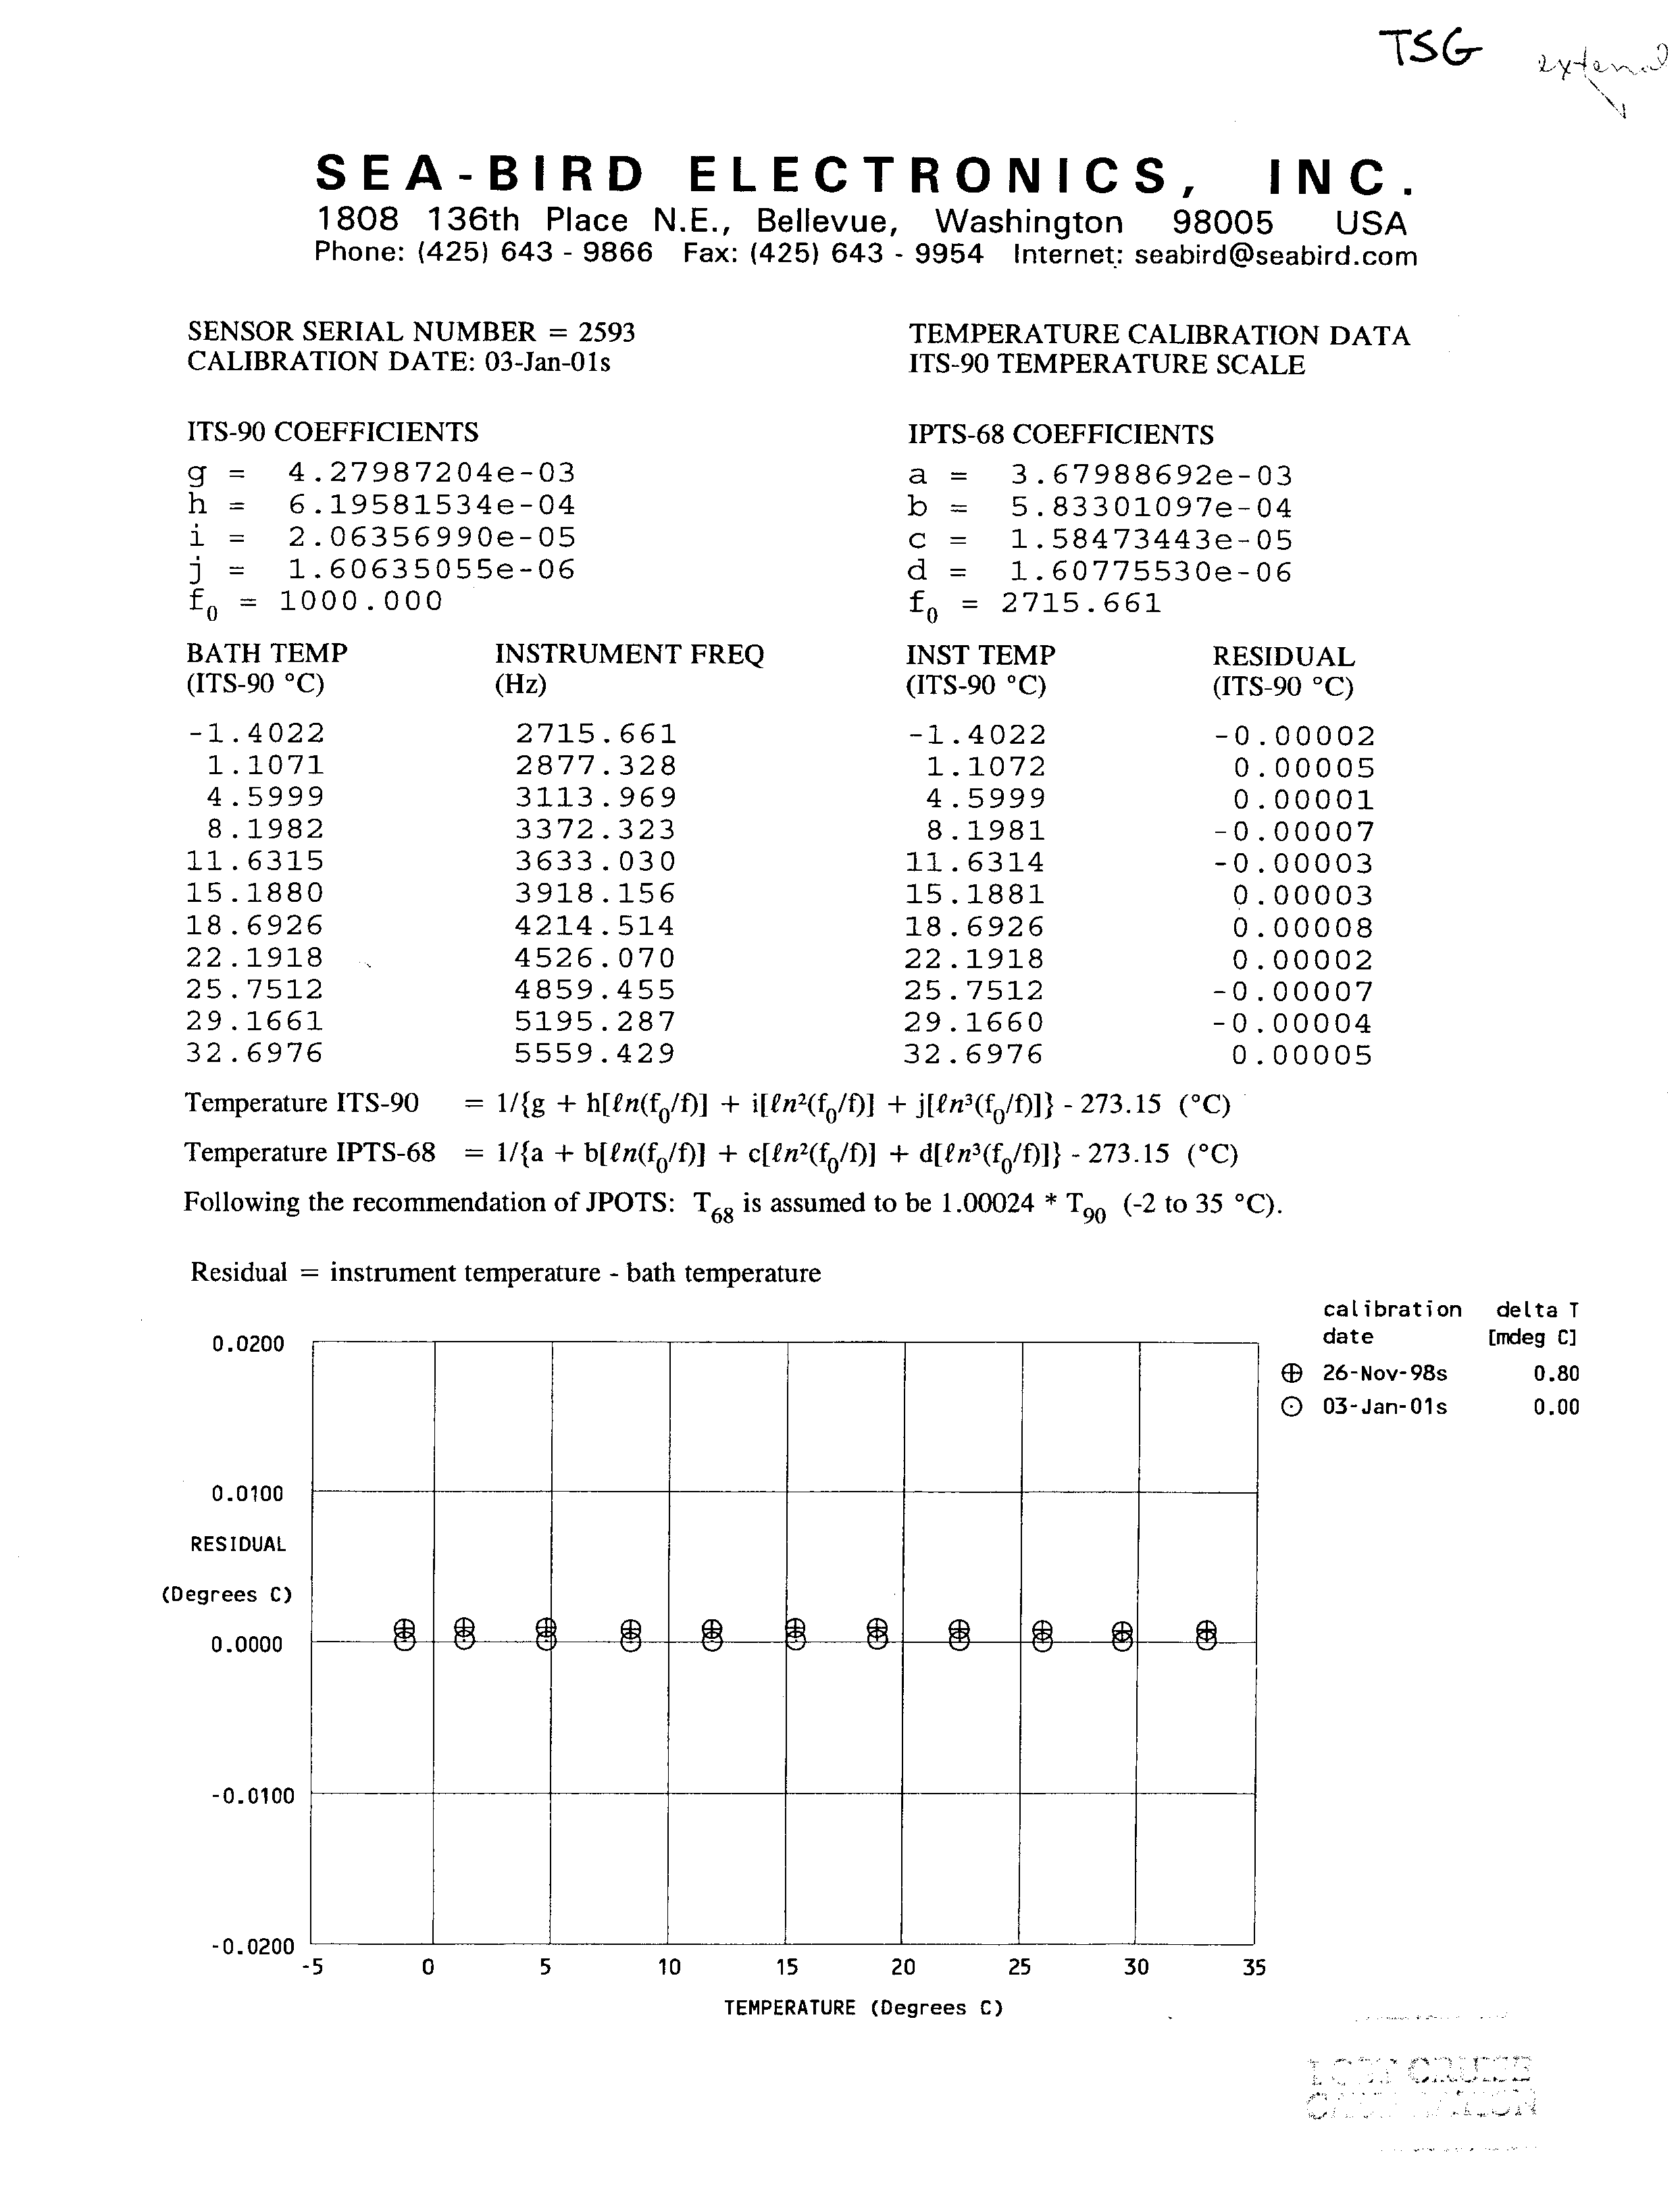

Transmissometer
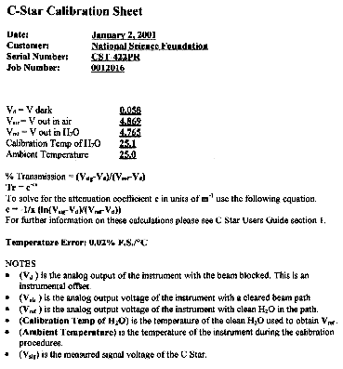

Meteorology System

Windbirds
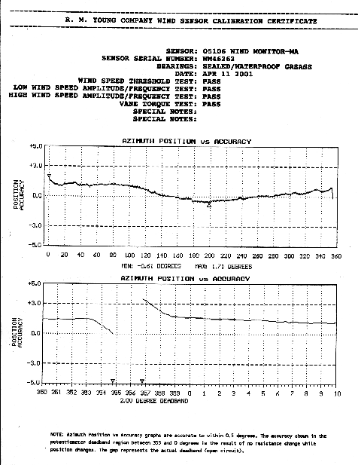

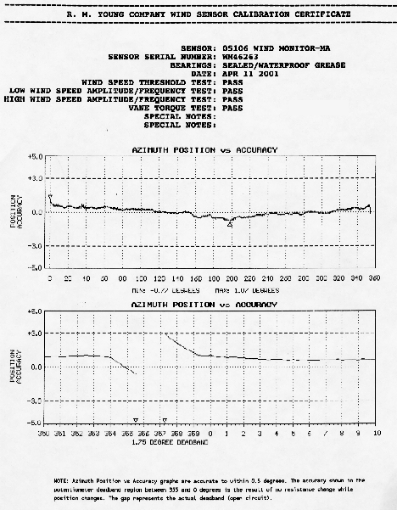

Mast PAR
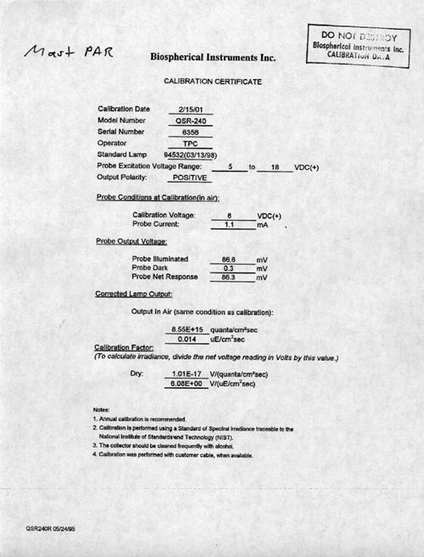

PSP
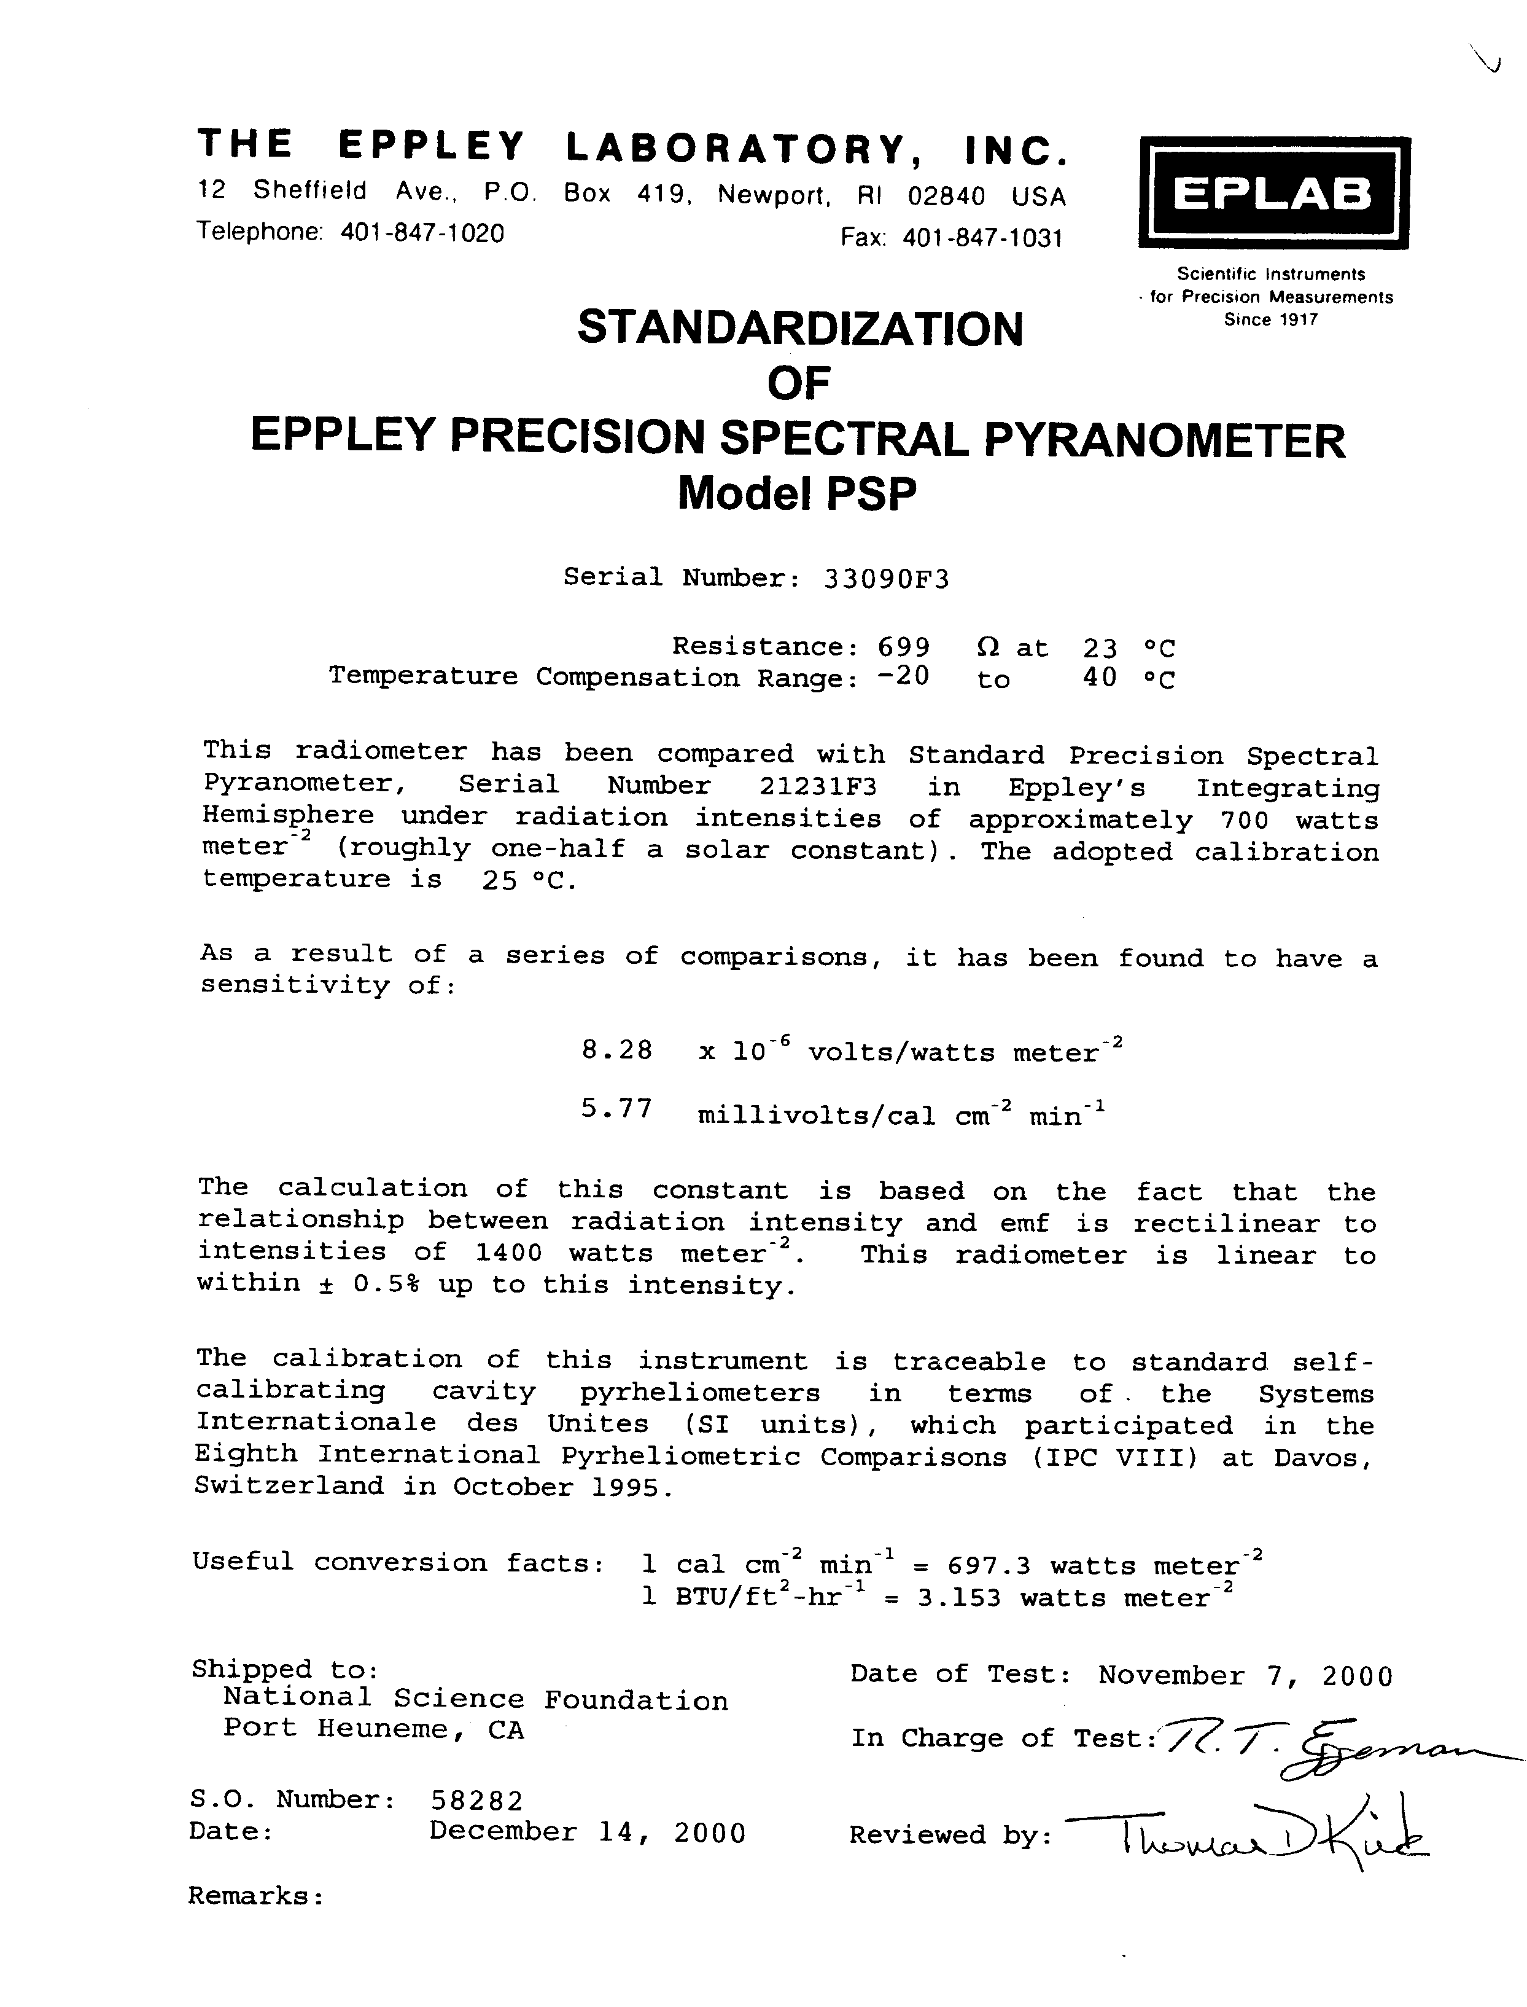

PIR
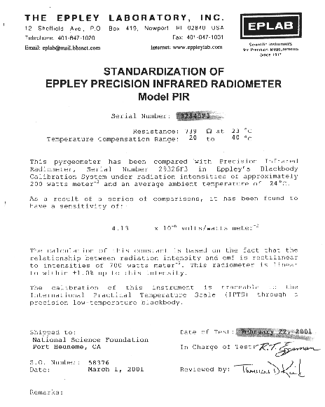

GUV
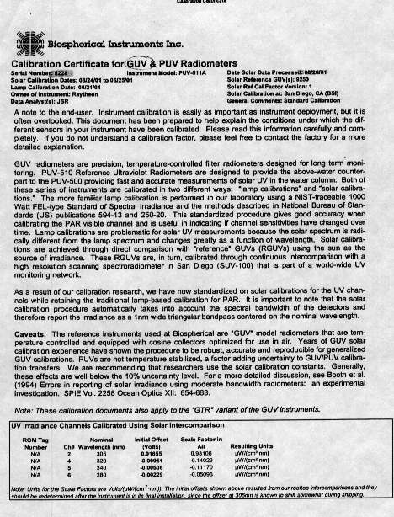
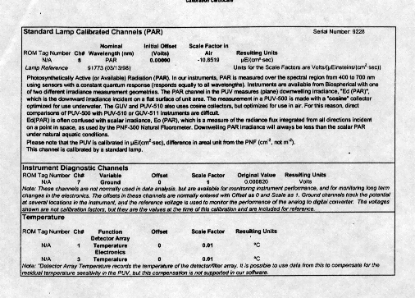

CTD

Pressure Sensor
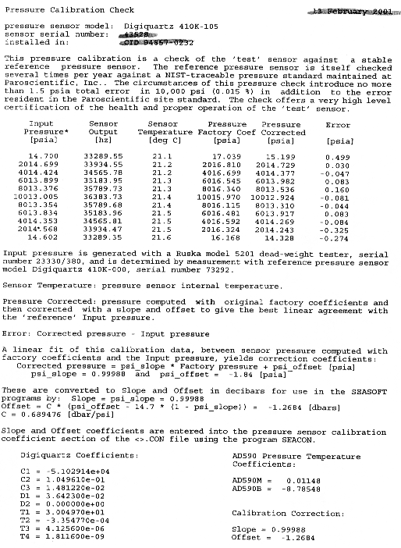

Temperature Sensors
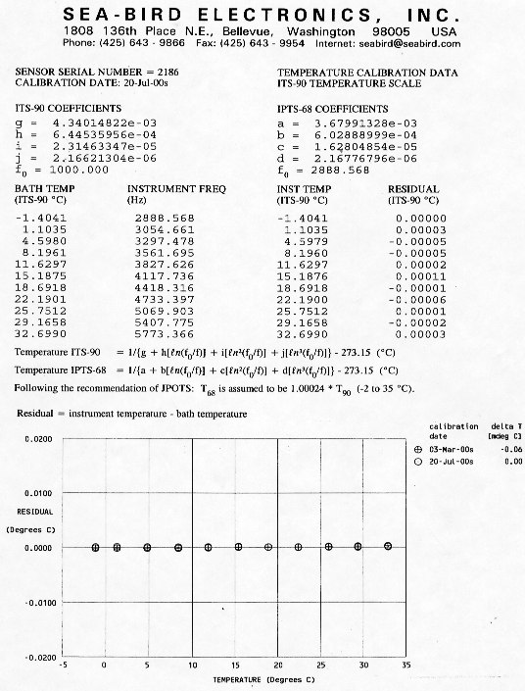
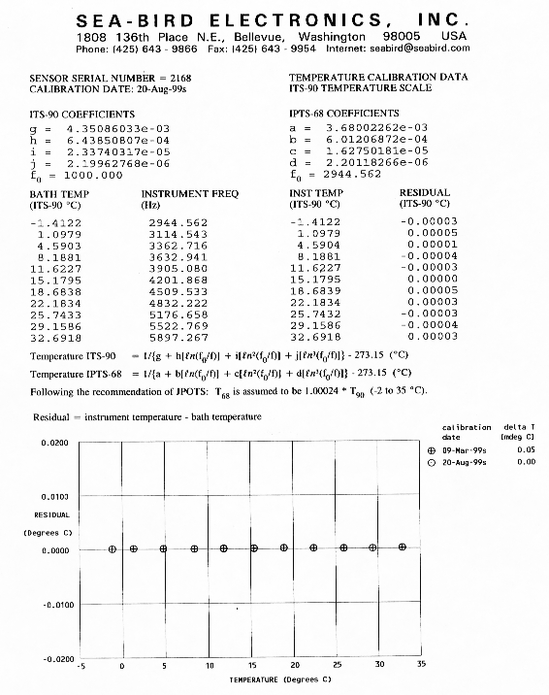

Conductivity Sensors
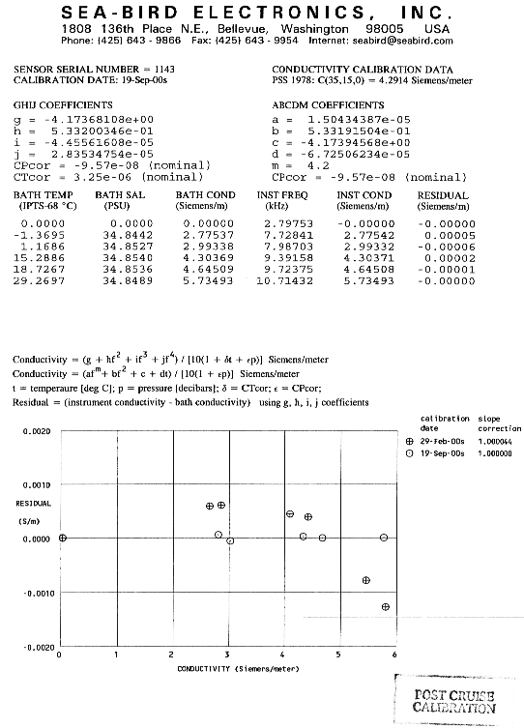

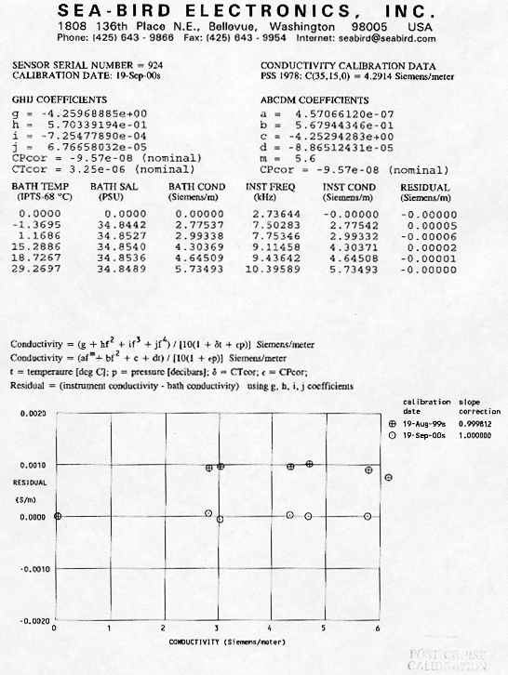

Dissolved Oxygen Sensor
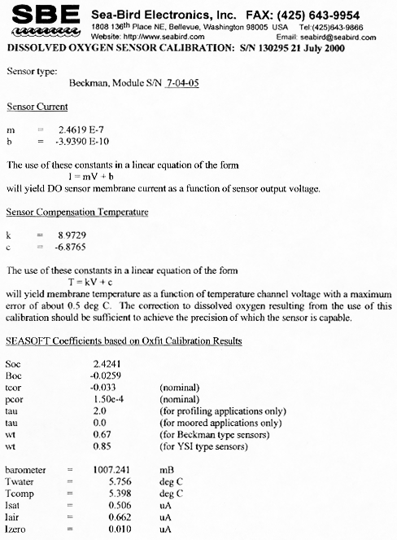

Fluorometer
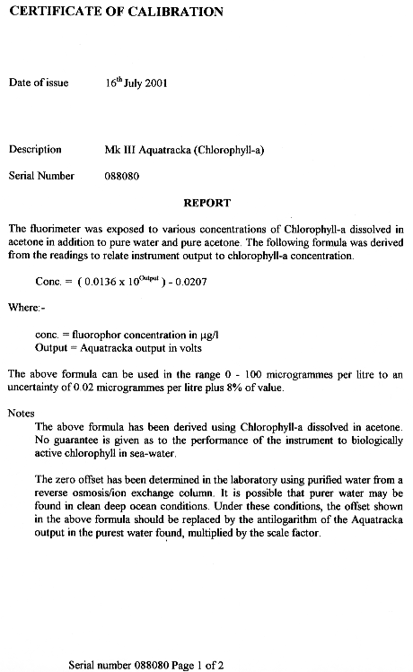
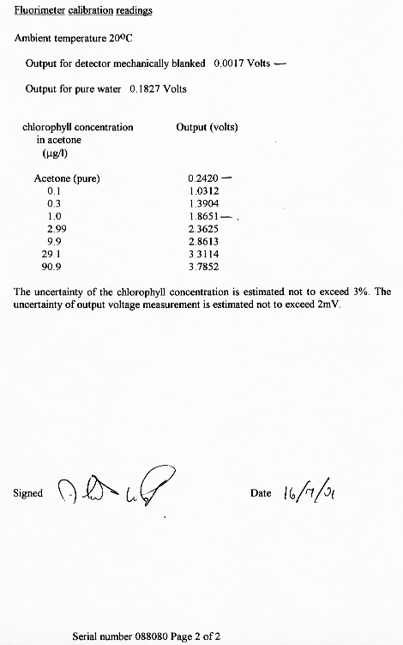

CTD PAR
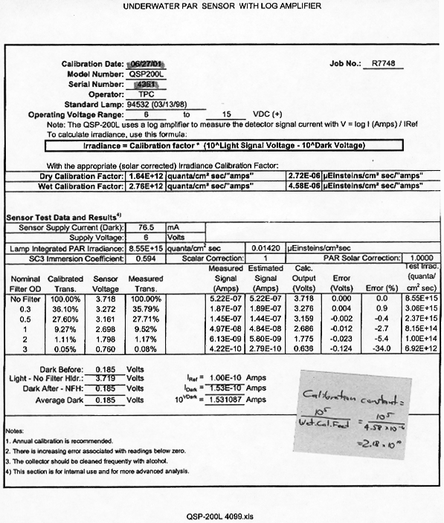

CTD Transmissometer
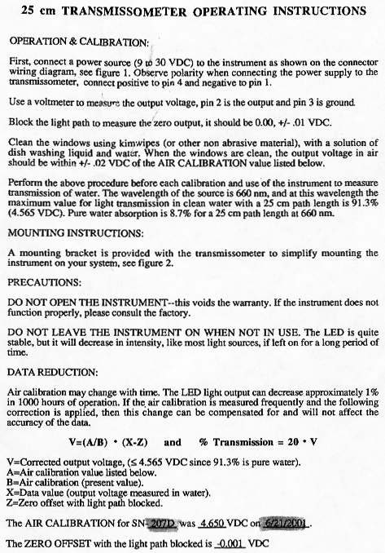

10 m² MOCNESS

Pressure Sensor
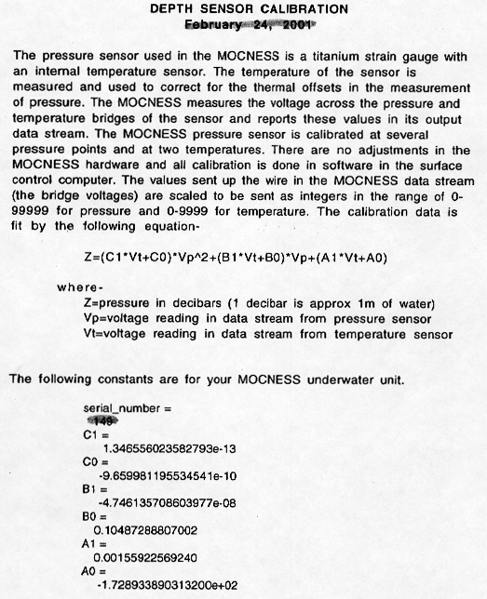

Temperature Sensor
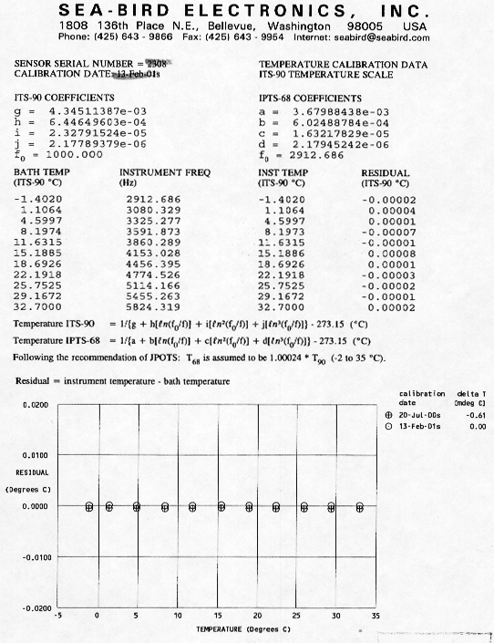

Conductivity Sensor
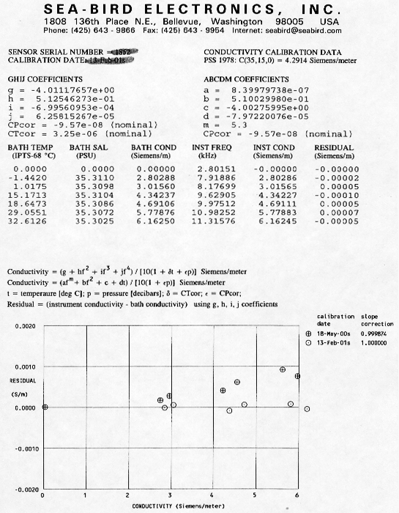

1 m² MOCNESS

Pressure Sensor
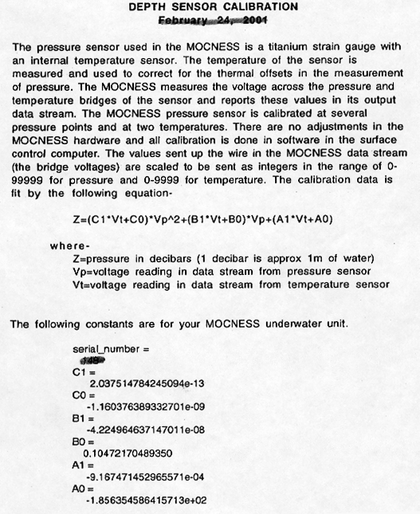

Temperature Sensor

Conductivity

Transmissometer
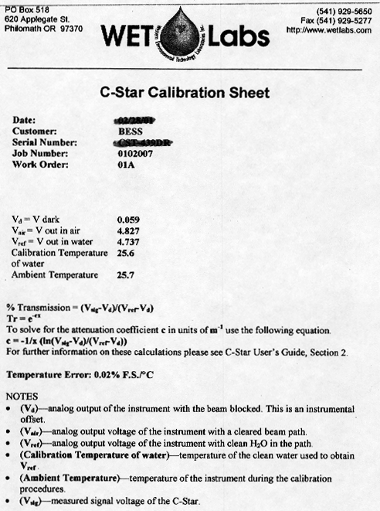

Fluorometer
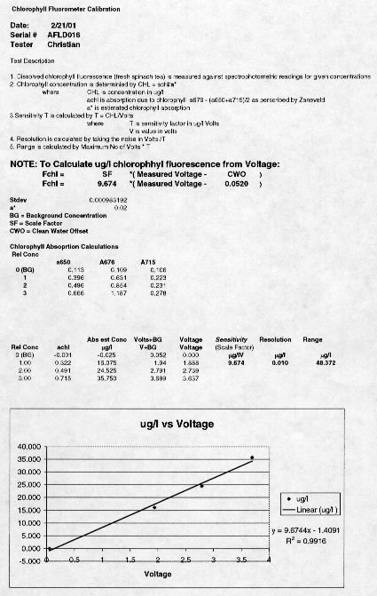

Optical Plankton Counter
