CTD Operations and Processing

The CTD system worked well on GLOBEC III, being operated primarily by the grantees. Marine ET Sheldon Blackman oversaw its operation on the night shift and trained the Grantees on cast procedures. Marine ET Romeo LaRiviere oversaw operations on the day shift. All 92 scheduled stations were completed with 95 casts. Twelve (12) additional casts were done at areas of interest, giving a total of 107 CTD casts for Globec III.

SENSOR CONFIGURATION
Dual Temperature and Conductivity sensors and pumps were put on the frame, as well as a PAR sensor, a Chelsea Fluorimeter and a Transmissometer. The PAR sensor was removed for all casts over 1000 meters and the Transmissometer was removed for all casts over 2000 meters. (For channel connections to the Underwater Unit, See pages 3 & 4.) (For sensor location and distance from the pressure sensor, see Page 4).

A Fast Repetition Rate Fluorimeter (FRRF) was attached to the CTD frame on casts less than 500m.

A CMiPS (CTD-mountable Microstucture Profiling System was mounted on the CTD frame for most casts. Temperature Sensor, T1 was connected to Voltage Channel #6 on the CTD. (For channel connections to the Underwater Unit, See page 4.)

A new SBE-43 Oxygen sensor was mounted on the frame. After considerable investigation, it was discovered that the new sensor required the latest version of Seasave for Windows (Version 5_25A) in order to collect the data. Also, the old Oxygen sensor cables would not work with the new sensor. Therefore, a cable needed to be fabricated, as the cables that came with the sensor were too short.

A bottom contact switch and a O.L.S. pinger were added to prevent bottom contact. The pinger started giving a very faint trace on the EPC plotter, which turned out to be due to low batteries. It was replaced with one of the spares and the EPC trace then became much darker and easier to read.

BOTTLES
There were 24 bottles mounted on the CTD Rosette. When it was used, the FRRF was mounted in place of Bottle #23.

Early on in the cruise, there was a problem with the sample bottles misfiring. Over a number of casts the same bottles would not fire. The problem was finally linked to the titanium trigger mechanisms. It appears that the older mechanisms started to exhibit an inability to respond adequately to the electromagnets. Replacing a trigger mechanism with a new or newer looking one, generally solved the problem. After repeatedly removing the carousel and replacing trigger mechanisms with some from the spare carousel, bottle misfires were eliminated.

DATA ACQUISITION & PROCESSING
Both CTD computers worked well during the cruises. Seasave for Window Ver. 5_25A was downloaded in Punta Arenas on the Web from SeaBird and installed on the acquisition computer. The batch files on the processing computer were modified by Suzanne O’Hara to accommodate using Seasave and SeaProcess for Windows. With the new O2 sensor, it wasn’t possible to exactly match previous cruises processing. The SeaSoft windows versions of the programs do the steps in a different order from the DOS versions, so the same order of output columns couldn’t be generated. The new Oxygen sensor (SBE-43) also generates slightly different output columns.
Seasave for Windows turned out to be quite easy to use once the operators got used to it. A set of cast instructions were generated and an electronic copy is available on the NBP Network at:

O:\et_dir\documents\ctd\Cast_WinInstructions.doc

The configuration files for the cruise are located on the acquisition computer in:

C:\seasoft\NBP0202

The soak time for the CTD was greatly reduced due to the use of the new oxygen sensor. The sensor stabalized within 5 minutes. However, there appears to be some time lag problems associated with the sensor that are greater than specified in the SeaBird documentation. The difference between the upcast and downcast oxygen readings varied as much as 0.5 ml/l. SeaBird was contacted about this problem. Dave Armstrong at SeaBird stated that ‘The oxygen data needs to be aligned. I would suggest advancing the oxygen data by 7 to 10 seconds, this should correct the data’. Senior Analyst, Suzanne O’Hara ran some tests with time advancing of the data. These tests resulted in the data being brought closer together, but did not align the data adequately.

To verify the oxygen sensor time lag problem, a second SBE-43 Oxygen sensor was mounted on the CTD frame and connected to ExternalVoltage Channel 2 in place of the PAR sensor for casts #070 – #073. The second oxygen sensor exhibited the same time lag problem. A copy of the raw data files is being forward to SeaBird for their analysis.

John Klinck, the head oceanographer on this cruise, has stated that he is going to correct the data himself using the bottles samples that he has collected. This is the way that the data for the Beckman style sensors has been corrected in the past. Therefore, no time advances have been applied to the oxygen data in the standard processing.

Also, after all CTDs were completed, using the Term11 program, Sheldon Blackman advanced Voltage Channel 0 (O2 Sensor) on the CTD Deck Unit by 9.9 seconds and re-acquired Cast #107 from the cassette tape. The plot from the re-acquistion was then compared to the original acquisition. As with the post processing tests, the downcast and upcast traces for the SBE 43 Oxygen sensor were brought significantly closer together but were still off by quite a bit. The Term11 program only allows the deck unit to be advanced by a maximum of 9.999 seconds. The time advance on the deck unit was put back to 0 seconds after the tests were completed.

The raw data from Cast #38 had to be recovered from the audio cassette tape. The raw data file (p202038.dat) became corrupt when an attempt was made to edit the header in the file on the acquisition computer. The file was transferred over to the network and subsequently to the processing computer. An attempt to process the file revealed its corrupt status. Fortunately, the file was recovered from the backup audio tape. All processing after that went well with the exception of the sound velocity file (sp20238.cnv) file did not process properly. For some reason there is still a problem with raw data files that prevents this file from being created properly.

There were occasional problems with Seasave starting the acquisition if the NMEA GPS string was not there. Occasionally the Ashtech GPS would fail to be locked on a GPS fix and would not be sending a NMEA string. Resetting the Ashtech GPS system solved the problem and the NMEA string was then available. However, the Seasave software sometimes needed to be rebooted when this occurred or the software would still fail to start the acquisition. No data was lost due to this problem. By making sure the Ashtech was operating immediately before the cast started, the problem was minimized.

SBE-9 Plus Underwater Unit

S/N 09P10716-0377

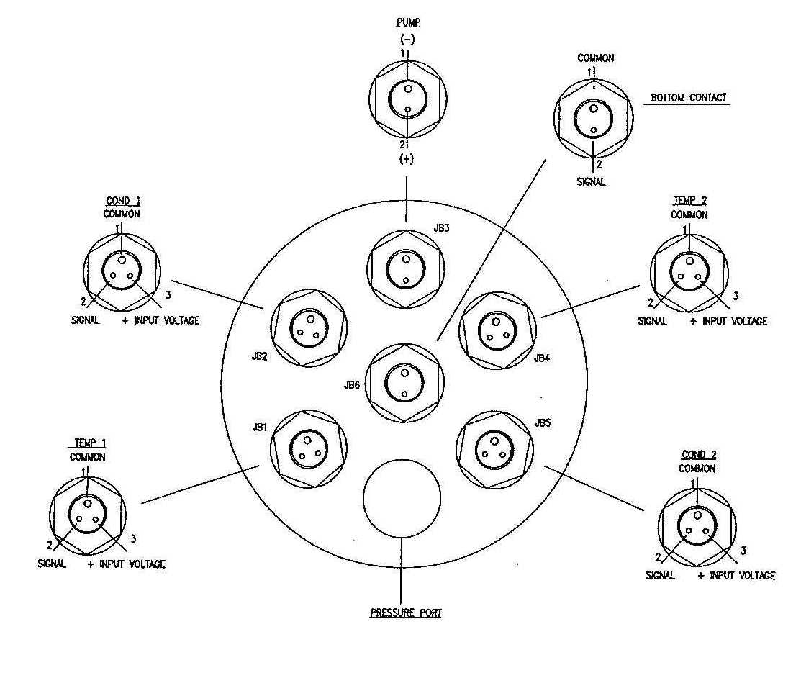
Primary Conductivity
S/N 2067

Primary

Temperature
S/N 2367

Secondary

Temperature
S/N 2186
Secondary Conductivity
S/N 2513

Digiquartz
Pressure Sensor
S/N 58949

Bottom End Cap Connector
(Configuration on NBP0202)

SBE-9 Plus Underwater Unit
S/N 09P10716-0377

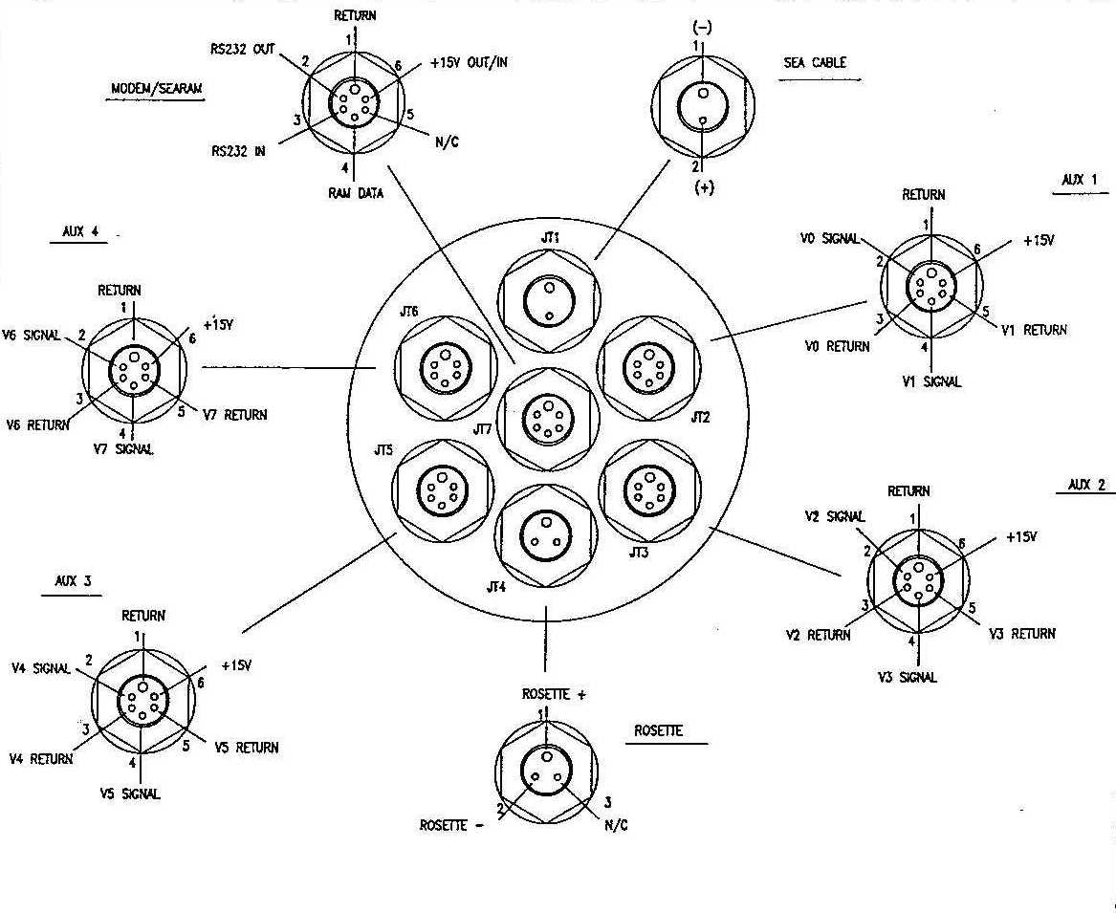
Ext. Volt 6: CMiPS__
Ext. Volt 7: ________
Ext. Volt 4: Transmissometer, S/N 207D
Ext. Volt 5: Flourimeter, S/N 080880
Ext. Volt 0: Oxygen SBE43,S/N 0080
Ext. Volt 1: _____________________
Ext. Volt 2: PAR/Irradiance, S/N 4361
Ext. Volt 2: Oxygen SBE43,S/N 0082*
Ext. Volt 3: _____________________

* Note: Secondary Oxygen sensor replaced
PAR on casts #070 – 073.

Top End Cap Connector
(Configuration on NBP0202)
CONFIGURATION for NBP0202 CTD

ASCII file: C:\seasoft\NBP0202\Nbp0202.con or Nbp0202_Ox.con (with secondary Oxygen sensor)

Configuration report for SBE 911/917 plus CTD
---------------------------------------------

Frequency channels suppressed : 0
Voltage words suppressed : 0
Computer interface : RS-232C
Scans to average : 1
Surface PAR voltage added : No
NMEA position data added : Yes
Scan time added : No

1) Frequency channel 0, Temperature
Serial number : 2367
Calibrated on : 12-JUN-01
G : 4.33466091e-003
H : 6.43057120e-004
I : 2.37105286e-005
J : 2.29326732e-006
F0 : 1000.000
Slope : 1.00000000
Offset : 0.0000

2) Frequency channel 1, Conductivity
Serial number : 2067
Calibrated on : 13-DEC-01
G : -1.03980803e+001
H : 1.46700966e+000
I : -5.12766449e-003
J : 4.41800486e-004
CTcor : 3.2500e-006
CPcor : -9.57000000e-008
Slope : 1.00000000
Offset : 0.00000

3) Frequency channel 2, Pressure, Digiquartz with TC
Serial number : 58949
Calibrated on : 13-JUL-01
C1 : -4.840395e+004
C2 : -2.017057e-003
C3 : 1.464810e-002
D1 : 3.990600e-002
D2 : 0.000000e+000
T1 : 2.998386e+001
T2 : -2.560542e-004
T3 : 3.869120e-006
T4 : 2.452640e-009
T5 : 0.000000e+000
Slope : 0.99999000
Offset : 0.21880
AD590M : 1.146000e-002
AD590B : -8.457340e+000

4) Frequency channel 3, Temperature, 2
Serial number : 2186
Calibrated on : 15-DEC-01
G : 4.34039770e-003
H : 6.45080125e-004
I : 2.35267825e-005
J : 2.25318679e-006
F0 : 1000.000
Slope : 1.00000000
Offset : 0.0000

5) Frequency channel 4, Conductivity, 2
Serial number : 2513
Calibrated on : 13-DEC-01
G : -1.05905818e+001
H : 1.63509839e+000
I : -2.18814632e-003
J : 2.63682166e-004
CTcor : 3.2500e-006
CPcor : -9.57000000e-008
Slope : 1.00000000
Offset : 0.00000

6) Voltage channel 0, Oxygen, SBE 43
Serial number : 0080
Calibrated on : 02-JAN-02
Soc : 3.8100e-001
Boc : 0.0153
Offset : -0.6242
Tcor : 0.0005
Pcor : 1.35e-004
Tau : 0.0

7) Voltage channel 1, Free

8) Voltage channel 2, PAR/Irradiance, Biospherical/Licor
Serial number : 4361
Calibrated on : 12-DEC-2001
M : 1.00000000
B : 0.00000000
Calibration constant : 19801980198.01979800
Multiplier : 1.00000000
Offset : 0.00000000
(Replaced PAR sensor for Casts 70, 71, 72 & 73)
8) Voltage channel 2, Oxygen, SBE 43, 2
Serial number : 0082
Calibrated on : 12-JAN-02
Soc : 3.7100e-001
Boc : 0.0214
Offset : -0.6270
Tcor : 0.0023
Pcor : 1.35e-004
Tau : 0.0

9) Voltage channel 3, Free

10) Voltage channel 4, Transmissometer, Chelsea/Seatech/Wetlab CStar

Serial number : 207D
Calibrated on : 21-JUN-2001
M : 20.0000
B : -0.0200
Path length : 0.250

11) Voltage channel 5, Fluorometer, Chelsea Aqua 3
Serial number : 088080
Calibrated on : 01-FEB-2002
VB : 0.027300
V1 : 1.860200
Vacetone : 0.117900
Scale factor : 1.000000
Slope : 1.000000
Offset : 0.000000

12) Voltage channel 6, CMiPS Temperature Sensor

13) Voltage channel 7, Free

